Greetings from Mesoamerica (Maya Worlds Summer Institute 2006), (June 21)
There are 26 scholars from across a variety of disciplines journeying across four countries: Mexico, Guatemala, Honduras, and Belize. Our focus is on Mayan history and culture. Along the way we'll visit a number of prominent archeological sites such as Palenque, Tikal, and Copan. The trip is sponsored by the Community College Humanities Association. It is funded in part by the National Endowment for the Humanities. I've been told that the NEH is one of the few decent governmental agencies that the ugly politics of Washington of the past 25 years hasn't affected greatly. Its budget has been slashed dramatically but it still funds quality academic experiences like this with little interference.
This opening photo (of what I hope will be many interesting photos) is of my brother Stan and me standing in front of Lake Atitlan, Guatemala last year. I include this because were it nor for Stan's expertise, this web blog would not be possible. Please come back to the site every few days or so--I will update it with pictures and stories from our travels. I cannot assure you a new entry everyday, however; the download time for these images is interminable and access to internet cafes is uncertain!
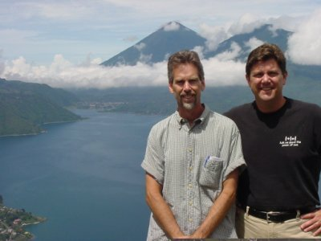
We got our start in Villahermosa, Mexico (June 19-20) where we visited the Olmec archaeological site of La Venta. Unfortunately, the impact of the oil industry over the years has been detrimental to the actual site. Therefore, farsighted individuals saw fit to remove a number of the important pieces to either a museum or to an open-air park that has a feel for the original setting. Among the more dramatic items from La Venta are four colossal heads carved in basalt (volcanic rock). They supposedly represent images of various Olmec rulers. The Olmec are considered to be the parent culture of the Maya. The head shown below could be as old as 1500BCE. Folks..., that´s old! BTW, the mosquitos are horrible! So far, Bert´s Bees, along with wearing long-sleeved clothing and a hat seems to be keeping them at bay! Keep fingers crossed!
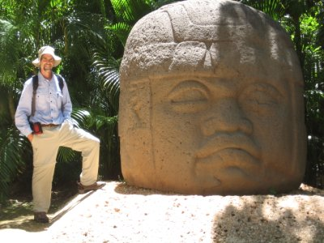
For you athletes in the crowd, the following picture from La Venta Museum shows a couple of yugos (yokes) used in the famous Olmec (as well as Mayan) ballgame. These are stone carved replicas of what might have been wood or some sort of matting worn around the waist and hip and designed to protect the body from the crushing weight of an extremely heavy ball that MUST be kept in the air by hitting it with the hip. The game supposedly resembles soccer a little bit.
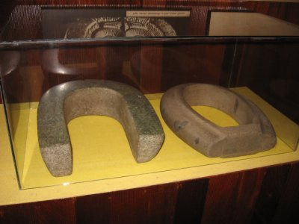
I'm inserting the following piece after the fact, i.e., at the end of the trip. I got a late start on the blog and in trying to play catch up, not everything of interest from our time in Villahermosa was included. Our first scholar was Karl Taube, an anthropologist specializing in Mesoamerica. In one of his readings he noted that the presence of large quantities of jade celts (polished axe-like heads) and quetzal feathers at La Venta were evidence that the Olmec had reached a point of economic surplus; meaning that they had moved beyond simple self sufficiency in basic foods and were in a position to hold a surplus against future calamities. He suggested that they stored their surplus, at least in part, in the form of these jade celts and quetzal feathers. These were highly valued possessions and represented not only a store of wealth, but a medium of exchange, as well. All interesting... I asked him how these objects came into their possession since they were not produced locally. If you think about it, there are only two ways this could have happened; either through trade, or through military actions. If trade were the means, then what would they have produced to sell to people as far away as the Motagua River Valley or the jungles of Guatemala? Corn? Well, corn was produced in abundance--it was the basis of their diet, just like for the Maya civilization that was to come later. Yet since there were no wheeled vehicles or draft animals in those days, human porters would have been the only means of transportation. Karl and I were speculating that to cover such long distances with enough corn to exchange for jade celts and Quetzal feathers, and also to provide enough sustenance for the porters themselves would have likely been impossible. Archaeological evidence for military actions is nonexistent. That leaves one other possibility: chocolate, or more accurately, cacao. Cacao was, in fact, produced in the Olmec regions around La Venta, it was highly prized, and it would have had an exchange value far in excess of corn. Therefore, less of it would have been needed to transport to far off regions to buy jade and quetzal feathers. Is there hard archaeological evidence to support this hypothesis? Not yet. As an economist, this is all fun and interesting to think about, but I'm at the mercy of archaeologists to come up with evidence. What would such evidence look like? Olmec pots from La Venta with cacao residue hidden away in a site somewhere in the Motagua River valley or in the jungles of Guatemala would be a good start.
This opening blog is covering a lot of ground. We traveled south to the classical Maya site of Palenque in Mexico. For you lovers of flora and fauna, there is beauty and something of interest at every twist and turn. The following image is of a hibiscus tree. They are everywhere, along with an African red Flamboyan tree (dazzling!!!). I don´t have a camera with a telephoto lens, so you´ll have to take my word that I have seen cool birds such as a Bat Falcon (yes..., it eats bats). I saw this today (June 21--Happy Summer Solstice) at Palenque. I have seen a Yellow Hooded Oriole, and a Great Kiskidi (a fly catcher). How do I know this? One of our local guides, Alfonso, is somewhat of an expert in these matters.
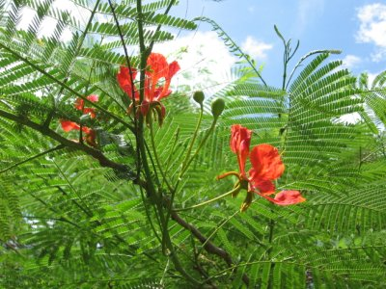
I´ll close for today with two pictures from Palenque. In showing these pictures, I have moved us forward over 1000 years to the Mayan era. The Olmec kind of dropped off the map around 500BC. The first photo is the famous burial site (Temple of the Inscriptions) of the famous leader Pakal (around mid 600s AD). The second is of the central palace, an intricate web of homesites, throne rooms, and ceremonial sites of the various rulers. Palenque's architecture is considered to be the finest quality of the Classical Mayan era (250-900AD).
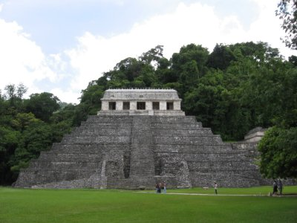
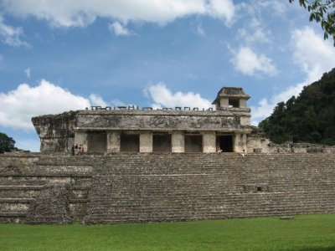

June 22, 2006: A Beautiful Day At Palenque
Today was an amazing day at Palenque. Nature threw its best at us. In addition to the incredible ruins, there were Howler Monkeys, a Toucan, glorious red-flowered trees called Flamboyan (in addition to the Hibiscus I mentioned in the last blog), towering Cieba trees, the rainforest in general, and a nature trail wandering through a wildlife preserve (with amazing waterfalls and wading pools)!!!! It doesn't get much better than this. The first picture is of the Toucan! I wandered off from the group for a bit to climb up a nearby medium-sized temple and observe life from on high. Well, what to my wandering eyes should appear, but a Toucan with a berry in its mouth. I'm assuming that if you can open the picture on your own machine and enlarge it, you'll be able to see the following detail: The huge two-part beak (upper half cream-color, lower half black) with the berry, a red patch around a yellow eye with a black pupil, upper feathers of black and an underbelly of yellow. I had the good fortune of observing all this with my binoculars, and fortunately, the camera picked it up as well. Absolutely stunning!!! Here goes. He's in the bright green tree in the foreground. More later...
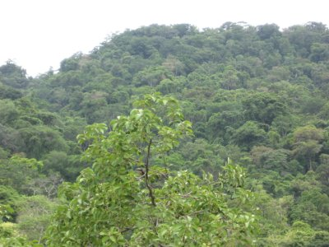

June 24, 2006: Greetings from San Cristobal de las Casas, Chiapas, Mexico
Yesterday (Friday) was a huge day. Lots of distance traveled on winding mountainous roads. Two and a half hours from Palenque to Tonina, then another two and a half hours or so to San Cristobal de las Casas. We stopped at Tonina because this is one of the relatively close kingdoms (nation-states) that was in constant conflict with Palenque. Palenque has this storied history as being one of the premier Classical Mayan kingdoms. People who pay attention to such things all know about the glory days under the kingship of Pakal (mid-600s). So, how is it that the relatively small kingdom of Tonina was able to defeat Palenque on more than one occasion, and on one of those occasions, capture Pakal's second son? The modern day equivalent of this would be for the Mexican army to march on the United States and capture Jeb Bush, or something. There is no good answer to my question of how they pulled this off. As we traveled from Palenque to Tonina, I was trying to imagine the difficulties in outfitting an army and supplying it with enough food and armaments to travel the 80 or 90 kilometers over some of the most rugged terrain in the world. They didn't have horses or other draft animals. They had discovered the wheel, but apparently it was never used for commerce or war!
At any rate, the picture below is of Tonina. It is a rather tightly clustered community (at least what has been excavated at this point), unlike Palenque, which is spread over several square kilometers. If you can blow up my picture below, you'll see that there are 7 terraced levels all built up the side of a hill: 86 meters high and 260 steps to the top. And I should note that the Mayans built extremely tall steps. I'm 6 feet tall and have to take huge strides to be able reach the next step. The overall construction would explain why Tonina wasn't easily conquered--because there is only a single approach. However, this fact doesn't explain their own military prowess.
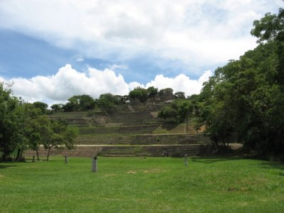
Enough about military prowess and such. The flora and fauna continue to impress. Check out my favorite flower of the day pictured below. If anyone can identify it, please let me know. Our hotel is a sprawling hacienda surrounded by lush gardens full of cool flowers. Oh, by the way, the Toucan I had in the previous blog was a Keel-Billed Toucan.
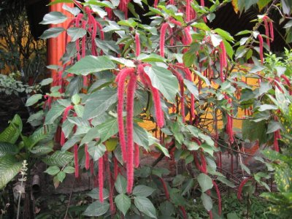

Sunday June 25. More from San Cristobal
We have visited two Mayan communities since we arrived in San Cristobal de las Casas, Chamula and Zinacantan, both Tzutzuil speaking communities. In spite of this commonality, they each have their own separate traditions, and native attire (traje). Zinacantan is thought of as being a relatively well-off community, while Chamula is less well off. There are at least two reasons for this. Zinacantan received land during the post revolution (1910-1917) agrarian reform and Chamula did not. The Zapatista rebellion of 1994 created further conditions that ended up making life worse for Chamulans, but worked to the advantage of Zinacantan. The Zinacantan community sided firmly with the PRI party that had run the government since the earlier revolution. The Chamulans were sort of divided as to their allegiances, though. The Zapatista rebellion was all about indigenous rights. Unfortunately, many indigenous mayors (caciques) had long ago been co-opted by the government, a tradition that dates back to the conquest. There was a lot of infighting that also broke down along Catholic vs. Protestant lines. To make a complicated story short, the government threw tons of money at Zinacantan to make sure it stayed firmly in the PRI orbit. Chamula got little of it. Much of the money that went to Zinacantan went for investments in what is known as non-traditional agriculture, things like flower growing, broccoli, snow peas, cauliflower, and so forth, all destined for export. When you drive into Zinacantan, one sees endless greenhouses such as the one in the following picture (which, if you look carefully is growing geraniums, among other flowers). Plastic-sheeted greenhouses cover all available land not already used for housing and corn fields (milpa).
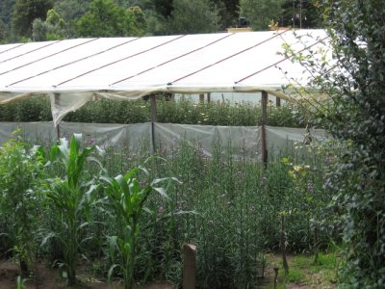
You may be aware that Mexican presidential and senate elections are approaching on July 2nd. The countryside is dotted with campaign posters. This should be an interesting election to watch. The PRI party I mentioned above lost the presidency in the 2000 election for the first time since the revolution to the right wing PAN party (of Vicente Fox). This in itself was revolutionary. It threw the long established PRI into fits!!! Currently the three parties, including the left of center PRD are all running neck and neck. Apparently PRI is no longer guaranteed anything. Look carefully at the following campaign poster of a candidate, Manuel Velasco, running for Senator of the state of Chiapas. His poster reads El Guero si puede. This roughly translates as follows: Vote for me because I´m the white guy!!! To me this is amazing that in the poorest state of the country, where the largest single voting block would be Mayan people, all with dark skin, a candidate would run on such a blatantly racist platform!!!
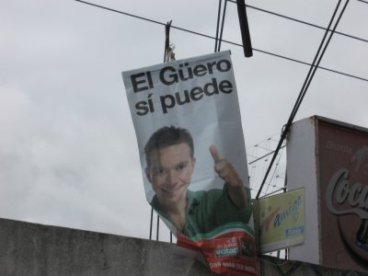
Let me conclude with the flower of the day, a gorgeous Phallianiposis El Tigre orchid. Is this not the coolest thing!!!???
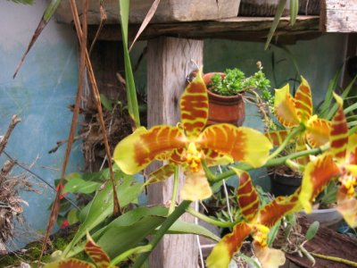
More soon!

Monday June 26 More from San Cristobal
Mayans have been discriminated against for 500 years, ever since the conquest. Early on, it was bloody; today it is more subtle, but occasionally bloody. As recently as the 1960s Mayans simply were not allowed to set foot in the Ladino town of San Cristobal de las Casas. The Zapatista rebellion of 1994 changed all that. Mayans are now more commonplace and stores selling Zapatista posters, t-shirts, and information are quite acceptable. In the past decade or so a Maya theater movement has begun. The focus is either on retelling an accurate Mayan history or on addressing current social issues. The following picture shows the women of the acting group FOMMA at the conclusion of a play they put on for us today. Their signs indicate that women's deaths, as a result of the birth process, are completely unnecessary. They are doing good work to educate Mayan women as to their rights both at home and in society. More later.
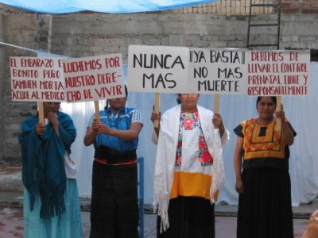

June 27, 2006 I´m still in San Cristobal.
As we walk the streets of the city and if one pays only a little bit of attention, you get a sense that not all is well. The buildings are full of graffiti and it's not just gang-related, though there is a little of that. There are two kinds: 1) Messages in support of the Zapatistas and against the Mexican establishment, and 2) anti-George Bush messages. Note that I did not say anti-American or anti-USA, but the messages are very specifically anti-Bush. The following picture captures that sentiment quite succinctly. I don't think this message needs any translating from Spanish to English. We were told by one of our speakers that a survey of Mexican journalists revealed that they felt that this administration was the most anti-Latin America in 100 years. Given Reagan´s time in office and his contra war against Nicaragua and support for the blood thirsty El Salvadoran and Guatemala military regimes, that is saying something indeed.
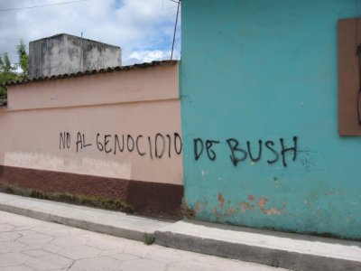
Let's end today's blog on a brighter note. Here is the flower of the day, found in the garden right outside my hotel room. I think this is an Amaryllis. If not, I´m sure you´ll let me know. This garden has more flowers than you could imagine. I could send you a different picture every day of my 6 week trip, just from it alone.


June 28: Last full day in San Cristobal
We hit the road tomorrow for Palenque (again). The main reason for the backtracking is to be able to enter Guatemala (ultimately headed for Tikal!!!) on a decent road, though, if my memory serves me, there is a river/border crossing on small boats that awaits us.
We've had some free time to wander the city and yesterday I checked out the local market--the one that serves the masses. It was the usual riot of color and beautiful-looking food, tienda after tienda. It's not necessarily better or different from other mercados in other cities, but there is an interesting human-side bar to the photo below. If you look carefully at the last woman in the middle tienda, she is holding a cup in front of her face. For those in the know, i.e., for culturally sensitive travelers, you might assume that I was insensitive and just whipped out my camera and took the shot. Not so. I carefully asked someone at each tienda in the picture if it was OK to take the shot to share back home. In fact, I got such permission and the photo below is the result. When I saw the cup in front of the woman's face, I realized that the woman I asked permission from--who apparently was the daughter--wasn't speaking for her mother. I took another picture of another tienda, where once again I asked permission as a back-up. However, after talking with a friend on the trip about this photo experience, it was suggested that the picture and the story behind it was interesting and worth sharing with all of you. So there you go!
If you haven´t traveled to Latin America, this is the kind of beautiful market place you can expect in practically any country, and you definitely want to ask permission for your photos. Supposedly, many Mayan people, mostly women I´ve been told, are fearful that when someone takes their picture, they are stealing a part of their soul!!! Ouch...
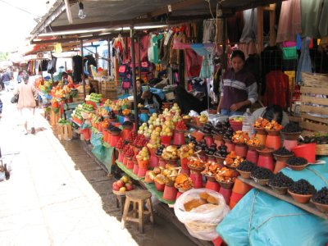
Here is the flower of the day, featuring one of my traveling companions, Dulce. If any of you know the name of this flower, let me know.
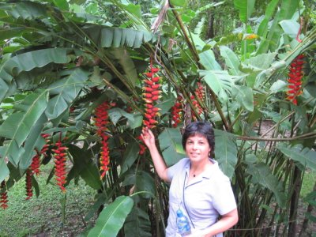
More later...

June 29: Back in Palenque: A hard day on the road!
We drove to Palenque today without benefit of the stop in Tonina we had on the way to San Cristobal in the first place. It was a motion-sickness nightmare: Speed-bumps every few miles, hairpin turns, potholes, and stuff... About 6.5 hours or so.
Last night a few of us went to the movies and saw a must-see documentary on Chiapas by a Canadian production company. It was titled "A Place Called Chiapas," and it was about the Zapatista uprising. The film company had been in place from the start of the uprising. In fact, the film began with close ups (using a telephoto lens) of the elite of Mexico celebrating New Year's eve (Dec. 31, 1993) on their balconies around the Zocalo (the central plaza). Their cameras were also ready the next day, Jan. 1, 1994, from a vantage point near the government office buildings in San Cristobal de las Casas. The New Year's eve celebration was supposed to be more special than usual because the NAFTA accord (North American Free Trade Agreement) joining the US, Canada, and Mexico together as trading partners was to go into effect the next day! (Whether the agreement was balanced and whether it addressed important things like the environment and labor are issues for another tirade on another day).
Sub-Comandante Marcos and the Zapatistas spoiled the celebration, however, with their attack on the government offices in four Chiapan cities, including San Cristobal. They were making a statement that the free trade agreement, along with seven decades of rule by the PRI (Institutionalized Revolutionary Party--by the way, think about the irony of that name...), had ignored the needs of the indigenous Mayans of Chiapas and other indigenous peoples throughout the rest of Mexico. Their demands were for recognition of indigenous rights, including autonomy, and for access to the country's resources. Chiapas is an incredibly rich state in terms of natural resources, including oil and timber, which the elite families exploit for their personal well-being.
Yes, there was bloodshed, but not a lot by the normal standards of rebellions. A few rich families owning thousands of acres had portions of their estates confiscated. The Mexican military shifted into high gear, but was not really prepared for the kind of guerrilla warfare needed to fight in the jungles of Chiapas. A stalemate and cease-fire ensued after less than two weeks. Over the years (12 now), there have been endless cease-fires, peace negotiations, and even signed agreements, yet the government has always insisted that to make the accords "stick," they need to be made part of the constitution. This hasn't happened yet.
The film was fairly-well balanced in its presentation, I thought. In addition to portraying the message of the Zapatistas and the plight of the poor masses--the usual fare--it went so far as to include extensive interviews with one of the elite families who had land taken by the rebels and subsequently redistributed to Mayan homesteaders. The family was pissed, to be blunt about it. Any of us would be pissed to have our lands taken from us. And, in addition to the irritation of having their lands taken, they couldn't see that the homesteaders had used the lands for any good purpose. Their homes and barns had simply been destroyed and little infrastructure had taken their places.
Interviews with the homesteading families revealed that they had land for the first time ever and had big plans to build schools and health care facilities, and even a soccer field. They simply didn't have access to the financial resources most of us take for granted. Therefore, their big plans would have to wait.
There were questions that were not asked though. In particular, the main question not asked has to do with HOW that elite family came to own five separate haciendas (of which two were taken by the rebels). The answer to this question is one that the Mexican government and the elite families simply won't answer, because it would force them to take a closer look at the conquest of 500 years ago. The Spaniards came ashore with cross and sword and took whatever they wanted and ignored the debate back in Spain among priests and philosophers as to whether "Indians" were really human beings or not. Little has changed over the course of five centuries.
The documentary also covered the intimidation in a northern Chiapas town of a right-wing paramilitary group ironically calling itself "Peace and Justice." They ran a number of families out of town who they accused of having sympathies with the Zapatistas. These families got caught in the cross-hairs of the long, drawn out peace negotiations. As a result, the Zapatistas, who were adhering to the accords which called for a cease-fire, couldn't come to their aid. The government and military, on the other hand, simply stood idly by and actually supported the paramilitary group, refusing to guarantee the safety of its own citizens in that little town.
The stalemate continues, with the Zapatistas remaining in total control of vast swaths of the Chiapas country side. There are a number of totally autonomous communities that have sort of removed themselves from formal participation in the state. They have set up their own schools and health care systems, for example. The following picture shows a mural on a school building in a Zapatista-controlled town we passed today on our trip from San Cristobal to Palenque. It accurately depicts the appearance of the rebel soldiers and states that this is a Zapatista school.
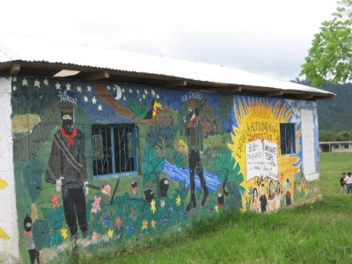
And speaking of revolutions, as we prepare to leave Mexico, it is probably a good idea to include a photo of a flower that was the centrepiece of many of Diego Rivera's paintings. His work in the 1930s covered everything from the Mexican revolution to the situation of ordinary peasants doing things such as carrying lilies to the market. I suspect that if Diego were alive today, he wouldn't be too happy with how the revolution has turned out.
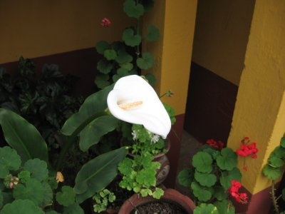

June 30: Palenque (Afternoon at Misol-Ha)
Do you recall a few days ago when I showed you some images from the nature trail at Palenque and stated that nature had thrown its best at us? Well, apparently, nature held some good stuff in reserve. A handful of us (Nora, Marlene, Alma, Dulce, Martin, and I) went to Misol-Ha, the Mayan name for a gorgeous waterfall a few kilometers from town. The pictures below will hardly do justice to the power of nature, but they're all I have. The whole experience was breathtaking. I have always heard about how moving it is to walk BEHIND a waterfall, but I had never experienced it until today.

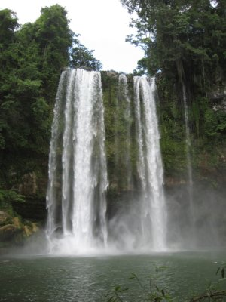
Top row; Marlene and Martin. Bottom row: Me, Dulce, and Alma. Not shown: Nora (the photographer).
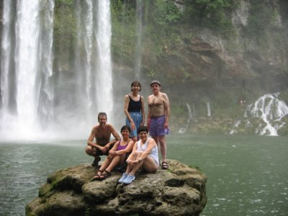
The following picture is for my son Taylor if someone can strong-arm him in front of a computer. It is a 4-5 foot green snake--very handsome. We also saw a modern-day relative of a velociraptor! Taylor, he had a bit of a frill around his neck, but not quite as big and colorful as your frilled dragon. The photo of him was not of high-enough quality to add to the blog. You´ll have to take my word on this!
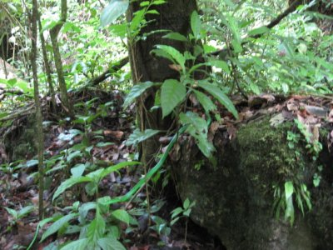
Tomorrow we head for the Mexico-Guatemala border where we'll visit the Classical Mayan sites of Bonampak and Yaxchtilan. Then we take boats across the border in order to make our way into Guatemala and on to Tikal. I anticipate that Tikal will be the highlight of all the archaeological sites for me, but time will tell. The rough accommodations and amount of travel involved for the next couple of days may make web blogging difficult I suspect.

July 2 Tikal
We have had rather rustic conditions over the past few days and they will continue to be rustic here in Tikal. We took a boat up the Usamacinta River to a Mayan site called Yaxchilan. Way cool. Hotel with mosquito nets no a/c, etc. Today we took a boat up the river to the Guatemala side for a very interesting border crossing. Dirt road half way to Tikal. I will probably make another entry once we arrive in Belize. It is simply too difficult to get to a computer here (or phone for that matter).
Adios for now!

July 5: San Ignacio, Belize
We arrived a little while ago in San Ignacio, Belize. It has been an interesting past several days.We have been in rustic circumstances ever since departing Palenque--that is why I have not been able to communicate. We stayed for one night near the Mexico/Guatemala border in order to see the famous murals at the Mayan city of Bonampak. We then took a boat to Yaxchilan to see the archaeological site there. We crossed the border to Guatemala by boat, and drove to Tikal. We spent our first day in the Tikal area at the pre-classical (prior to 250 AD) Maya site of Uaxcatun (established well before the Christian Era). Next day was (finally) Tikal. I'm sure there will be wonderful visits yet to come, including Copan, Honduras, but I can't imagine anything comparing to Tikal. It was all I expected it to be. The primary temples were stunning and if I can get this extremely slow computer to upload at least one picture, I'll show you an example of one of them. Ah... here we go. That would be me standing atop Temple II with Temple I behind me. Temple I is the funeral site of the king who restored Tikal to its glory in the early 700s (714 to be exact) after a hiatus with defeats at the hands of rival Calakmul. The experts aren't sure who is buried in Temple II. These temples, in addition to being burial sites are also ceremonial sites, where the kings can make big religious presentations and reinforce to the masses how important they are and why they need to keep supporting them.
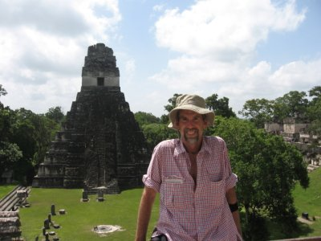
I should note that our guide for this part of our travels was Professor William (Bill) Saturno of the University of New Hampshire. He is an anthropologist/archaeologist, and a most personable fellow. He is a rising superstar in the business. You can find an article about his work at the Mayan preclassical site of San Bartolo in the northern Peten, Guatemala (north of Tikal) in the January 2006 National Geographic magazine. How he found the site is an interesting story in itself, primarily because he and his companions were without food and water for a long while and near death. He accidentally stumbled upon some amazing murals that had not even been part of what he was searching for.
We have talked during our travels a lot about the "collapse" of the Classical Mayan civilization. What is meant by the collapse? Well, around the 800s (AD) no more construction occurred at a majority of the Mayan sites such as Tikal, Palenque, Dos Pilas, Copan, etc. And the sites themselves seem to have been mostly emptied of people. And..., in the case of Tikal, we're talking about a lot of people-- maybe 100K in the city proper and another 500K in the surrounding areas. There are a lot of theories as to why this happened. Parts of all of them seem relevant.Over-use of scarce resources, and drought seem to be at the top of the list. And these two things are related, as you might suspect. These cities were amazing spectacles of construction. Where, today, you see mostly rain forest cover between the temples, back in the Classic period, the entire space was shiny white stucco or plaster. Everything was gleaming, and we're talking several square kilometers of city. The plaster to cover everything was made of limestone. For every bucket of limestone plaster, you need to cut down 4 trees and use several gallons of water. So..., you begin to cut away the forest and when you do this, you begin to affect the hydrology cycle. The rains become more scarce, and one day they stop.
These people were brilliant engineers, as you can tell from just looking at the temples themselves (the grandest ones are over 200 feet tall and are still some of the tallest structures in the new world). They knew how to organize a city. You need water, right? Well, you build your gleaming structures and causeways that connect everything with the shiny plaster. You create water channels and gutters so that the rain water all collects in the very limestone quarries where the limestone was excavated in the first place. But when the rains stopped, as archaeological evidence suggests that they did at the time of the collapse, the 18 month water supply ran out and the people had no choice but to flee for other sites where maybe rain and food were more abundant.Unfortunately, this was a region wide phenomenon, and there were few places to flee.
Lastly, it has been argued that people simply lost faith in their leaders to provide. Any of the brilliant engineers I just mentioned who might have had the good sense to suggest to the king that he was building ceremonial buildings at an unsustainable pace, given his limited resources, would have been tossed off the top of one of the tallest temples. You just didn't question the kings. They had no vision of how to rule other than to create and consume more stuff than the previous king. So he just had his engineers pile more and more and bigger and bigger buildings using more and more resources...
Is this beginning to sound like something from more modern times, in a more modern place like..., shall we say..., the USA? Perhaps there's something we could learn from the Mayans' experience, if those at the top were willing to listen. Well, it's hard to listen when you operate from such lofty heights as the top of Temple IV shown below. You can't begin to relate to the masses and what they are experiencing. Let me close by noting that this view from Temple IV was absolutely stunning. A careful look reveals Temples I, II, and III miles off in the distance and the entire panorama of the Mayan countryside.
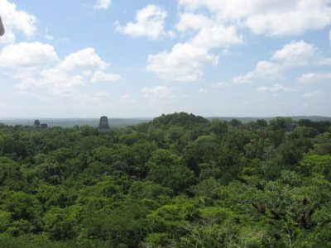
The pictures above are from my camera. Unfortuantely, they can't do justice to the grandeur of Tikal, so I'm going to cheat (now that I'm back home) and add an aerial photo of Tikal from the cover of Peter Harrison's book, The Lords of Tikal. Temples I and II are in the foreground, and Temple IV is in the background, at the top of the picture!
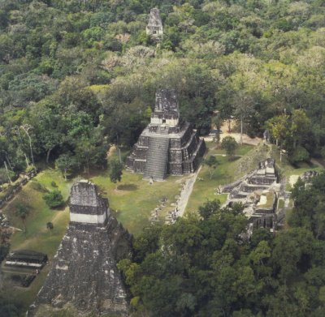
More on the collapse and other things tomorrow.

July 6 San Ignacio, Belize
Sorry about the typos in yesterday's blog. After 4 days in the jungle, to find a useable internet cafe, but with a balky keyboard and a slow-as-molasses server was frustrating.
We have a new archaeologist guide for the next few days, Anne Pyburn. She has added immensely in only a few short hours to our understanding about the Mayan "collapse." I will probably refer to the "collapse" with quote marks from now on. Her own work has centered on a Mayan community (I'll get the name tomorrow) that has been functioning for 3000 years continually. For it, there was no collapse. There is also the fact that at places like Chichen Itza in the Yucatan of Mexico, they were going strong well after the lowland Maya "collapse" of 800 or 900 AD. Many of the Yucatan cities were there at the time of the conquest to make sure that the Spaniards didn't simply stroll onshore and take what they wanted. In fact, as late as the Caste Wars of the late 1800s, many were still rebelling. A few Lacandon Mayans never did surrender.
Anne suggested that what happened in the 800 and 900s was more of a revolution, rather than a collapse. Revolution suggests a dramatic change in the order of things. For the ruling elite who lost the ability to erect magnificent monuments to their greatness, and who could not guarantee food on the tables of the masses, the loss of their kingdoms was devastating. For them it was certainly a collapse. For the masses, Anne suggests, the "collapse" might well have been liberating. They may have finally been able to produce for themselves on their own plots, without having to fork over tribute to the king for the first time ever.
And..., let's not forget that there are six million or so Mayans still with us. The "collapse" didn't mean the end of the Mayans, by any means. In spite of the diseases and death brought by the Spanish conquest, and in spite of the efforts by military dictators like Lucas Garcia and Rios Montt in Guatemala to try and exterminate the Mayans in the 1970s and 80s, the Mayans are here to stay. In fact, they are the majority population in Guatemala. Mayans themselves don't generally like to speak of a "collapse." That's a Western concept, an oversimplified concept.
The picture below shows me atop El Castillo, the 2nd tallest structure in Belize. This is a temple at the Mayan site of Xunantunich, near San Ignacio. I guess I'm fond of providing pictures of these impressive structures. Sitting atop them, you get a sense that the Mayan kings might have had of being closer to the heavens. For the masses assembled below, watching the king doing his thing during celebrations, they must have thought he was god-like for sure. Being up here also makes me wonder how the kings could have really been in touch with the needs of the masses. You can look out and see wondrous edifices that you have built, but, can you see the problems of the huddled masses? Have you ever visited the top of a skyscraper, say, in the boardroom of a bank on the 50th floor? Surely, modern bankers or CEOs of companies like Enron must have the same problem in identifying with the masses as the Mayan kings did.
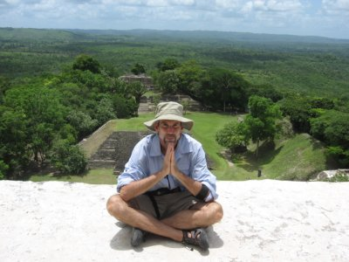
Even though we've moved on, I still have tons of pictures from Tikal. I thought I'd show you a couple of a Ceiba tree. To the Mayans these are sacred trees. You can see from the pictures how big they are. The root structure that you see is expansive; twice as big as the branches themselves, and thus viewed as a conduit to the underworld where ancestors go, and where death and rebirth take place. The branches spread out and seem to reach all the way to the heavens. In fact, the branches are thought to support the heavens. It is perfect vision of the Mayan cosmos. When a Milpa field (corn field) is prepared, any Ceiba trees are left standing. You see them dotting the countryside as a result.

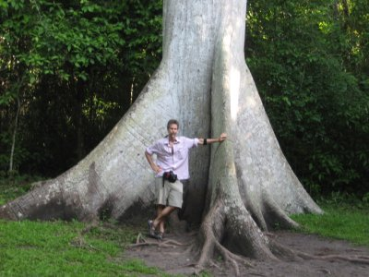
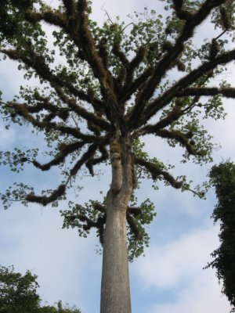
More later.

July 7, San Ignacio, Belize. Good news readers: It's Panty Ripping Day!!!

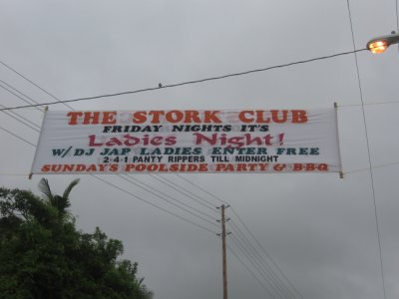
For three weeks now our group has been on the most serious of undertakings: studying ancient Mayan history and culture. Well today, Friday, July 7, 2006 we have the opportunity to study modern Maya culture (sort-of). Yes it's Panty Ripping day, and the banner above announcing this fact spans the street immediately in front of our hotel (an otherwise impeccable establishment). You can image how smoothly our afternoon session today at 3:00 PM on the topic of "engendering the Mayan world" will segue into Panty Ripping later. Ha!!!
I'm assuming that there will not be any actual panty ripping going on tonight at the hotel bar, though I could be wrong about this. Panty Rippers are actually drinks; in fact, this is the national drink if you can imagine that! You need to remember that we are in a tiny Caribbean nation. Perhaps that explains it. Panty Rippers consist of coconut rum, pineapple juice, and grenadine over ice.
We had great fun last night at dinner with the concept of Panty Rippers as we continued our discussions of the Maya collapse. We speculated that had the aloof, elite rulers of Tikal, Palenque, Xunantunich and such places made Panty Rippers available to the masses, there would never have been a "Mayan Collapse." Who would have abandoned these great cities if there had been Panty Rippers? A lesson for George Bush???
Yesterday afternoon's continued conversations with Anne Pyburn were interesting and lively at times. Her research at three northern Belize communities--Chua Hiix, Atun Ha, and Lamenai--has led her to some interesting conclusions about the Mayan economy. She is operating from the framework that ordinary Mayans were surplus generating (as a safety valve in case of drought), diversifying (to avoid having all "eggs in a single basket), and in general, acting as utility maximizing rational economic agents. Her evidence of this behavior is the existence of jade and other "exotic" items found in the middens (trash heaps) of the houses of ordinary Mayans; we know already that the elite had all this stuff. She concludes therefore that since these exotic items weren't produced locally that the ordinary Mayans must have been engaged in an vigorous local market economy that also traded with the outside world.
I'd like to think that she's 100% right. In my own work on Guatemala, specifically the economics of the Lake Atitlan community of San Lucas Toliman, I argue that if ordinary Mayans and campesinos have access to the means of production--meaning having access to land, credit, transportation and distribution systems, and other critical factors--that they would behave exactly as Anne's model suggests. We'd all behave that way, right? We'd produce more food than just enough to get us through the week, we'd have more than one skill or trade to get us through a rolling recession that leaves pockets of unemployment in some, but not all areas of the economy, and so on. But the key to such behavior is the access to the means of production, and for most ordinary Mayans and campesino farmers, they simply don't have it. Most modern day Mayans don't own land, they borrow money for their seeds and fertilizer at usurious interest rates, and they rent small agricultural parcels with worn-out soils in locations far away from distribution centers, among other problems. Under such circumstances, where 18 families in Gautemala some of whom trace their heritage back to the conquest run the whole show, a vibrant local economy isn't possible.
When I think about extrapolating Anne's ideas to the broader world, I can't help but think of places like Palenque and Tikal,. Those expansive cities, with their enormous temples, suggest that the control of resources must have been highly skewed in favor of the elite. (Plus, there is no evidence in such places that the masses were in possession of jade and such). Now, I have to admit that to run such an economy, the elite few could not have done it all themselves. The relatively short-lived Soviet Union is evidence of how difficult it is to run a totalitarian economy. It eventually collapsed of its own weight after just a few decades, while the Mayans had it going for as many as 3000 years in some places. Like the Soviet Union, the Mayans would have had to have an elaborate and enormous enforcement mechanism. Or not. Perhaps with our Western lenses with which we look back so far in time, we under-estimate the role that the Mayan religion may have played in motivating the masses to willingly give of their time and resources in the construction of these great cities. I trust you all know what Karl Marx said about religion. I suspect the archaeological findings at all these great cities will only begrudgingly yield the evidence we need to know about how the Mayan economy actually worked.
Here is one final thought about the implications of the shards of jade found in the middens of the homes of the masses. Suppose that in 1000 years, an archaeological team digs around the corners of one of the 1000 acre coffee fincas in Guatemala. Suppose they find in the middens, evidence that there were apparently small home owners who possessed teflon-coated pots and pans, can-openers, and bicycles, among other things, none of which were produced in the highlands of Guatemala.. Might they conclude that these small land owners were engaged in a lively local economy that involved trade with far-off places? They might, depending on the assumptions they're working with. But if they could actually know what was going on in Guatemala, rather than having to rely upon archaeological remains, they would know that the people living in these homes did not own their homes, but lived there at the mercy of the finca owner who may have occasionally passed along as hand-me-downs such as the teflon pots and pans when they upgraded to Calphalon pots and pans.
I should conclude this section by noting that Anne Pyburn specifically stated that where the small holders appeared to have greater control of the economy (as evidenced by the ownership of jade...), these communities lasted well beyond the "collapse" at the end of the Classical era. The one community of Chua Hiix lasted for over 3000 years until the Spaniards finally did them in. Where the elite appeared to have had firmer control in places like Tikal, the collapse was rather dramatic and final.
Let me end on a more upbeat note. Let me tell you the tale of a bird called Montezuma's Oropendula. While in Tikal this bird graced us all day and night with a most unusual call, which I won't attempt to spell out phonetically. This was apparently the male's mating call. He is a large brown/gray bird with a fantastic bright yellow tail. His calls are designed to attract females to visit his nest which is shown in the picture below. If she comes to visit and likes his decor and architecture, then they..., well..., mate. If she doesn't care for it, then she destroys the place! Apparently, only those males who finally get the hang of understanding the females' housing demands will be those who are able to propagate the species.
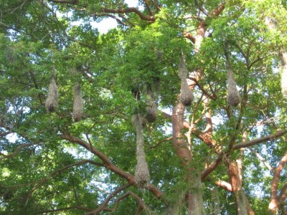
More later.

July 8 Belmopan, Belize
Greetings from the "cheery, sunlit, upscale, fun-filled" environs of Belmopan, the capital of Belize. Note carefully the quote marks surrounding the superlatives in the previous sentence. For a long time Belmopan was simply a backwater of the British Empire. For those not in the know, Belize was once called British Honduras. The country gained its independence only as recently as the late 1970s or early 80s (I don't have the exact date). A decision was made about 15 years ago or so to move the capital from Belize City to Belmopan. Apparently all the high quality economic growth that was to have accompanied this move hasn't trickled down yet. Oh well, we're only here one day, then it's off to Punta Gorda (Fat Point???) on the Caribbean coast.
So..., what have we here (in the picture that follows)? You may recall that in yesterday's blog I spoke seemingly tongue-in-cheek about the segue from our afternoon discussion about gender images in Mayan cultural representations to Panty Ripping? Well, I wasn't too far off. During our conversations, Alma suggested that the banner across the street was initially a bit off-putting with the advertising of what appeared to be Panty Ripping for Jap Ladies. A closer inspection reveals instead, that the DJ's name is Jap, and that it is simply ladies night. When the afternoon session ended, the serious partying began at the famous local hangout known as Bettye's Bar. In the picture below you see Dulce and Deborah dancing the Caribbean dance known as the punta. And what, may we ask, is Grant laughing so hard about? Is it because he actually knows how to dance the punta (because he has local connections), yet has adroitly managed to avoid the entreaties of all the women wanting him to dance with them? We'll never know.

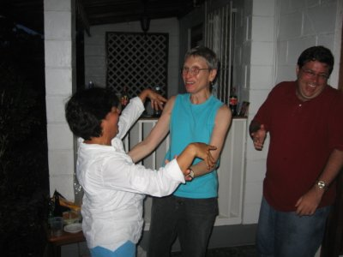
It's kind of a slow news day. I'll close with more of the beauty of the country (found back in San Ignacio--none found so far in Belmopan): a Bird of Paradise flower. Stay tuned, though, for there will be even more beautiful Bird of Paradise photos to come as we continue our travels.
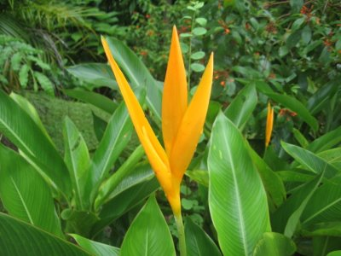

Monday July 10, Punta Gorda, Belize
Greetings from Southern Belize. We arrived in Punta Gorda last night after a long, hot, bumpy drive down from Belmopan. We're right next to the Caribbean Sea. It's quite humid, but there are wonderful sea breezes. As soon as I can, I will add some pictures to this entry. Pictures will go a long way in embellishing our stay the previous night at Belmopan, at a motel that received a variety of designations: Motel Hellmopan, Motel -3, and Midden Motel.
We have been learning about the (Spanish) conquest from Matthew Restall. He is a Maya historian who has discovered a treasure-trove of documents both in Spanish and in a variety of Mayan languages from the immediate post-conquest and colonial eras that shed new light on what he refers to as Seven Myths of the Conquest. As an example of one of those myths, most people who have learned their conquest history from Spanish-only documents, have been under the impression that the indigenous peoples, whether the Mexica or the Maya, were so in awe of the Spaniards and their horses, that they concluded that the Spaniards were Gods. Supposedly, some even thought that the man and the horse were a single being! Restall suggests that in reality there is no serious evidence that the indigenous peoples really believed any of this. Apparently of all his myths, this is the one that is embraced with the most serious zeal. As a result, his myth-busting (in this particular case) has not been well-received. Maya peoples, of course, are quite happy to have this myth busted.
Another myth has to do with refuting the so-called "Black Legend," which depicts the Spaniards "as brutal and bloody colonists who systematically victimized their native subjects." (the quote is from Restall). The key word in that quote, in my opinion, is the word "systematically." The conquest was brutal and bloody, period. If you can somehow show that it wasn't systematic, does that somehow make it more benign? I personally don't think so. Restall suggests that much of the really gory violence was part of what he calls "display violence," horrible and sadistic acts designed to "shock and awe" a population into submission. Once the population submits, then the Spaniards can simply go about the business of religious conversion and political colonization. In other words, the Spaniards don't have to keep repeating the "display violence" over and over.
Evidence of display violence was widespread and does not make for pleasant fireside reading. Display violence was part of what Restall refers to as the "conquest playlist." This playlist is a list of things that worked for the Spaniards as they pursued the "reconquista," the re-taking of Spain from the Moor occupation, a project that was completed in 1492, the same date as Columbus' first trip to the New World. In addition to display violence, it included things like making allies with the enemies of your target conquest group, a technique that was applied with great success in the case of Hernan Cortez' alliance with the Tlascalans in the advance on the Aztecs in Tenochtitlanin (Mexico City) in 1519. Restall suggested that display violence wasn't officially sanctioned by the Spanish Crown. However, the Crown gave the conquistadors carte blanche authority to conduct their military affairs in whatever manner resulted in successful colonization and submission. In fact, the "requerminento," which was read to each indigenous population at the point of first contact, said in essence that if you don't convert to our Christian god right here and now, then we will bring great harm to you and your families. Given the violence that followed this reading in case after case, to me, this is as close to an official Crown sanction as you can get.
Beyond the requermiento, there are hard facts of endless acts of horrible cruelty, which, in my opinion add up to systematic violence. There is the famous massacre at Cholula on the part of Cortes as he and his soldiers marched on Tenochtitlan. This killing of as many as 30,000 people was undertaken to show what would happen to anyone who might consider not submitting to the Spaniards. It was a pretty strong message I'd say. There was the cutting off of hands in Hispanola if the Indians there didn't bring a "hawksbell" full of gold dust every month. Well, since there wasn't any gold dust to speak of, lots of hands were cut off. Ouch...!!! There are endless stories of horrible cruelty carried out by soldiers that are reported by numerous priests, including Bartolome de las Casas. On the other hand, there are endless tales of horrible acts of violence carried out by sadistic priests. And the list goes on and on. I'd have to conclude that there is some merit to the notion of the "Black Legend."
On a different note, we visited a Mopan Maya community near Punta Gorda today. They treated us to displays of pottery making, basket weaving, embroidery, and also to a fine meal of chicken soup and fresh tortillas! We also heard of the community's attempts to gain a foothold into the eco-tourism industry. So far they have had little success. They have been overly dependent on two groups that have proved to be unreliable: 1) the Belize government, and 2) NGOs who kind of come and go. At the moment, they have vague hopes for getting this industry off and running, but nothing concrete.
More later.

Tuesday, July 11 Punta Gorda, Belize
We crossed the halfway point of our journey over the weekend, by the way. Three weeks to go.
Recall the picture of the Punta dancing a few days ago, and the big wide grin on Grant's face? I was speculating that the grin was because he had successfully fended off all attempts by the women in our group to dance. Well, it turns out that there was more to the grin than that. Grant has apparently accepted a tenure-track position in the interdisciplinary studies department at the (brace yourself for this) University of Alaska-Juneau. Congratulations Grant. We wanted to know, however, whether this was good news or bad news--given our biased impressions of Alaska's weather. Grant assured us that it was just fine, that it was about the same as Maine's weather. Aiieehhh....!!!! Coming from the south, myself, I'm not sure I view that similarity as reassuring. At any rate, you go Grant! Good luck in the fall. Also, supposedly Grant has just experienced a birthday, but he's being rather coy about the details.
Recall that I mentioned the fun and exciting stay at the motel in Belmopan? We think the official name might be the Motel Belmopan, but we're really not sure since there were no signs. It was under a state of total renovation. In fact, the owners asked us to assist them in promoting the exciting new changes that were occurring. Here is a shot of some of the members of our group by the pool that will be used in an upcoming promotion for the motel. From left to right: Mark, Jeff, Laura, Martin, and Elisa. My..., don't they look happy, especially Elisa. You'll note how the management has creatively used mold on the exterior wall surfaces to give the place that relaxed tropical climate appearance.
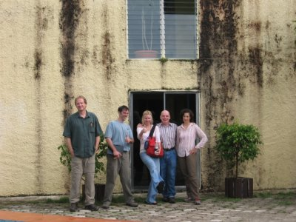
On a more serious note, the visit to the Mopan Mayan community yesterday got me to thinking about the issue of land. Nobody in the developing world has enough land, except the oligarchy who run the countries. We met one of the Mopan community's leaders who unfortunately has to work in Belize City because there simply isn't enough land to make a viable living. He works for a month at a time, only getting a day or two per month to see his family. His wages are partially eaten away by the cost of the lengthy commute.
Another land issue has to do with titling. The Spaniards arrived in the 15th and 16th centuries with the concept of land titling well established. The indigenous peoples didn't operate under the Spanish system, obviously. To the Spaniards, the lands of the Americas appeared to be free for the taking. This legacy is still a problem today. Any powerful person with connections can lay claim to practically any parcel of land that he wants. Throw a little money at a judge, and presto, you've got your land.
We visited another Mopan Mayan community two days ago on our way to Punta Gorda which has struggled with land problems for years. Every time they get settled into one community project or another, someone (usually from the government) comes along and issues edicts as to how they have to use their land or claims that they have no right to that land. They were encouraged at one point to take up citrus farming. This worked out reasonably well until the bottom fell out of the citrus market. Today they are attempting to make a go of it with eco-tourism and selling crafts and medicinal herbs, in addition to subsistence farming. They seem to have a stronger leg up on the eco-tourism industry than the other community that I mentioned that has never really gotten its foot in that door. It is difficult to sustain a community with a product that depends entirely on the whims of foreign demand. How many eco-trekkers will come to Belize and find their way to these little communities is uncertain.
On the same topic, we spoke to a woman in a tienda yesterday morning, while out searching for coffee, who complained that the government, in conjunction with NGO "do-gooders," has set aside vast tracks of land and the sea to protect various animals such as iguanas and other endangered species such that the people are no longer able to farm, fish, and hunt in ways that are sustainable. She said the government has made vague promises to come through with jobs and economic development programs, but has not acted on them. As a result, poverty and unemployment remains a problem in the Punta Gorda region. I might add that the woman, who was extremely articulate, was as mad as can be on this topic. She became quite animated during our conversation.
Here are a couple of photos of the visit to the Mopan Mayan community:
Cuteness:
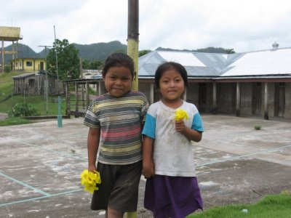
This woman was showing us how to weave baskets. We also saw pottery making and embroidery. Our pal Nora is in the background observing the daughter of one of the women who is just learning the finer details of these crafts.
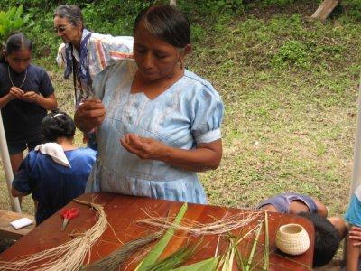
Here is one the prettiest flowers I've encountered yet. This was at the other Mayan community.
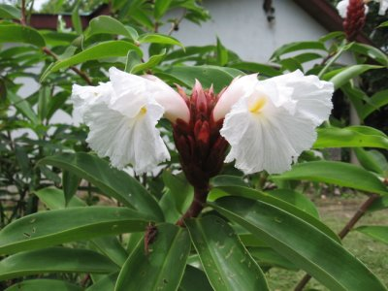
More later.

Thursday, July 13, Copan, Honduras
OK folks... Lots of material to cover since it has been two days since I last communicated. We were in Punta Gorda, Belize two days ago sweltering in the heat and humidity, and today, after passing through Guatemala by way of the Rio Dulce, we are now in Copan, Honduras, location of one of the most impressive archaeological sites in the Maya world.
Before we left Punta Gorda, we had one final session with Matthew Restall. We learned about one of the most complicated mixing of human beings anywhere in the world that resulted from the Spanish conquest of the Yucatan-Belize region. In addition to Spanish-Maya bloodlines, there were the African slaves brought over (as the indigenous populations began dying out) who intermingled with not only the Spanish, but with Mayas, and a variety of Caribbean peoples such as the Taino and Caribe Indians. As horrible as the Spanish conquest was, as I alluded to in the previous blog, the English were even worse. They made an appearance in the 18th century in the form of loggers and pirates. The Spaniards were simply incapable of controlling an empire so vast and, as a result, the English gained a foothold, especially in Belize, where they intermingled with Africans. Whereas the Spaniards allowed their slaves to buy their freedom--not exactly an easy thing to do--the English would have none of this. Slaves were slaves for life! At any rate, to sort out all the different mixtures of people, you need an encyclopedia or some sort of road map.
Now, lest you think that all of our lectures were dry as toast, hold your seat for this. We learned about love magic! There were a variety of people in the Yucatan-Belize region, mostly women, who sought the services of healers or spiritualists who offered spells and potions that purported to alter the direction of one's love affairs. These spiritualists were mostly, but not entirely, of African origins and usually female. Those seeking the services most often were Spanish women who apparently had nowhere else to turn. Here is one example: Suppose a widow is desperately seeking a new relationship. In her society she couldn't be very overt, so she might seek the services of a spiritualist. Now she couldn't expect her to cast such a wide net as to find just any ol' man, but rather, she would have to have a particular man in mind. The spiritualist might infuse some chocolate with some potions containing aphrodisiac or other suggestive qualities. Or she might bury a piece of clothing and utter a special incantation. At any rate, this was a way for women, who held far less power in this society, to feel as if they were gaining a modicum of control. While these practices were dominated by women, occasionally men might seek out such services.
What is interesting about all this is that while such practices were frowned upon by the Spanish Inquisition, in general, they were tolerated. Why? Because no one took them terribly seriously--therefore, there were few instances of severe punishments. However, on the other hand, they were taken seriously enough for people to seek out such services in great numbers and at great expense. An ordinary laborer would have to work for two or three weeks (incurring no other expenses) in order to be able to buy the services of a spiritualist.
The evening before our departure we had the pleasure of attending a performance by a local Garifuna (African-Caribbean-Central America) drum band. The word "cool" scarcely describes their music. A careful look at the following photo will reveal that the chap on the far left was playing drums made of tortoise shells! Hot dang!!! A good time was had by all! If there is a slow news day at some point in the future I´ll share some photos of Alma and Carol and some others dancing with the local boys!
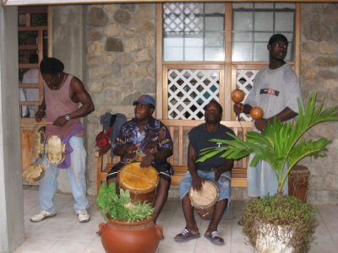
After the fact, here are some photos of our crew dancing
Alma and Patty:
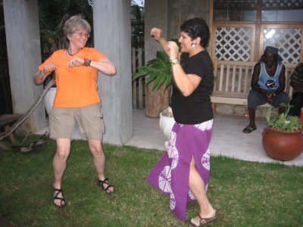
Carol and one of the local boys:
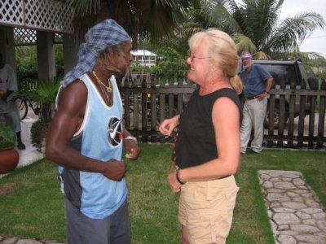
So much for Punta Gorda. We left town by speed boat (Belizian style) and crossed the bay of Honduras arriving about an hour later at Livingston, Guatemala (border crossing #1). We continued in the same boats up the Rio Dulce. Words can scarcely describe the beauty of this river; Dulce, by the way, in Español means sweet. Initially, the river was really narrow, bordered by towering gray/white limestone cliffs, lush with vegetation. Later, as it widened, we encountered whole communities living in floating raft homes. Also, there were thousands of multicolored birds by the thousands. You´ll have to trust me that the following picture just barely begins to bring justice to the beauty of this place.
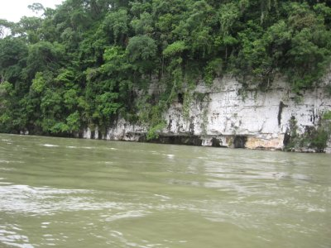
We docked at the town of Rio Dulce and took a bus to Copán, Honduras. Along the way, we paid a visit to Quirigua. This city was initially a protectorate of Copán. However, in the early days of the 8th century AD, a new ruler took power. He was not content with Quirigua´s status in the Mayan world. This guy was so special that words escape me. I have called upon a guest blogger to share with you exactly how special he was. As you will see, a female perspective is called for.
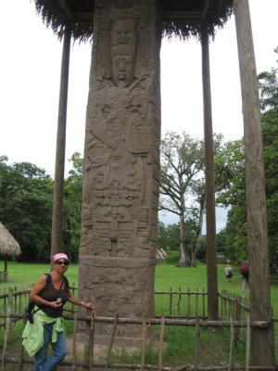
Sybil with Stela A, a massive stone carved with the story of the ruler "affectionately" known as:
COSMIC PENIS THAT SPOUTS FIERY LIGHTING
I'm not making this up. This name has been verified by David Sedat, an archaeologist who has been working this site for years. At any rate, let me turn this over to Dulce:
Dulce Maria writing here. Hmmm... not the headline I should use for my first guest blogging experience. Cosmic Penis was the 13th ruler of Quirigua, aka Kák´Tiliw Chan Yoaat or (for the more conservative translation of his name, Fire-burning Sky Lighting God--in case you find the word penis unpalatable). In any case, he's part of a long line of rulers who participated in bloodletting, that is, piercing the penis (women pierced their tongues) as an offering. At the risk of being titillating, I'll say that our group found this bit of info rather interesting. And today, at Copan, it was all even funnier when we encountered the great phallic bat (see picture below). Sorry folks, this internet cafe will close momentarily (John hogged all the time!). More later.
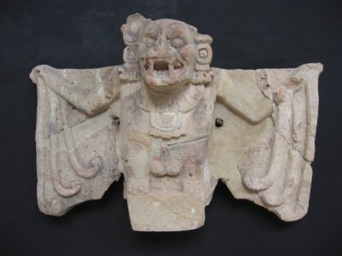

July 14, Copan, Honduras
Yesterday's blog ended rather abruptly as my guest blogger, Dulce, and I were attempting to explain something that, on the surface, might look like we were merely making fun of, when in reality, this obsession with phallus symbols and the business of ritual bloodletting was quite serious in the Mayan world.
So where does a ruler of a subsidiary city like Quirigua--K'ak' Tiliw Chan Yoaat-- get off calling himself or thinking of himself as the "Cosmic Penis That Spouts Fiery Lightning"? Well, he better have mighty large ambitions..., mighty large. On May 3, 738 AD, he pulled off the upset of the millennium. He defeated the ruler of Copan, 18 Rabbit, in some sort of engagement and beheaded him. He then embarked on one of the most prolific building programs in his city's history. Like a lot of government programs, this one resulted in a lot of public outlays and a lot of flash and pizzazz, but nothing that would truly extend the life of his kingdom. i.e., nothing that would put food onto the plates of his people. Specifically, he erected endless monuments that detailed his victory over 18 Rabbit.
The question arose as to why, in the aftermath of this ruler's great victory, Quirigua didn't grow larger in stature. The answer is that unfortunately, it got a late start. By 738 AD, when it was finally out from under the "wing" of Copan, the classical Maya kingdom, broadly speaking, was beginning to exhibit signs of distress, as I have commented on previously. The great "collapse" was near, and Quirigua, like most of the other great cities, was soon to experience an exodus. So it simply didn't have as much time as Copan or Tikal to build up its infrastructure.
And..., what about the phallic bat sculpture in the other picture? All Mayan cities have name glyphs and the name glyph associated with the city of Copan is the bat. The phallic part??? I'm not sure.
Just outside the gates of Quirigua was a banana plantation that appeared to extend for several hundred acres. In fact, on our trip to Quirigua from the Rio Dulce, we passed several of these. I was reminded of a notion that I have heard about and spoken about for years of teaching and researching about Latin America, that of the "banana republic." However, in my previous travels, I had never seen a banana plantation of any size. These are sources of great wealth for the fortunate few who own or control them, but are sources of great (land) inequality, poverty, and suffering for the masses. Even today, well into the 21st century, there are frequent stories of banana workers demanding better pay and working conditions who are attacked by paramilitaries representing the banana owners. This story actually has its origins back in the late 1800s when the United Fruit Company (of the US) gained ownership over vast tracks of land in Honduras and Guatemala and came to exert serious influence over the governments of each country. The company was behind the CIA overthrow of the civilian government in Guatemala in 1954, that resulted in four decades of bloody civil war. However, I will wait on the telling of that story until we actually get to Guatemala. I have a feeling it will come up as a topic in one of our future lectures.
In the picture, you can see blue bags covering bunches of near-ripe bananas that will soon appear on supermarket shelves in the US and Europe.
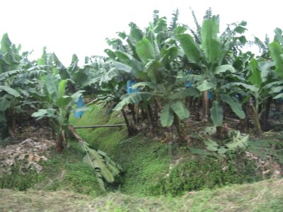
The archaeological site of Copan is amazing. To the experts, it is the archaeological jewel of the ancient Maya world. It has a bounty of well preserved and restored buildings, temples, home sites, stele, tombs, and so on. The following picture is of a replica of an intact building called Rosalila. It is located in an on-site museum that our archaeological guides Bill and Barbara Fash helped to design.
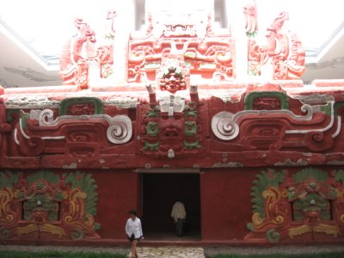
We later were able to view this masterpiece of Early Classical Mayan architecture in its original preserved state hidden deep within the Acropolis. It is evidence of the use of public buildings as public billboards, given that perhaps only 5 percent of the population could read and write. You didn't need a lot of education to figure out what kings or mythological beings or messages were being depicted. These buildings, seen in this light, remind me of the artwork of the Mexican muralists (Diego Rivera, David Siqueros, and others) of the early 20th century whose work was designed to tell a complicated story of conquest, indigenous struggles, labor struggles, inequality, and so on through glorious building-sized murals.
When Rosalila was decommissioned in approximately 570 AD, it was painted white and buried under tons of clay, making room for a newer, more impressive, and more relevant structure in the Acropolis collection. When it was discovered late last century, Barbara Fash, with painstaking detailed work, was able to determine the original color scheme shown in the museum recreation in the picture above.
Beauty awaits you at every turn in Copan. At the entrance to the site, one is welcomed by dozens of colorful Macaws, as shown below. At first we thought they were captive, perhaps tethered, but they are free to fly anywhere, though a breeding program makes it attractive for them to stay close by.
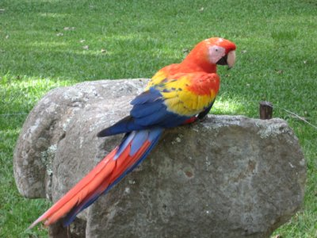
Let me close with a picture of some flowers that adorn our wonderful hotel. In sharp contrast to the Motel Belmopan, this is a place I could come back to again and again!
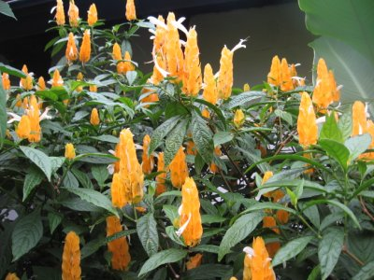

Saturday, July 15, Copan, Honduras
I wish to offer one final thought (I promise) about the business of ritual bloodletting. Yesterday we were back on site with Bill Fash at the Acropolis, the ceremonial palace. It is here that the most important ceremonial and religious events took place. According to the official story (and I'm thinking of a modern equivalent like the State of the Union Address or something), the king would kind of magically appear at the top of the temple, possibly in a cloud of smoke and with the sounds of music, bells, rattles, and drums adding to the suspense. With the crowds assembled below in the courtyard, and after uttering all the important incantations, the king would arrive at the critical moment of the ceremony; the piercing of his penis with a stingray spine and subsequent bloodletting. This would send him into a trance, during which he would consult with the ancestors and with the various gods (Sun, Rain, Maize, and others) asking for divine inspiration, vision, and prophesy. When he awoke from his trance, he would share with his people the revealed vision for the future of the city. Upon being appropriately awed by the king, the people would return home, content for another year or so that the king is taking their well-being and concerns seriously.
Listening to all this, I got to thinking that it all seemed a bit preposterous. I asked what I was afraid might be a terribly impertinent question. I asked if there were another version of the story that might go something like this: Just suppose that if you actually pierce yourself with a stingray spine (run this jagged little needle all the way through!), that instead of going into a trance where you speak with the gods, you simply pass out from the searing pain. Upon waking up after some while, you hurt so dang bad, that the best you can do is to read a speech that you and your high-ranking officials prepared well in advance. This speech will tell the people to be content, that you have spoken with the gods and they told you to maintain the status quo--i.e., to use more government money to build more temples and stelae, and for the people to continue paying their hard-earned tribute to the king, and that if they don't, the gods and ancestors will not be pleased. So I asked Bill Fash this, and he said that I was probably dead-on, that other archaeological experts had arrived at the same conclusion. Oh well...
Some of my colleagues have suggested (among ourselves) that the actual incidents of bloodletting may have been few and far between. There is too much archaeological evidence to discount the whole thing, but, it might be the case that if you have pierced yourself once (and experienced the pain), you will find other ways to to accomplish the same thing in the future--methods of subterfuge to trick the masses.
Something else we did yesterday was pretty interesting. Copan has one of the most complete and well preserved collections of city dweller home sites of any Maya city. These sites range from the homes of the elites (level 4) to those of the poorer classes (level 1), and an upper (level 3) and a lower (level 2) middle class in between. The picture below is of a bedroom of one of the elite, probably a lord or priest of the court of the king. It has a king-sized (or larger) stone slab bed with a glyphic linealogy spread out just below the level of the bed. This alone is an indication of the stature of the person living here. You certainly wouldn't find something like this in the homes of the poorer classes. We have learned that throughout the classical Mayan era, there were strong kings who could rule with an iron fist and who would not tolerate competition from someone of the likes of the priest who lived in the home pictured below. On the other hand, there were weaker kings (especially as the "collapse" was nearing) who maintained their stature only by appeasing the tier of lords and priests just below them. These folks would be the (now-deceased) Ken Lays, Donald Trumps, and James Dobsons of the modern era. Without their support, and the support of the masses they control, the rulers (whether George Bush or a late-era Maya king) would not be able to maintain their positions of power.
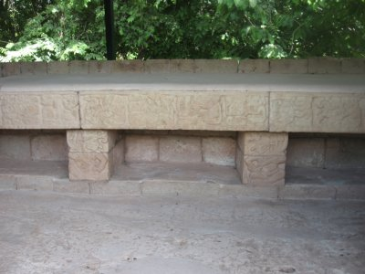
This lordly king-sized bed raises another interesting issue yet. Certainly the lords wouldn't just plop down on a stone slab. Can you imagine the back ache every morning? There is evidence that these beds were covered with stuffed spreads or pillows, possibly encased with jaguar pelts. So..., who do you think stitched all of this together? You got it... the women of the community. Evidence from the Aztecs (a much more recent civilization than the Mayas) suggests that the weaving industry was one of the most important of all the industries of the kingdom and that women in this profession represented the single largest collection of employees. Finer pieces of cloth even served as a medium of exchange, i.e, as money. Bill Fash thinks that cloth and weaving, and the women who worked in this industry were probably equally important in Maya cities like Copan.
The following picture takes us to the other end of the economic spectrum. Here you see my colleagues Grant and Mario standing next to a couple of rock mounds associated with homes of the lower classes. A closer look at the background of the photo, by the way, reveals a sea of grasses, which, in centuries past, would have been a reservoir for the collection of rainwater. To me, the fact that the lower classes had homes built on stone foundations suggested that they were relatively well off in comparison to their rural counterparts. Bill Fash suggested that, in fact, rural dwellers living on the other side of the Motagua River would certainly NOT have had stone foundations.
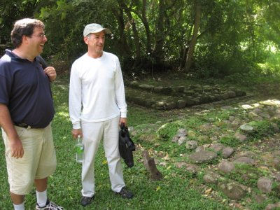
This leads to one other issue that has been on my mind, the overall societal structure of Mayan communities. The Mayas think of themselves as having a communal heritage, meaning that there is sharing of land, labor, and other possessions and resources. We heard this from many of the Mopan Mayan peoples we met back in Belize. I have encountered this concept myself with the Cackchequel Mayan community of San Lucas Toliman, Guatemala. For example, on those rare occasions when a large parcel of land comes into the possession of a number of families, they will first build their own individual homes and set aside a small portion of the land immediately adjacent to their homes for things like vegetable gardens. But, the community may also pool together the prime agricultural land for communal milpa (maize) farming. Interestingly, a wall mural at the museum at Cahal Pech, Belize, depicted this exact type of land holding scheme.
How did this come about, and when? There is insufficient evidence from archaeological digs to tell us exactly how land was held in, say, the pre-classic or classic times. Somehow, the rulers were able to summon the resources they needed to have their families and their royal courts fed and clothed, and to exact labor and tribute to build the fantastic temples and monuments. Did they accomplish this by force or did the Maya religion exert such a pull that people willingly offered their tribute and resources? Or were there some other means?
Suppose it was all accomplished by force, for the sake of argument. Then, after the "collapse," or, as Anne Pyburn would put it, the "liberation," whereby the masses suddenly were able to provide for themselves instead of for the rulers, how did the small holders shift from forced production to a communal style of production and land holding? Perhaps, it was a natural progression if the rulers had them all working collectively in the fields to produce for the community as a whole. Lots of future research to be done in this area!
Lastly, let me note that in addition to farming, there had to be a whole supporting network of artisans and craftsmen who were skilled at a variety of things, from building monuments, to carving stelae, to painting, to writing, to building boats (for those communities living along water routes), to making sharp edged obsidian blades, and on and on. These had to have been extremely complicated societies. That some of them were constantly occupied for 3000 years is amazing.
I include the following picture of Whitney with a soldier/guard at the entrance to one of the sites to make the point that there is a fairly heavy military and police presence throughout Honduras. Guards stand outside banks with shotguns. The police and soldiers bring their weapons into restaurants while they eat. Martin, Linda and I made a poor choice for breakfast the other day and found ourselves at a local restaurant that seemed to cater to the military. They got served quickly while we waited and waited. Linda sat in the crosshairs of a very young soldier's gun casually sitting in his lap the whole time!!!
The young soldier in the picture was quite happy to pose for the picture. His friends ribbed him afterwards.
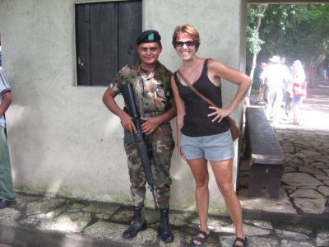
Let`s close with some color:
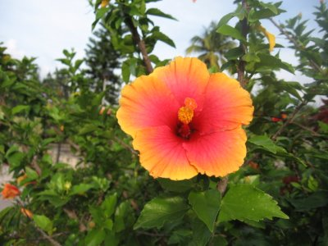

July 17, Antigua, Guatemala
Yesterday was a big day of travel that got us from Copan, Honduras to Antigua, Guatemala. I was thinking that today would be a slow news day, but we ended up being absolutely blown away by the sights and sounds and history and beauty of Antigua. My friend Dulce found enough things of interest that I´m going to give her free reign to discuss all that is on her mind.
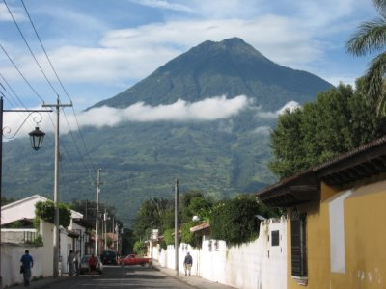
Dulce Maria writing:
"Free reign" he says. Okay. So, we traveled almost all day in order to get to Antigua. Good thing the bus was comfortable, not like the bus we took a couple of weeks ago. That one had no air conditioning and the windows would not open. Once many of us started to melt, the driver decided to crack open the emergency windows, but there was no way to keep them in place. Imagine our white knuckles as we swerved round and round the mountains. Yesterday's trip was much better. As you enter Guatemala from Honduras there's not much discernible difference between the countries. Everything´s equally green and lush. But the deeper into Guatemala, the more dire and obvious the poverty. In Antigua that poverty is less blatant; in fact, it's simply veneered by lovely and intensely colored Spanish colonial architecture. I haven't been in Antigua in ten years, and seeing it again is no less exciting than that very first time.
Antigua is surrounded by two volcanoes: Fuego and Agua. Right now Fuego is smoking. No matter where you stand, they loom, as you see in John's picture above (of Agua), and remind you of the city's tenuous location. Antigua used to be the capital, but after several devastating volcano eruptions and several earth quakes, the capital was changed to Guatemala City, which is only (in good traffic) 45 minutes away. In the early 1800s it was even illegal for anyone to live here. That's one reason why today there are abandoned monasteries like Capuchinas; the nuns who lived there for a mere 37 years were forced to relocate. Although many Americans have been retiring or simply choosing to live in Antigua for hundreds of years, but particularly since the second world war, today the city is best known as the center of numerous language schools. Thousands spend weeks or entire summers studying Spanish. Consequently, there are many of the amenities we'd find in the States, for instance, a pretty good gym and yoga classes, internet cafes that actually provide DSL and fewer power outages, varied shopping opportunities and absolutely expensive (but fabulous) restaurants that serve food from all corners of the world.
Today our group took an introductory walking tour of the city. One of my favorite sites is Iglesia San Francisco el Grande. In it there's a huge didactic mural, painted in 2004 (see picture below), that reminded me of the conversations we've had about bloodletting and body piercing. In John's last blog he promised he would not discuss this topic further, but he has given me free reign...
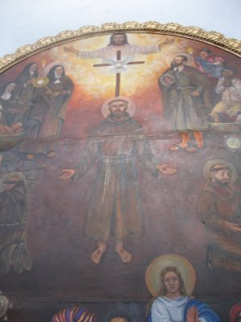
Other than being aghast at some of the tattooing, body piercings (think about all of our students... or maybe even our own kids who have pierced tongues, eyebrows and whatever else!) and implants (you've seen all those spikes protruding out of people's heads, right?) that are so popular today, most of us rarely think about the connection between offering sacrifices and (what some might call) mutilation. Yes, Maya men pierced their penises, and women their tongues, in order to offer the blood to the earth, and to the greater powers they believed influenced their lives, but I want to emphasize (because I don't want anyone reading this blog to walk away with new or affirmed stereotypes) that much of that has been aggrandized by us scholars who sometimes (re)present what seems odd to us as the mundane. There is no evidence that indicates that all Maya people engaged in bloodletting routinely; depictions of such events are as frequent as depictions of Jesus Christ nailed to the cross and bleeding from nail and sword wounds. I think that it's important to look in our own backyards when we encounter what is unfamiliar (and perhaps even unsavory) to us.
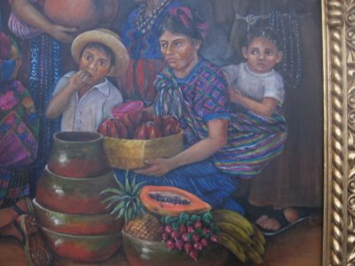
The lower right hand side of that same mural has a very interesting depiction of a woman and her children (see picture above). They are surrounded by fruit, and the cultural theorist in me simply had to "read" it: it's not news that historically fruit, some more than others, has been used to represent reproduction, fecundity, wealth/poverty, sexuality, body parts, love/hate and you name it. This section of the mural, despite being painted only two years ago, reveals (to me at least) many of those same (not so subliminal) themes. In this case there's a cut papaya with exposed seeds right next to almost ripe bananas, radishes, pineapple and in the woman´s arms a basket-full of the perennial symbol of reproduction--and therefore immortality (or continuity, as that can be considered)--a pomegranate-like cut and exposed fruit (right now I forget what the Guatemalans call this fruit). What is all that reference to sensuality, sustenance and reproduction doing in a church mural that depicts the crucified Christ at its center? I can write reams about the answer, but I guess, since John is waiting to take over his blog, that I will leave you to decide what some possible answers could be.
Before I sign off, I take responsibility for inserting this picture of a relaxed John next to one of the many impressive doors in Antigua.
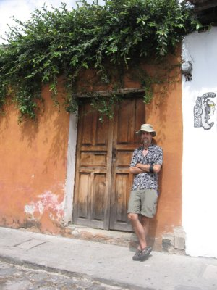
And, since I may not blog again before the 20th, I want to wish my dear sister, HOMERINA, a truly happy birthday. Feliz cumpleaños; may you have many more. I love you.
And, hi GEORGE my darling husband. I can't wait to see you. I love you!
Oh okay, the rest of my family and friends will be jealous if I don't say hello. HELLO!

July 18, Antigua, Guatemala
Yesterday was a big day in the life of our travel group. Why? It was Bettye´s birthday. Yes. This is the same Bettye I referred to a couple of weeks ago who was masquerading as the proprietor of Bettye's Bar & Grill in San Ignacio, Belize. Here is a picture of Bettye on her birthday (dressed in bright Antigua-like colors) standing in front of a room in the nun's cloister area of Nuestra Señora del Pilar de Zaragoza (Capachines). No..., she is not testing the waters for becoming a nun!
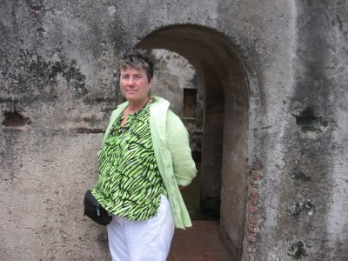
We have been touring around town for the past couple of days learning about the history of Antigua. It was the first post-conquest capital of Guatemala, established in 1543. It served in that capacity for 233 years until it was devastated by the earthquake of 1773 and the capital was moved to Guatemala City. Much of the colonial grandeur remains and much (but not all) has been restored or rebuilt. In 1944 the Guatemalan legislature declared Antigua a national monument and in 1979 UNESCO declared it a World Heritage Site. It is a place you should add to your future travel itinerary.
The following pictures highlight some of Antigua's beauty (and reflects my own fascination with its interesting doors and windows). Check out Linda in front of one of my favorite doors:
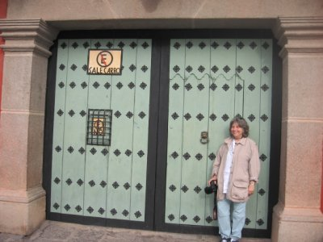
Here is a window that you probably won´t see on just any ol' building in the States:
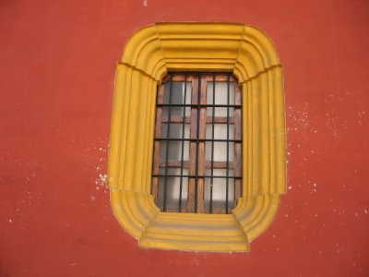
We also toured the Casa de Jade (Jade House), which serves as: 1) a jade-making factory, 2) museum, and 3) retail sales outlet. Jade is considered to be the most precious gemstone in the world. Its supplies are limited and its prices correspondingly high, especially if you make your purchase in a Niemann Marcus or a Saks 5th Ave. It is the jewel of Mayan kings and queens. Rulers adorned their bodies with jade for religious ceremonies and were buried with copious quantities (that archaeologists (and tomb robbers) have uncovered over the years.
Here is a photo of a jade replica of the mask that the famous king of Palenque, Pacal, was buried in.
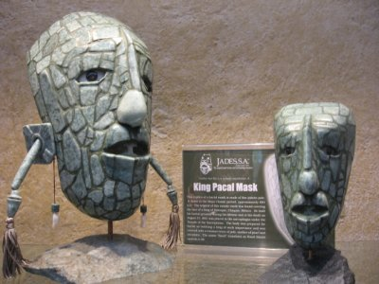
Jade is found in very few places in the world. One of them is Guatemala's Motagua River Valley. It was discovered by Mary Lou and Jay Ridinger in the 1970s, acting on a tip from a local archaeologist. Prior to this finding, archaeologists had not been sure of the source of all the jade that they kept finding at Mayan sites. The Guatemala government didn't really believe that jade existed in the Motagua River Valley and essentially gave away the jade mining license to the Ridingers. They bought the land itself from local farmers who also were in disbelief that the land could be worth as much as they were offering. Well, they knew what they were looking for and sure enough, they struck jade. The actual location is still a secret. In fact, you wouldn't know you were anywhere close to a jade mine because there is no mine in the traditional sense. There are simply rock outcroppings in and around milpa fields.
The Ridingers leased the land back to the maize farmers who still work the land and look after the property and guard it as their own, preventing the necessity of having to have armed guards on duty 24-7. I'm not revealing anything that would jeopardize the Ridinger´s operation. This info is available in print and video with the National Geographic Association. And Mary Lou will tell you this story herself if you can get down here to visit.
The mining itself is done in about as earth-friendly manner as possible. You simply walk around the edges of the milpa fields and look for large rocks. Your primary investigative tool is a hammer. You hit the rock with a good whack and if the hammer bounces back and the rock doesn´t crack or splinter, then you have a good candidate for jade. You also need some "heavy water." You put a piece of the rock into the heavy water and if it sinks, you have jade. Everything else will float. Below is a picture of Patty who has convinced herself that she has just stuck jade!
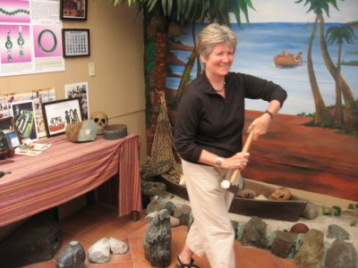
Jade in this part of the world is formed by the grinding of the North American and Caribbean tectonic plates which occurs in the Motagua River Valley. Subduction faulting causes the high pressure and low temperature metamorphic environment necessary for jade. There are two kinds of jade: Nephrite and Jadeite. Both are white in their pure state. When, over the years, they come into contact with other minerals, they take on the colors we're all familiar with: Copper--dark green jade; Chromium--bright emerald green; Cobalt--blue; Manganese and ferrous iron--black.
If you are lured into buying greenish colored stones from street venders for a couple of Dollars, you are definitely NOT buying real jade. You are probably buying a stone called serpentine or something of even less value. You will be able to scratch these stones, whereas you could NOT scratch jade except with a diamond drill.
I´ll close with a beautiful Bird of Paradise form the garden of our hotel.
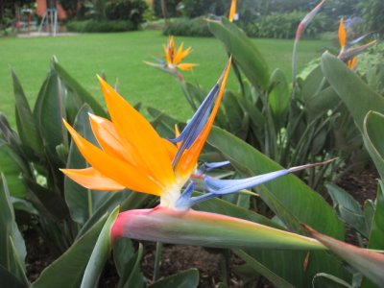

July 19, Antigua, Guatemala
Our stay in Antigua is proving to be quite therapeutic after four weeks of a rather heavy schedule. Our first scholar, Victor Montejo, was not able to come until today. We'll be listening to him in about an hour. More on him later (in this blog).
The therapy is coming in the form of relaxing, sleeping, shopping, sightseeing, and visits to a variety of churches and museums.
Here are Barbara and Carol (respectively) at an impromptu end-of-day therapeutic fiesta yesterday at our hotel. You can see from the background of their photos that our hotel grounds are impeccably groomed--full of trees, flowers, a pool, and even some Scarlet Macaws.
Note: Barbara is never too far away from her trusty computer. If you want a hardcopy analysis of anything we have done, she is the go-to person, and the info is stored in that powerful computer of hers.
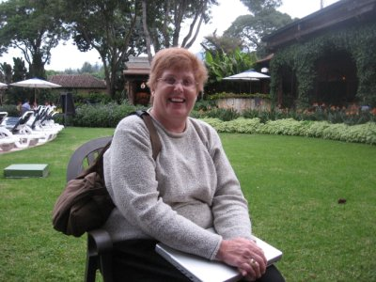
Carol, by the way, is beaming because her therapy was to get the full treatment at a nearby spa: massage, nails, hair, the works!
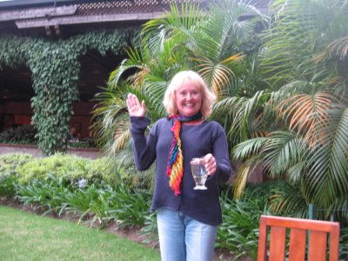
Victor Montejo will be talking with us here in a little while about Maya repression and resistance. His own personal story or testimony involves an event from his young adulthood in the early 1980s when he was a teacher in a highlands Maya community. The silence of his classroom was shattered one day by the sound of machine gun fire. The village was under attack by the Guatemala military. The reason was that one of the Civilian Defense Patrollers had accidentally fired upon a squad of approaching soldiers. They had mistaken the soldiers for "communists." For this offense, a number of members of the community were assassinated under suspicion of being communists themselves and the rest were simply killed as examples of what happens to people who even think of aiding or abetting the communists. Montejo himself, because he was a teacher--meaning that he was literate--and because he vocally asserted himself on behalf of the accused, was arrested, beaten, and faced death. He was eventually able to extricate himself from this peril, but was forced to flee during the worst of the war years. He eventually earned advanced degrees in the US and today holds simultaneously a teaching position in the US at UC-Davis in the Department of Anthropology and an elected position in Guatemala's government and serves as the President of the Commission of Indigenous Peoples. He formerly served the government as the Secretary of Peace, where his commission was supposed to work to implement the 1996 Peace Accords.
One can start a discussion of Mayan resistance at practically any point in history you want. You could begin in the early 300ADs with the "entrada" of outsiders from Teotehuacan, Mexico who helped to completely reshape the face of the Mayan world. Or you could move up the analysis over a thousand years to 1492 and Mayan resistance to the Spanish onslaught. Where Montejo's analysis will begin I'm assuming is in the latter half of the 20th century when the Maya came under attack from the Guatemalan military, doing business on behalf of the oligarchy--the 18 extended families who run the whole show here in Guatemala, many of whom trace their lineage all the way back to the conquest. During this period the Maya also came under attack from the effects of the global capitalist trading system, though, a more precise date for Guatemala's entry into the capitalist system would be 1871 and the "liberal" reforms of General Justino Rufino Barrios. For Guatemala to grow and prosper, he argued, it needed to export cash crops. Coffee was the chosen product. To make room for growing coffee, it was necessary to make land available. That land, unfortunately came from the Mayan people. Bananas came next, then sugar, then cotton, and all required land!
From 1944-1954 Guatemala had a ten-year experiment in democracy under the leadership of presidents Juan Jose Arevalo and Jacabo Arbenz. Arbenz' goal was to bring the country into the modern capitalist era by allowing all Guatemalans the chance to become property owners. However, his efforts at agrarian reform (which included appropriation and redistribution of large land holdings) ran afoul of the United Fruit Company, the largest single land owner in the country. Even though the government was willing to pay the company for the land that was appropriated (and pay it the value it declared for tax purposes), the company wasn't interested in this deal. By maintaining vast tracts of unused land, it could guarantee that ordinary Guatemalans would not have access to land and would therefore have no choice but to come work for United Fruit at dirt-cheap wages. So, the company simply made use of the clout of its US investors who were well-positioned in the Eisenhower administration, namely John Foster Dulles (head of the US State Dept) and Allan Dulles (head of the CIA). The Arbenz administration was labeled communist, a CIA coup was initiated, and Arbenz was overthrown.
To make a long story short, the ensuing military government attempted to undo the fruits of the short-lived experiment in democracy. Land was reclaimed and the oligarchy saw to it that nothing like democracy would ever again upset their privileged positions. The clampdown on the democracy movement was brutal. It led to an insurgency of rebel forces (labeled communist) who fought the government for the next 40 years, demanding land and human and indigenous rights. The military undertook a counterinsurgency that included forced conscription of boys as young as 13 or 14, and the forced service of adults into the aforementioned Civilian Defense Patrols, allowing the military to sort of artificially expand to nearly a million persons. It was one of these Civilian Defense Patrols that ran afoul of the military in Victor Montejo´s community.
More tomorrow. Close with a picture from Antigua.
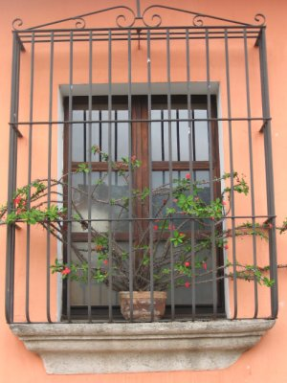

Thursday, July 20, Antigua, Guatemala
Today was another of those big days in the life of our group when we celebrate someone's birthday. Today, finally, after much suspicion and debate, it really is David's birthday. Happy Birthday David! Here he is enjoying a leisurely 10:00 AM breakfast on his big day. David is a linguist who has been meeting regularly with a local Mayan family from whom he is learning some fundamentals of the Cackchequel langauge. If I can arrange it, I’ll post a picture of David and his new family.
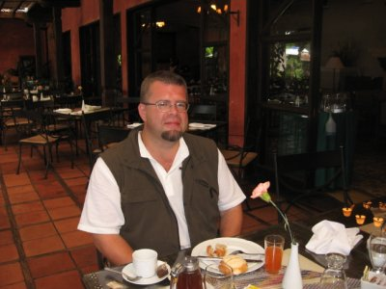
Victor Montejo was finally able to join us today for a couple of very interesting sessions. Here is a picture of him and Cameron (after his presentation).
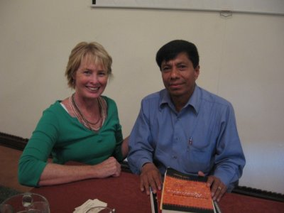
George, Larraine, and Robin follow Montejo´s comments with rapt attention:
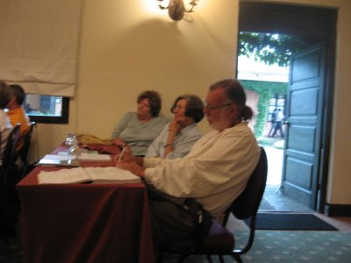
Montejo's reason for being delayed was certainly understandable. In his position in the Guatemalan congress as the President of the Commission of Indigenous Rights, he has been fighting with the government to disburse reparation payments to victims of the violence of the war years, 1961-1996. The violence during these years was horrible at best and sadistic at its worst. The Mayan people were caught in the conflict between the Guatemalan military and the rebel forces of the URNG (a union of five separate rebel groups). While there is a lot of blame to be spread around between the military and the URNG, two separate post-war truth commissions found that nearly 95% of the atrocities could be blamed on the military and paramilitary forces.
Over 100,000 individuals were killed and 1,000,000 were displaced (some fleeing to refugee camps in Mexico, some forced into "model communities" where the military could better supervise them, some fleeing to the jungles of the Peten, some making it to the US, and some seeking the anonymity of Guatemala City). Over 600 villages were simply wiped off the map. Much of this violence occurred during the late 1970s under the military regime of Lucas Garcia, and especially during the reign of General Rios Montt during 1982-3. Families will suffer for generations as they try to come to grips with such violence. Many of their loved ones who were "disappeared" (abducted) from their homes by masked gunmen in the middle of the night will probably never be found. Places to look are in the bottoms of dry wells, in mass graves, and in garbage dumps.
It is the hope of Montejo and others to provide reparations to these victims. They fall into four categories: those needing: 1) Psychological/social reparations, 2) Cultural reparations, 3) Economic reparations, and 4) Material reparations. Points 1, 3, and 4 are fairly obvious. People to this day, a decade after the signing of the peace accords that formally brought an end to the violence, still suffer serious psychological trauma. Their economic and material losses were severe, ranging from the loss of property and land, to the loss of the ability to provide their own means of living. Those engaging in the reparations discussions in congress can sort of agree on these concepts. The loss of culture, as you can imagine, is a bit more tricky. How to identify or quantify such a loss will be difficult. In spite of agreeing that there were, in fact, psychological, economic, and material losses, the congress has been slow to disburse monies to those experiencing such losses. In fact, none has been disbursed at all! Montejo thought that after lots of intense negotiations recently, an agreement with the vice-president of the country had been worked out that would make payments to 8000 victims. These negotiations were what caused him to be delayed in coming to speak with us.
So, why have only 8000 victims, out of hundreds of thousands of victims, been documented at this point? And why has no money been disbursed? Montejo suggests that the usual reason is is to blame--that the victims are mostly Mayan, and that those in a position to do something about the problem are Ladino. They have bigger, more impressive, and more glamorous development projects to spend scarce monies on; projects that will bring profits to a) the elite, b) the entrenched military, and c) international investors. Also, projects that will bring greater growth to the country's export sector and add to its GDP (Gross Domestic Product), things the IMF and World Bank demand so that the country can repay its external debt.
In spite of such a gloomy outlook, Montejo remains hopeful for the future. Something that he feels especially optimistic about is the Pan-Maya project, or what one might refer to as Maya revitalization. A few weeks back you may recall that we had Matthew Restall and Anne Pyborn with us. They both took great exception to the false notion or myth that as a result of the Mayan "collapse," the Mayan peoples or their culture had essentially been lost for all times. That is obviously false because they are the largest bloc in Guatemala with over 60% of the population. They obviously didn't go anywhere after the "collapse," but rather had to adjust and resist in order to keep their culture alive. One problem that the Maya face however, in contending with the authorities in Guatemala is that there are 21 language groups--all Maya--but with distinct traditions and cultures. The violence of the war years, especially, which resulted in a common suffering among all of these distinct Maya peoples led to this revitalization effort in which they began to speak with a common voice and to demand their rights as human beings. They are no longer afraid to self-identify as being Maya. There is a growing sense of pride and confidence. I should note that the timing of this effort is good because in this age of the internet and instant communication, the Maya find a lot of international support. There is more of a global focus on cultural diversity, as well as on human and indigenous rights than ever before.
Lots of work remains. Barbara Borg, from our group, asked what we, as educators, should do with all this information. Montejo's answer, of course, was to keep on educating. Don't assume that our students are culturally aware in this age of affluence in in the US. How could they be very culturally aware when there is hardly a creature comfort that they are lacking? Why should they bother to ask who picks the coffee beans that turn into their Starbucks Double Shot Espresso, or the sugar that sweetens it. So..., we need to raise these issues in the classroom. Take student groups to these places, invent new courses on Latin American history, culture, and economics. Everyone taking the time to read this blog is in a unique position to take steps to bring healing to this part of the world. Ask your congressperson what steps the United States is taking to help with Guatemalan reparations. Ask them what the US role was during the war years and during the 1954 coup. Our country need not sit idly on the sidelines. Bill Clinton's post-presidency 2002 apology to Guatemala for the US role was nice, but not enough. "A day late and a dollar short," I believe is the appropriate expression.
I’ll close with another image from the city. Check out these cool doorways with the obvious Moorish influence:
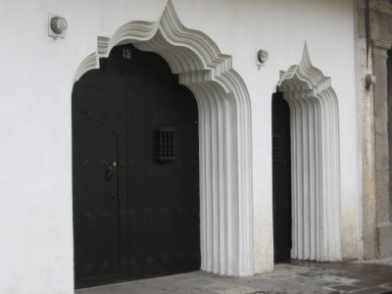

Friday, July 21: Antigua, Guaremala
This is our last full day in Antigua. Tomorrow we travel to Chichicastenango by way of the ancient capital of Ixcimche and the city of Tecpan. After that we head into the final week which we'll spend in Guatemala City.
All of us are pursuing some kind of project during this NEH institute. For example, some will be creating new courses in Pre-Columbian art or literature. Others have books or journal articles in mind. Roger Balm is an artist in the Geography Department at Rutgers University. One of his projects is to capture the beauty of the people and the architecture of Mesoamerica on his sketch pad. While people like me are feverishly snapping photographs of any and everything, Roger will sit patiently in front of a monument or temple and, with his trusty pencil, sketch a preliminary drawing. Later, he´ll pull out his watercolors and complete the picture. Here is Roger at work putting some finishing touches on some of his drawings.
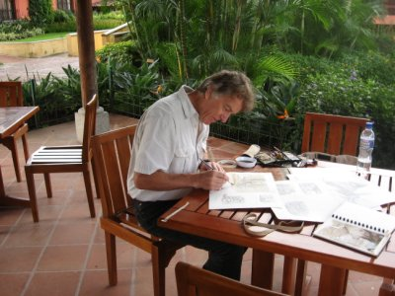
The following is a pencil sketch of Temple 1 at Tikal:
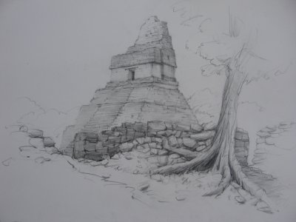
Here is one of his finished paintings showing Maya market stalls outside a church in San Cristobal, Mexico.
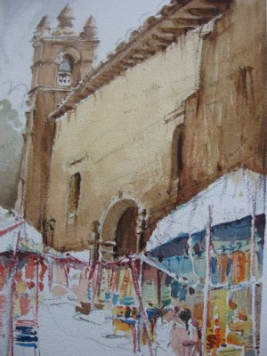
The following photo shows Nora and Alma with one of Antigua´s older citizens.
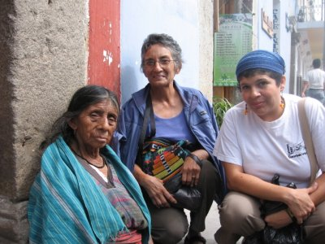
We spent this morning in discussion with Carol Hendrickson who is an expert on Mayan traje (traditional clothing). Beyond the generic topic of Mayan traje, we addressed the rather controversial topic of the selling of Mayan culture to foreign tourists. In the afternoon, we visited the nearby community of San Antonio Aguas Calientes, a community whose residents are highly dependent on tourists for their well-being. I will admit that I have rather strong feelings on this issue, being uncomfortable with the idea of "invading" peoples' homes to be witness to a display of their culture and their retail products. My good colleague, Dulce Maria Gray has some ideas about this issue, so let's see what she has to say.
Dulce Maria: Today our group visited San Antonio Aguas Calientes, a town near Antigua that has been documented by Carol Hendrickson, the scholar who will be with us for the next two days. She studies contemporary Maya textile traditions, particularly as they manifest changing gender roles. (We all read her book, Weaving Identities: Construction of Dress and Self in a Highland Guatemala Town.) Since yesterday’s discussion about pan-Maya identity(ies) with Victor Montejo, I’ve been especially preoccupied with how Maya (or any) “identity” is affected by the selling of culture (and, of course, vice versa). I’ve been thinking about our day in Zinacantán, Mexico: on the plaza we were approached by young girls inviting us to their homes. Margarita, an eleven-year old with clear brown eyes, latched on to me. “Invita a tus amigos,” she kept asking and asking. “Okay,” I promised, I’ll ask my colleagues if they’ll come along to see your house. John would not go; he’d already been through a similar experience, one that involved lots of high-pressure salesmanship and guilt. Nevertheless, a group of us followed Margarita who was thrilled with what seemed (to me) to be “her catch of the day.” As we entered her compacted-dirt-floor house far from the plaza, I too began to feel uneasy. Clearly, by going to Margarita’s house I’d be contributing to her family’s economic needs. What’s wrong with that? But then again, I thought as we all milled around her courtyard, am I not also participating in the commodifying (and thus prostituting?) of Maya culture? Am I not objectifying (and thus denigrating?) a way of life? Am I not being voyeuristic, perhaps even seeking the “primitive” experience? A light bulb went on in my head: if you have nothing at all and you want to survive, what do you do? (The same question is often asked when the sex trade is examined.) Ah, a lot of Maya are selling their culture of poverty, and why not? (I was startled to remember visiting burial grounds in the Valley of the Kings in Egypt and being amazed at how entrepreneurial impoverished men can be; many, for instance, simply find a cardboard and offer to fan you as you walk through the hot narrow tunnels.)
Carol Hendrickson writes about the political subjugation and consequent subversion that Maya continue to experience. The selling (and thereby the construction) of a way of life, in particular of the ways in which Guatemalan Maya women dress, is the main commodity. In Guatemala women still wear “traje” (a term I use cautiously, despite its acceptance by scholars and most people; traje in Spanish means clothes, but when it’s used by English speakers it takes on a very different connotation—as if somehow everyday clothes, once decontextualized, become the sort of costumes you wear on Halloween). Each town has its own unique design that the women weave in backstrap-looms and embroider in significant colors. In the last fifty years or so, Hendrickson notes, the design of those trajes and huipiles (blouses) has changed with the influence of tourists and the commercialization of culture. During our talk this morning, Carol told us about the changes in colors and types of threads: if tourists prefer cobalt blue or magenta, then women’s huipiles begin to be woven in those colors; if tourists want denim fabric, then trajes begin to be made of denim. Yet, tourists arrive in towns like San Antonio Aguas Calientes expecting the “authentic ethnic” version.
Today some of us where uneasy once more, because we were to visit a town and a specific home that would be selling us “ethnic” artifacts and, again, the experience of seeing first-hand how the “other” lives. Isn’t culture what we buy any where any time we go any place? So what truly is the problem and un-ease? Perhaps the discomfort lies in our very own affluence. Perhaps in buying a piece of fabric that may have taken a Maya woman a year to weave on her knees (and that we’ll turn into a pillow), or a huipil that we’ll hang in our living room, we feel guilty that we can enter and exit—that we can freely participate in buying and helping to construct—the culture of poverty. (I also think about the numerous Anglos carrying Guatemalan babies that I’ve encountered in Antigua; many spend up to seven months fostering the children they’ll take home to Minnesota and rename Jaeden or Jennifer.)
My point is: in buying their culture have we truly helped the Maya to step out of the cycle of poverty, or have we simply perpetuated dependency? So we went to San Antonio Aguas Calientes, and we sat in a circle while the woman, a participant in the Cooperativa Ixchel (named after Ixchel, the goddess of weaving) performed Maya customs, dress and the culture of poverty. Yes, perform: that is what Hendrickson and other scholars call it. To me that’s not necessarily a bad thing; we all perform every day of our lives. (Hendrickson also discusses how the Maya perform their culture to themselves, and therefore engage in the process of [re]creating it.) We were served pepían (a bowl of rice, beans and chicken molé), told basic stories about the Cooperative and how women’s roles have changed as a result of serving the needs of tourists and becoming less economically dependent on their men. Of the twenty-five participating families, most now have fewer children, and those children, unlike their parents, attend school often up to the sixth grade.
As part of this performance, one of the women in the Cooperativa, as seen in the following picture, illustrates how to wear the various parts of Maya traje.
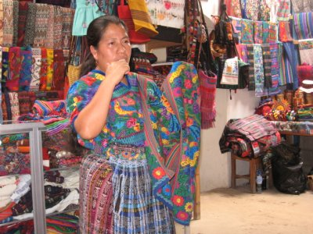
We all participated in the performance. We ate; we asked questions. Despite his initial hesitation, John went native: along with Laura and Marlene, he agreed to dress in traditional Maya wedding traje. John and Marlene, as you see in the following photo, played the role of bride and groom; Laura played John’s mother. After the official performance ended, we all dutifully proceeded to buy fabrics and trinkets.
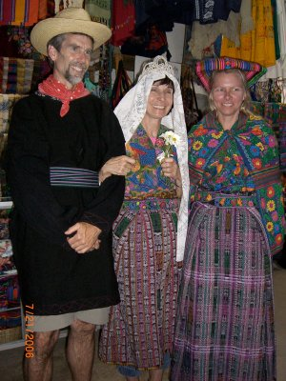
John writing again:
I´ll close with a shot of a giant bouquet of flowers in the entranceway of our hotel. There are at least a dozen or so of these bouquets spread around the grounds and they get refreshed every few days! I assume they get picked from the hotel gardens.
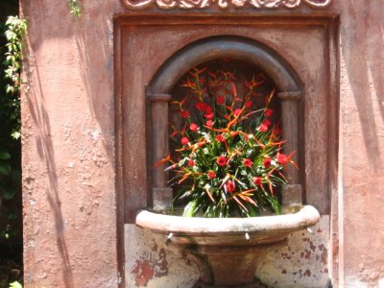

Saturday, July 22: Chichicastenango, Guatemala
We just arrived a half hour ago in Chichicastenango, by way of Iximche, the former capital of the Kaqchiquel Mayan kingdom (founded in 1475, practically on the eve of the Spanish conquest). The Kaqchiquel were militaristic in a manner similar to the Aztecs of Mexico in that they were constantly expanding their sphere of control and influence ever further outward, absorbing neighboring cities. This came to an end when in 1524 one of Hernan Cortez' (conqueror of Mexico) lieutenants, Pedro de Alvarado, arrived with his troops. The city was abandoned as the Kaqchequel were forced into guerilla warfare. It took about a decade for Alvarado to completely subdue the country we now know as Guatemala. Like a lot of other conquest scenarios, Spanish diseases wiped out at least as many Maya as did guns and enslavement. Nevertheless, because the Kaqchequel were so numerous, this reduction in population was not as significant as in other places like the Caribbean, for example.
We were able to participate in a Mayan spiritual ceremony on the grounds of the ancient city. A Mayan priest summoned Mayan ancestors asking for their blessing and for safe travels for our group. Here is a photo of Jeff adding an offering to the ceremonial fire.
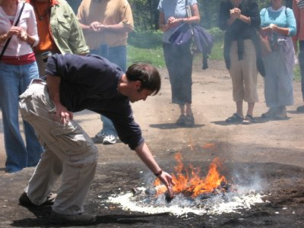
Along the road here we passed a number of farms that had diversified beyond the usual milpa (corn) to include non-traditional exports bound for the US and other foreign markets. They include broccoli, snow peas, flowers, and cauliflower to name a few. The designation as non-traditionals suggests a departure from the traditional Guatemala export products like coffee, sugar, cotton, and bananas. This was encouraged by the World Bank and other development agencies in the 1980s in an effort to generate extra hard currency earnings (to be used in repaying external debt) from products whose international markets had not yet been saturated. In the case of the traditional exports, a saturated world market meant too many producers and not enough demanders and, as a result, falling prices.
Sounds logical so far. Problems arose when farmers faced the difficult decision to actually take some of their farmland out of the production of corn and shift into the non-traditionals. In the short-run, this would mean less food on their table. The hope was that when the non-traditional crops actually came in, the additional income would more than make up for the loss of the corn harvest. To make all this work, farmers went into debt to buy seeds, fertilizer, and pesticides. The chemical additives were necessary to make sure that the produce had the perfect appearance that North Americans demanded. Regarding the fertilizers and pesticides, critics noted that workers would be given spray tanks full of dangerous chemicals (many of which we would not even allow on our crops up north) and not be provided with any protective gear. Problems also arose when farmers, who had undertaken such a monumental investment, brought their crops to market and discovered that 1) their produce didn't meet the appearance standards, or 2) the buyer already had a full truck and simply didn't need any more produce. A whole year's work might sit beside the side of the road with no market. Such problems were compounded over time as more and more countries were all similarly encouraged to get into the business of exporting non-traditionals. This led to a glut on world markets and falling prices, thus diminishing the primary reason for getting into the market in the first place.
In spite of all of these potential negatives, this non-traditional market has grown. There are more plots of farm land sown with broccoli, snow peas, and flowers than I recall from my last trip to this part of Guatemala. And..., in spite of the dangers of the use of chemicals, I saw numbers of farmers out in their fields with spray tanks and no protective clothing. I hope to capture some photos of this during our travels, but so far, our bus has always been on the move.
Here is a photo of some flowers from the balcony of our new hotel, the Mayan Inn.
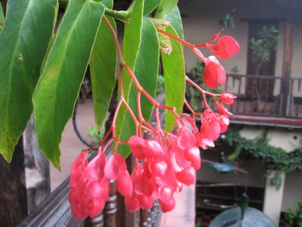

July 23: Guatemala City
Greetings from the garden spot of the Americas; Guatemala City. We arrived here about an hour ago after a drive south on the Pan America Highway. I suppose you're now imagining a multi-laned superhighway spanning the Americas from Nome Alaska to Tierra del Fuego. Hmmm... nice sounding idea.
At any rate, we had a wonderful stay in Chichicastenango. Chichi is in the state of Quiché and its name means "place of nettles." Chichi became an important city during the Spanish conquest when the Quiché were forced to flee their capital, Utatlán.
Sunday is market day, and the market there is one of the biggest and best known in the entirety of Central America. The physical location spans several square blocks and caters to both tourists and locals. The setup begins fairly early the day before and by 4:00 or 5:00 AM, firecrackers are going off, trucks are roaring by, and venders are yelling out last minute details. By the time we arrived on the scene at 8:00 AM, there was a crush of humanity. Our fist stop was to the market for locals. Farmers from all around the region set up shop with their produce. Anything you can think of in the way of food products is available for sale; carrots, corn, onions, cilantro, squash, beans, eggs, chickens (live, skinned, feet, etc.), meat, and on and on.
The photo below is illustrative of the many hundreds of food venders. I have never seen such a large stack of beautifully arranged onions before--at least not at the Lynchburg Kroger.
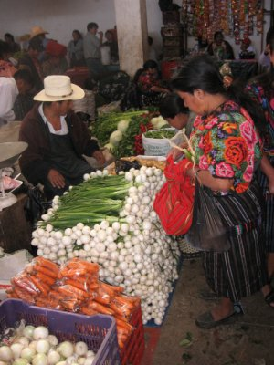
Yep... these are exactly what you think they are, pigs´ feet.
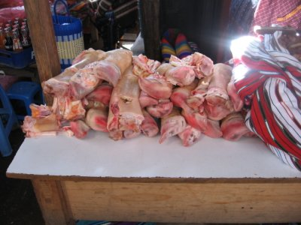
Food is available both raw and prepared. In the photo below, the women are cooking tortillas made of blue corn.
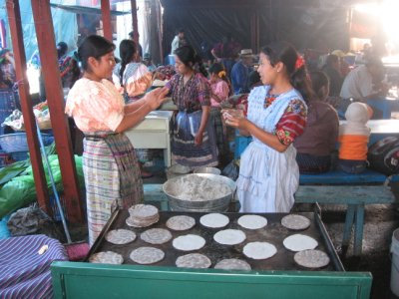
We observed mostly white and yellow, but also black and blue corn for sale.
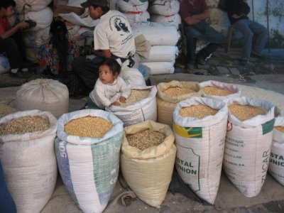
The tourist side of the market is a riot of color:
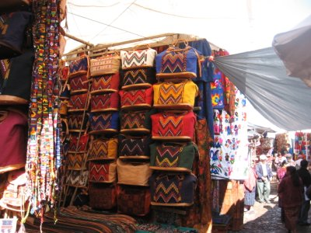
A central gathering place in the market is the cathedral. On the steps women gather to sell flowers, candles, incense, copal, flower petals, all destined for individual family worship offerings. These steps, at least on Sundays, are considered to be a sacred place, where tourists should not tread. As you can see, this advice is not strictly adhered to. Tourists hang out on the steps in droves taking photos like crazy. In order to enter the church, one ideally should go in a side door. Inside (no photos allowed, sorry) families and individuals were gathered for individual prayer. There were both traditional pews and square stone worship platforms for Mayan ceremonies.
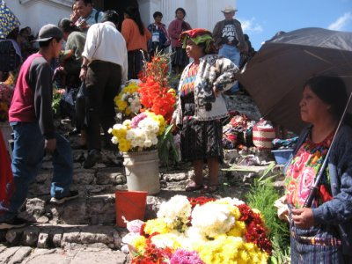
We also toured the city cemetery. Like the market, it was also a place of dazzling colors.
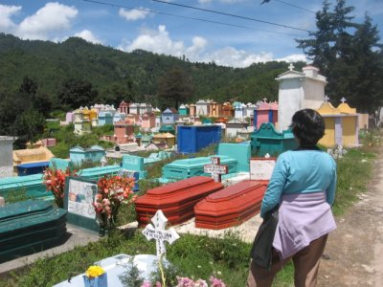
We found a most unusual mausoleum in the shape of a Mayan temple. It had a rather pointed message inscribed. It stated the following: "They cut our fruit. They cut our branches. But they could not destroy our roots. We are ephemeral. Not knowing our roots is to live lost in time and space." An educated guess is that this is making a reference to the violence the Maya have suffered; perhaps they are referring to the violence that extends all the way back to the conquest, or perhaps they are only referring to the more recent violence of the 1980s.
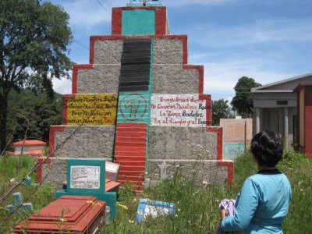
The final photos of interest center on the various modes of public transportation. Shown first is one of the famous "chicken buses," so named because families often use them to transport their produce to or from the marketplace including live chickens.
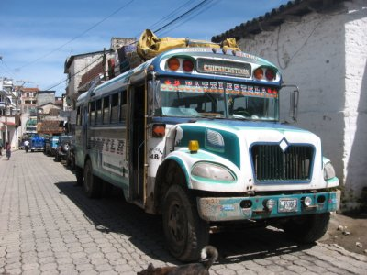
Next is the pick-up taxi, where everyone stands in the back, holding on to the center or side-rails.
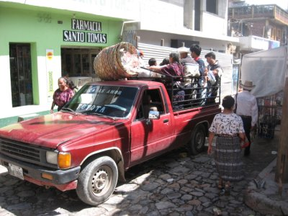
Finally, for local trips of short duration, there are the relatively new three-wheeled taxis.
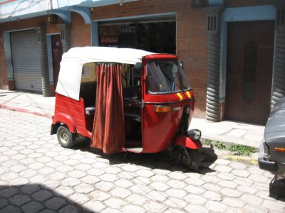
More tomorrow from the capital.

July 24: Guatemala City
We had three speakers today: Gaspar Pedro González, Maya Cu, and Emilio Del Valle, all Mayan writers and scholars. González is one of the premier Mayan writers and author of The Mayan Life and Return of the Maya. I wish to share with you one of his poems called "Over There."
Over there where I come from one single law applies: the law of the strongest.
Over there where I come from there are many poor and a few rich.
Most of the poor die from hunger. Most of the rich throw food away.
Over there where I come from they say the war is over. They insist the guns are quiet now, that there is peace. But an army of naked children sleeps on the lonely streets. The famished fight the vultures over garbage. The crying doesn't cease. The cemeteries multiply.
Over there where I come from we harvest sadness.
This poem kind of set the tone for the day. After hearing from Maya Cu about the difficulties of being a female Mayan writer, Emilio Del Valle had us watch a moving PBS documentary titled, Discovering Dominga. It is the story of a Quiché Mayan woman who was adopted into a US family at age 11 after feeling from the violence of Guatemala in 1982. Her community, Rio Negro, near Rabinal, was in one of the areas subjected to the worst of the violence. In this case, there was a World Bank-funded dam project on the Chixoy river. The rising waters were to inundate the Rio Negro community and the people were ordered to leave. They refused and the military swept through town and massacred over 170 people, accusing the community of being sympathetic to the communists.
Rather than reveal the rest of the plot for those who might wish to see the documentary, I´ll just say that as she came to grips with her past, and the loss of her family, Dominga's life was thrown into turmoil and confusion. Her life was even threatened by the perpetrators of the crimes against the people of Rio Negro. Over twenty years after the fact, there are still ghosts that haunt the highlands of Guatemala that the authorities wish to keep silent.
I had hoped to show you a couple of photos from the city to help make all these points. I´ll describe them today and hope that tomorrow, I´ll find a better computer. We took a stroll around the central plaza. I saw some plaques attached to the pillars of the fence that surrounds the Metropolitan Cathedral which I don't recall from my last visit. They listed the names, etched in stone, of the victims of massacres, and victims who had been "disappeared." There mere presence suggests a little progress in the country's coming to grips with its past, yet impunity still generally rules the day.
We also saw the usual signs of protest in the plaza itself. Sometimes the protests are by the people themselves, who often times camp out for days on end. Today, the protesters had simply left their art for us to consider. Try to imagine a picture of Uncle Sam with a giant military boot stamping out a group of campesino farmers gathered to demand that "the land should go to those who work it." This, of course, is the kind of rhetoric that, back in the 1980s, was labeled communist. The peace accords were, of course, signed in December 1996, as I suggested a few blogs ago, but the issues that led to the four decades long war and the associated massacres and disappearances haven't really been addressed. Land, as the protest picture of Uncle Sam suggests, is still the main issue. The top 10 percent or so of the richest Guatemalans own or control the majority of the arable land. Until this is rectified, there will never be true peace.
More later, and hopefully with photos.

July 25, Guatemala City Shopping Mall
Greetings from an internet cafe in the Tikal Centre, an upscale shopping mall in one of the fancier zones (Zone 10) of Guatemala City. I entered the first part of this blog from here, and completed the task later in the day from a downtown internet cafe. While at the mall, I felt as if I might be in a mall in suburban Atlanta or San Francisco or any other American city. Here is a shot from inside:
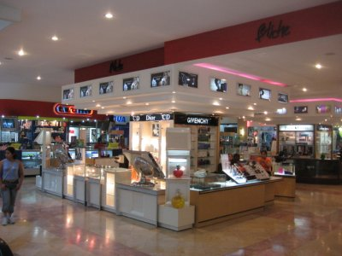
It's quite a juxtaposition being in that mall after yesterday's discussions about the Guatemalan civil war and racism of the Ladinos toward Mayans. I saw only a single Maya woman (dressed in her traje); ironic given the name of the place--Tikal Centre! The rest of the crowd was nearly as white as me and looked as if they would fit right in with the mall rats from the USA.
This was my first time ever in nearly 15 years of coming to Guatemala to visit a part of the city other than the rough urban center (Zone 1). The rich people apparently do quite well for themselves. I was trying to imagine, as I was sitting in the food court of the mall, how easy it would be for these folks to think that this was the lifestyle that they deserved and that anyone else who couldn't afford to live it must be lazy or shiftless or something. I'm sure they can't begin to relate to the Maya and how their own upscale lives and the impoverished lives of the Maya might be connected.
One of our readings from yesterday addressed this issue. Apparently there are Ladinos who hold dearly to the following beliefs:
1) "Killing an Indian is not the same as killing a man. It is like killing a subhuman or an animal."
2) "It is unfortunate that the Spanish conquistadors and the Guatemalan army have not exterminated the Indians once and for all. Now we have to finish them off using slower, even legal procedures."
There are more quotes just like these, but I better stop; It's difficult to write stuff like this. This is from a piece by Demetrio Cuxil.
Here is a shot of the Tikal Centre from the site of Kaminaljuyú (looking back across the city). It is the tallest building in the city and is built over top of a Mayan archaeological site. Such building is illegal, but those with the money to do the developing of the site had the connections to obtain a waiver.
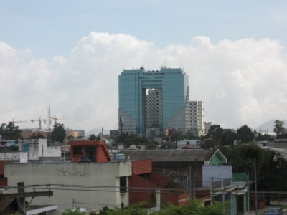
Here is shot of some urban housing on the hillsides of a ravine, taken as we were returning from our day's journey. You build where you can (and hope the authorities don’t bulldoze your homes down the hillside)!
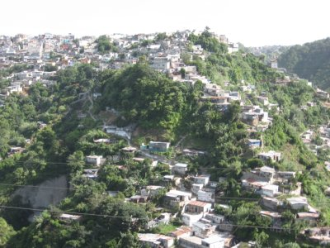
Here are the pictures I wanted to show you yesterday from the Central Plaza.
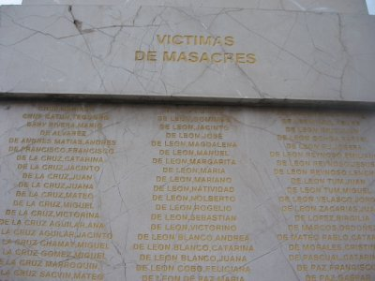
Here are portions of the sidewalk mural depicting Uncle Sam (and a generic businessman) squashing the campesinos demanding land:
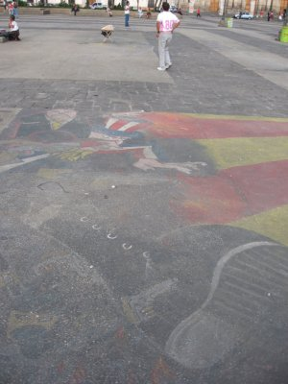
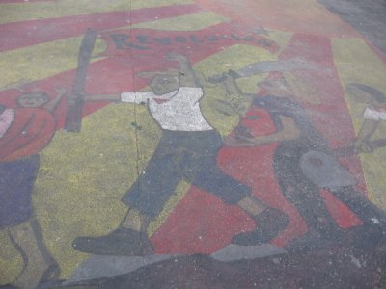.
More later...

July 27 Guatemala City 8:30 AM
Sorry for no entry yesterday. I´ll try to make it up today with a second entry later. There is much to share.
First, I should note that a couple of days ago another of our colleagues, Carol, had a birthday. You recall Carol´s picture from a blog of last week, right, looking freshly remade after an afternoon at the spa? Happy birthday Carol!
Guatemala City is beginning to wear on us a bit. We are staying close to the city center, in Zone1. The central plaza with the main cathedral and national palace are just a couple blocks away. Unfortunately, this part of the city doesn´t receive the kind of care and maintenance as the higher numbered zones where the rich and powerful live. It looks drab and depressed. We were warned of the potential dangers of the place; that we should walk in groups, not wear any flashy jewelry or easy-to-grab handbags, and so forth. We have observed a powerful police and military presence, much more obvious that that of Copán. You may recall that I commented on Copán´s military a few blogs back. A couple of my colleagues have witnessed military sweeps in which soldiers walk on either side of a road, two or three to a sidewalk and proceed to walk along block after block with weapons at the ready accosting individuals along the way. Another colleague witnessed some police or soldiers administering a severe beating just outside our hotel. My roommate said he saw police or soldiers stopping every public bus near the plaza, searching each bus thoroughly. Man-oh-man!.
Another reaction of my own is the pollution, congestion, and noise. There seem to be endless video arcades. I counted 7 alone on the first level of the mall where I am typing this blog. At 8:00 AM, several of them are already blaring with activity. There seems to be an endless capacity to put up with noise!!! Here is a photo of one of the video arcades just below me.
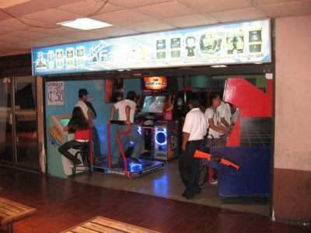
Another thing that strikes me is the street vending. I teach about this topic in my Economics of Latin America course. In Peru, according to the researcher Hernando de Soto, 60 percent of the country's economic activity is undertaken by informal or illegal market participants. Either because of outright discrimination or due to the lack of financial resources, many are forced onto the streets to peddle their wares. The same thing appears to be the case here in Guatemala City. Here is a photo of some of the tiendas that line the streets. A conflict arises when they block the access points to the fixed location shops. Also, passersby get pushed into a tight gauntlet between the stores and the street tiendas, or, dangerously, they walk out on the streets next to the traffic to avoid the sidewalk congestion.

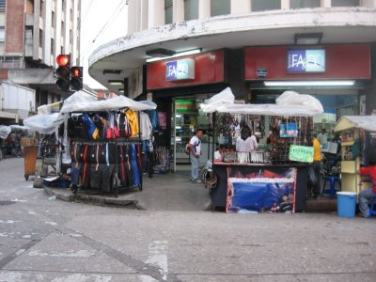.
More later.

July 27 Guatemala City 1:00 PM
Back at it on a keyboard with hardly any lettering!!!
More on Guatemala City. In every Internet Cafe I visit, there seems to be rampant and blatant viewing of pornography. I just saw two kids age 14 or so gathered at a machine watching some XXX rated stuff!!! But, all is not bad--I didn't intend in the previous blog to leave you with impression that we are miserable, though, there are some who are beginning to fade. Many of us have found refuge at one of the few nice restaurants in the Zone 1 area, Los Cebollinos, a Mexican restaurant. At every meal, regardless of lunch or dinner, they prepare AT YOUR TABLE fresh salsa, as shown in the photo below. We're practically on a first name basis with these guys.
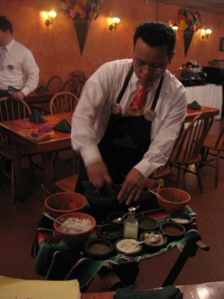
Also, several of us have taken up billiards during our down time. Here is Linda celebrating with Dulce after making a tough shot! Way to go Linda!
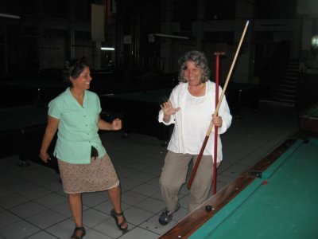
I want to try and bring some closure to the topic of the relationship between Mayas and Ladinos that I have been discussing, though, this could take 1000 blogs, rather than just one. Recall the blatant racism I mentioned in a previous blog of Ladinos toward Mayas? To most Ladinos, they idealize a unified Guatemala with either NO Mayas or well-assimilated Mayas. The Mayas of course have other thoughts about Guatemala. They agree with the UN Charter and the International Human Rights covenants that state that "All peoples possess the right to self determination." They wish for autonomy, and to have access to land, or better yet, to have all of the lands that were stolen from them over the years repatriated. I will have more to say about land tomorrow.
We have been hearing from historian George Lovell, author of A Beauty That Hurts. He suggests that the conquest took place in three stages; 1) Spanish conquest, 2) Global capitalist liberalization of 1871, and 3) the violence of the 1970s and 80s under the brutal military dictatorships. He also suggests that the colonial era has never really come to a close. Like other historians and commentators Lovell suggests that the problems of Guatemala will not be solved until the maldistribution of land is addressed.
I´ll use the following photo of a cacao goddess we saw at the Popol Voh museum as a transition to tomorrow´s blog that will address the important role that cash crops have played in the ongoing conquest of the Mayan people. Cacao used to be a measure and store of wealth for the Maya, it served as a medium of exchange, and was used in trade with foreigners. It is of lessor importance these days, having been supplanted by coffee, bananas, sugar, and cotton.
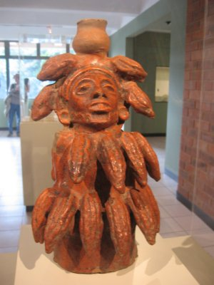
Let me conclude with a pleasant image, unfortunately, not found often in Zone 1.
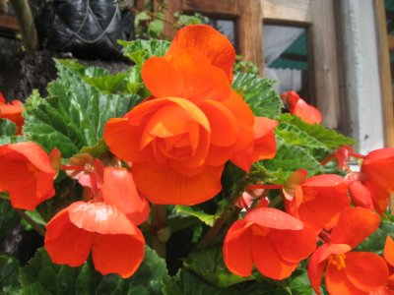

July 28, Guatemala City
Our Maya Worlds Institute officially ends tonight with our farewell dinner, and we fly home tomorrow. Therefore, unless I get a burst of energy once I get home to assemble some kind of summary, this will likely be my last entry.
We traveled yesterday beyond the confines of Zone 1 to check out the famous Guatemala relief map. I had seen this once before on my first trip here, but didn't have the appreciation for it that I now have after having traveled all around the country. The map highlights what a mountainous region this is. Volcanoes are scattered everywhere. The ruggedness of the countryside reminded me of why the Spaniards had such a difficult time setting up shop here, and why the conquest took so long, or should I say, why it is taking so long. There are lots of places for the Mayans to seek refuge and resist.
I have painted a bleak picture of Guatemala City's Zone 1. As we crossed over into Zone 2 on our way to the relief map, it was like going from night to day. Colors reemerged, there were trees and flowers, kids playing in parks, and an abundance of nice looking shops. Check out the Mayan temple-like children's slide in the following photo.
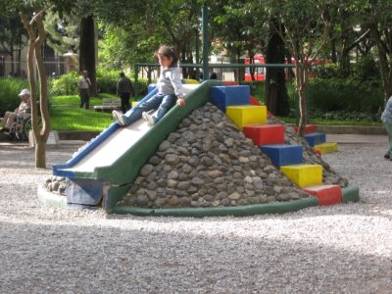
I'd like to close with a passage (pp. 155-6) from George Lovell´s book A Beauty That Hurts. This is an editorial that appeared in one of the major newspapers, El Periódico, on August 15, 1999 (by Mario Monteforte Toledo). It captures the essence of everything we have learned about the conquest, the ongoing colonial period, and Maya and Ladino relationships in general. The key issue is land. Until the maldistribution of land is addressed in this country, the conquest and colonial period will continue...
"Land is the root cause of our national backwardness, of economic megapower, of social imbalance, of the survival of precapitalist structures, of the overpopulation of our cities, of criminality, of the absence of internal markets, of menacing unrest in rural areas, of ignorance, of illiteracy, of the nostalgia that was this country five centuries ago.
A million peasants who know no other toil than to work the land, have none; two and a half million more scratch away at miserable plots on the sides of mountains and lay waste to forests in order to supplement their starvation wages; three hundred thousand others leave to work in Mexico each year between the months of October and January; half a million are bought and sold, as if they were cattle, by labor contractors who deploy them here in Guatemala on coffee and sugar plantations while their corn grows in the highlands; more than half a million, for years now, possess pieces of paper that entitle them to land, but at the same time there are more than ten thousand disputes among their communities over the rights to ownership, for which they kill one another; in the plantation zones, hundreds of peasants are murdered because they are thought to be "dangerous" or are believed to be "terrorists"; hundreds more plantation owners feel threatened by discontented Indians and so arm militias in order to defend their properties and themselves; and the countryside has given birth to its own form of justice (in the form of mob lynchings), because the state simply does not exist there and the rule of law does not apply."
Monteforte then asks:
"How is it possible that people with political and economic power, as well as ordinary folk in our cities, can ignore this explosive reality? How is it possible for them to believe that all is well in our country just because, in fashionable Zone 10 of the capital, restaurants are always full, shops busy, and streets jam-packed with cars? And yet it is so, just as it is that we grow accustomed to all the killings, all the people begging in the streets."
He reaches the following conclusion:
"But the most pathetic of all is that NO CANDIDATE OR PARTY MENTIONS, NOT EVEN MENTIONS, AGRARIAN PROBLEMS." The capital letters are Monteforte´s, not mine.
He continues:
"There appears to be a consensus not even to raise the matter of the most flagrant deformity in our country. The only explanation I can offer for this act of concealment is the fear to sound like a 'communist' and not compromise oneself with respect to solutions should one's party afterwards become the government."
Continuing with this same theme, here is how George Lovell concludes his book:
"Guatemala, it does no harm to reiterate, is not a poor and backward country. It is rich in resources, natural and human. Guatemala has been made a poor and backward country because the allotment of its resources, especially its land resources, is deformed by crippling structures of inequality. It makes short-term political sense, whatever party is in power, to proceed on matters pertaining, for example, to land taxation and the remuneration of agricultural labour. The fundamental issue of unequal ownership of land, however, can only be resolved if it is actually addressed. If it is not, the peace that was signed into being in 1996 may prove, sooner or later, neither as "firm" nor as "lasting" as its signatories, and the opposing constituencies they represent, had hoped."
The following photo is from a mural painted on the surface of the Central Plaza. It captures the frustration inherent in Monteforte´s and Lovell´s passages above. It reads: "Enough of the repression and exploitation in the countryside."
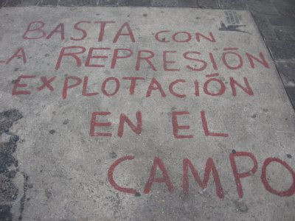
Meanwhile... the Mayan people continue to resist, even as the conquest continues into the modern age. Food still has to be sold in the marketplace,
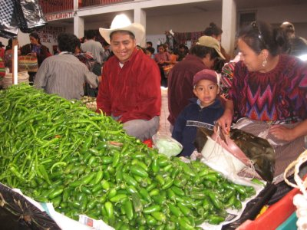
rituals still need to be observed,
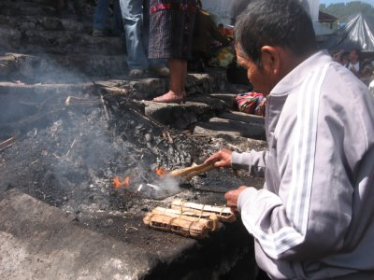
venders' stalls still need to be set up every morning,
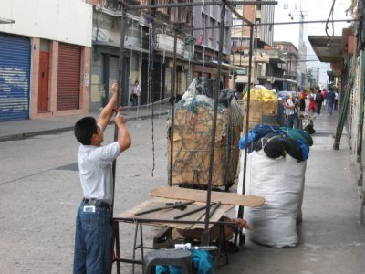
kids still need to play,
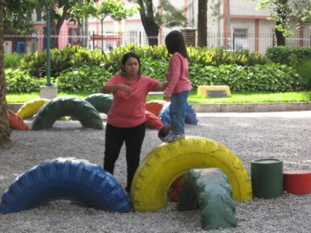
flowers still need to bloom...


