Creating an Excel 2007 Spreadsheet

Starting Excel 2007

In the following exercises you will learn some of the necessary steps to create a spreadsheet using Microsoft Excel 2007. You will learn not only how to type various items into the spreadsheet, but also how to copy columns, widen columns, fill columns, add, subtract, multiply, divide, do graphics and a variety of other “things.”
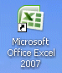
To begin, load the spreadsheet by quickly clicking twice on the Excel 2007 Windows Icon in the Windows Desktop. If you do not see an Excel Icon, click the Start Button in the lower left corner of the screen, move the cursor up to Programs, then move to Microsoft Office. Move down to Microsoft Excel 2007 and click.

A spreadsheet is a “number manipulator.” To make the handling of numbers easier, all spreadsheets are organized into rows and columns. Your initial spreadsheet will look something like the one below:
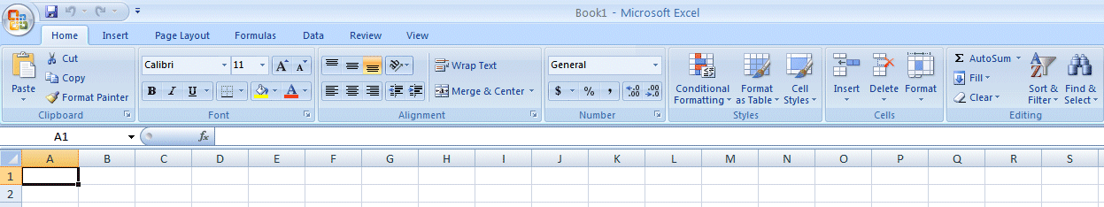

Notice that the “main” part of the spreadsheet is composed of Rows (Labeled 1, 2, 3, 4, etc.) and Columns (Labeled A, B, C, D, etc.). There are a lot of rows and columns in a spreadsheet. The “intersection” of each row and column is called a cell. In the image above the cursor is on the “home” cell – A1. Notice Row 1 and Column A are “bold,” and colored “orange.” This indicates what is called the “address of the cell. Notice right above cell A1, that A1 is displayed in a small box called the Name Box. Whenever you “click” on a cell the address of that cell will be shown in the Name Box.

If you have used previous versions of Microsoft Excel you will quickly notice that the above image is very different from what you are used to seeing. In Excel 2007 you will now use Tabs, Ribbons and Groups, as well as special Tabs/Ribbons. These replace the Menu Bar and Buttons in older versions. For an overview of 2007 Office, please see the Introduction to Microsoft Office 2007 Tutorial. This short tutorial introduces you to the many enhancements in the 2007 Office Suite.
In this tutorial, whenever we indicate that you need to click the mouse, it will mean to click the left mouse button – unless we indicate that you should click the RIGHT mouse button. So, always “click left” unless we tell you otherwise.

Moving Around the Spreadsheet

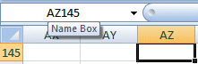
You can move around the spreadsheet/cells by clicking your mouse on various cells, or by using the up, down, right and left arrow movement keys on the keyboard. Or, you can move up and down by using the “elevator” bars on the right and bottom of the spreadsheet. Go ahead and move around the spreadsheet. Hold down the down arrow key on the keyboard for a few seconds – then click-on a cell. Notice how the Name Box always tells you “where you are.” Now hold down the right arrow key on the keyboard for a few seconds. Notice how the alphabet changes from single letters (A, B, C,. …. Z) to several letter combinations (AA, AB, AC). There are hundreds of columns and thousands of rows in a spreadsheet. Anytime you desire to return to the Home Cell (A1) simply click-in the Name Box and type-in A1. Then tap the Enter key and you will go to cell A1. You can go to any cell by this method. Simply type-in a row and column, tap the Enter key, and you’ll go to that cell.
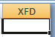
If you want to go to the last column on the right, hold down the Ctrl key and tap the right arrow key.
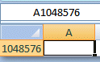
If you want to go to the last row at the bottom, hold down the Ctrl key and tap the down arrow key.

Now that you have the “feel” of how to move around the Excel spreadsheet, go to the cells as indicated below and type-in the following:

C1 (Your Name)'s Budget. It should look similar to the image below. Do not tap Enter when you finish
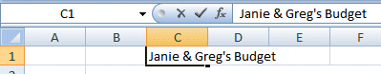

Look at cells C1 and D1. Notice how your entry has spilled over from C1 into D1. Sometimes this is a problem, and sometimes it is not.

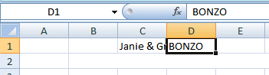
Tap the Enter key and then click-on cell D1 and type-in the word BONZO and tap the Enter key.

Notice how BONZO now COVERS the right part of your original entry!! Move your cursor over cell C1 and click-on it. Look at the upper part of the spreadsheet, just above the cells where you typed BONZO. Your name and the word budget are still there! Bonzo only COVERED the portion in cell D1. See the image and arrows below.

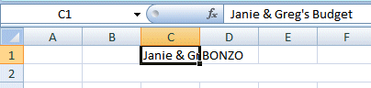

There are several ways to take care of this. For the moment move back to cell D1 and click-on cell D1. Tap the Delete key (above the arrow movement keys on the keyboard). Notice that Bonzo disappears and your entire entry reappears. This is one way to expose the entry. We'll look at some others as we go along.

Now we'll continue entering text and data. We think that creating a simple personal budget would be a logical way to show you how a spreadsheet “works.” Move to the following cells and type-in the information indicated. You can click-on each cell and then type-in the entries.

If you happen to make a mistake simply retype the entries. Later on we'll see how to
edit mistakes. Any time you want to replace something in a cell you can simply retype and the new entry and it will replace the old one.

Cell Type-in

A3 Income

B4 Parents
B5 Job
B6 Investments
B7 Total

A10 Expenses

B11 Food
B12 Beverages
B13 Parties
B14 Miscellaneous
B15 Total
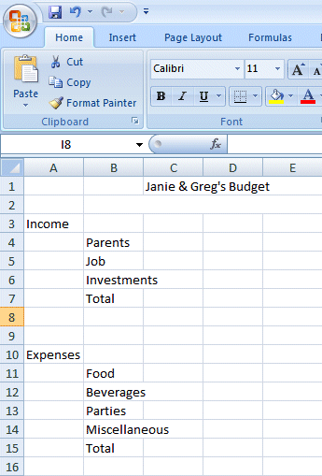

Your spreadsheet should now look similar to the image on the right.

At this point you probably noticed, the words "Investments" and "Miscellaneous" run over the spaces given in the cells. Do not be concerned at this point. We’ll soon fix this.

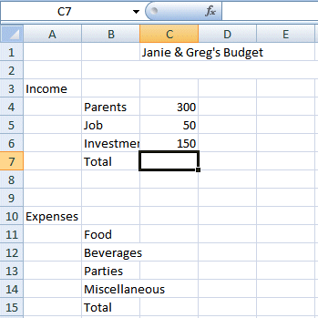
Now, type the numbers in the cells indicated:

C4 300
C5 50
C6 150

When you type-in the 150, tap Enter.

Your spreadsheet should look like the image on the right.

Notice, when you enter text that the words line up on the left side of the cells. When you enter numbers, they line up on the right side. This is because we are using the United States (English) version of Excel. Other international versions will line up logically for their text and monetary forms.

We would like to place an underline at the bottom of the three figures so that we can indicate a total below – in cell C7. Point to cell C7 (with the mouse). That's where we want the line -- always move the cursor to the place where you want to insert a line. With the Arrow on cell C7 tap the right mouse button.
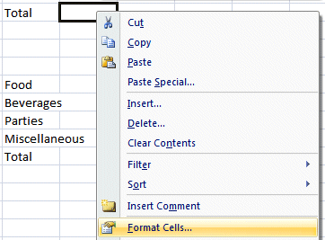
A sub-menu with a caption Format Cells appears.

The RIGHT click will “always bring up” a menu that is “tailored” to the “place” where you click. This will work in any Microsoft Windows product. You can always tell “where” you click the right mouse button for the cursor arrow will always be in a corner of the menu that appears – exactly where you clicked the right mouse button..

Select Format Cells.

When the Format Cells menu screen (below) appears, select the Border Tab.
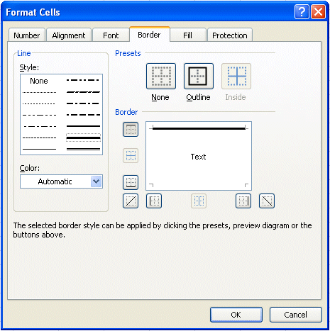

Look at the Line Style box on the right side of the menu screen. There are several types of lines that you can choose. Point to the thick single line in the Style Area (see arrow) and click the left mouse button. A box will go around the line. Look at the area which says Border. Point to the upper part of the Text box (see arrow) and click the left mouse button. A thick black line will appear at the top of the Text box.

If the thick line does not show-up at the top of the Text box, click-again at the “top line area in the Text box” and the line will “disappear”. Then click-on the thick, single line in the Line Style box again and repeat the previous instructions. If, somehow, you make a mistake, simply click “on and off in the Text line boxes.” You will notice that the lines appear and disappear. This is called a “toggle” in computer “talk.” So, work at this until you get the line on the top of the cell. We have indicated that we want a single thick underline at the top of the cell C7. Point to OK and click the left mouse button.
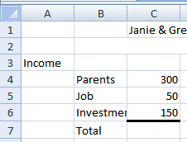
When you return to the spreadsheet, click somewhere other than cell C7. This is called “clicking away.” You should now see a line at the top of cell C7. Sometimes the box highlighting a cell hides the lines. If you “messed-up”, try again.

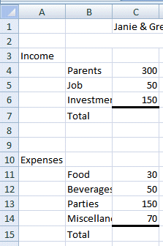
Now type in the numbers in the cells indicated.

C11 30
C12 50
C13 150
C14 70 (After you type 70, tap the Enter key)

Now, underline the top of cell C15 like you did cell C7.

Your spreadsheet should now look like the image on the right.

Widening Columns

You probably noticed, as you typed in the numbers, some of the words were just too wide for the default cell width (Investments and Miscellaneous). Let's widen column B to take care of this.
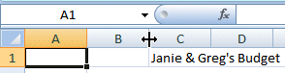
Slowly move the mouse arrow to the right edge of the B cell (between the B and the C). The cursor will turn into an arrow pointing right and left with a small vertical line in the middle (see arrow below). Hold down the left mouse button and move (drag) the line to the right.
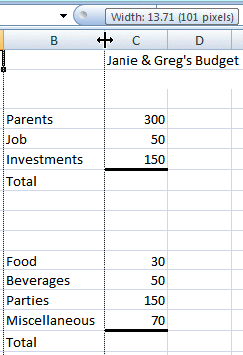

As soon as you start to move (drag) the mouse, a dotted vertical line will go down the spreadsheet and it will move as you hold down the left button and drag the mouse to the right. Keep moving your mouse to the right until you are past the widest word - and a bit more (for some space). Release the button. The column is widened. Notice, above the two headed arrow cursor, that as you hold down and drag, it indicates the current width of the column.
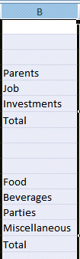

Here is another way to widen a column. Point to the B at the top of column B (in the Gray area) and click the left mouse button (The cell should turn dark blue and the column light blue.).

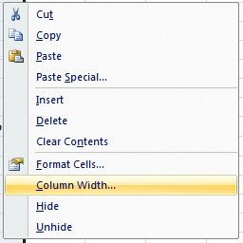
Now, keeping the cursor somewhere in the “blue” area, click the RIGHT Mouse Button. Notice that a menu with Column Width… appears. Click-on Column Width… A new Column Width menu appears. Type in 15 and click-on OK. This is another way to widen a column.
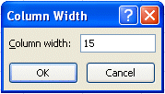

Inserting Rows

Oops... a mistake (on purpose). We haven't left enough room at the top of the spreadsheet to insert some budget months. So... move the cursor to the gray 2 along the left edge (this is the second row) so we can insert two new rows. Click the left mouse button. You will notice that the whole row goes light blue and the 2 turn’s dark blue. Make sure the cursor arrow is either on the 2 or somewhere in the blue row.

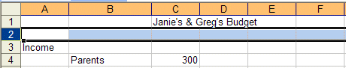

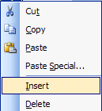
Click the right mouse button. A drop down menu will appear. Point to Insert. Click the left button on Insert. Notice how one row was inserted and how everything below moved down. Do this again to insert another row. Excel, and all spreadsheets, will remember where they moved your work and automatically adjust for these changes. Income should now be in cell A5.

Aligning Cells

Now we'll type some more text. Go to cell

C3 SEPT (Type-in SEPT and tap the Enter key)

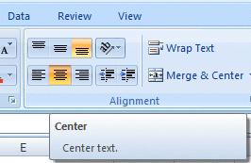
Notice how SEPT is automatically left aligned. Logically, since you are using Excel, the English version, the text is left aligned so that all of the text entries will line up nicely in the column cells. We would like to center SEPT in cell C3. Click on cell C3 to “mark” the cell. One way to center SEPT is to simply click-on the Center button in the button bar at the top of the screen. Make sure that you are ON cell C3, then click-on the center button (see image above right). You’ll notice that SEPT is now centered in cell C3.

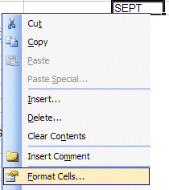

Here is another way to center SEPT. Click right on cell C3. Then click on Format Cells.

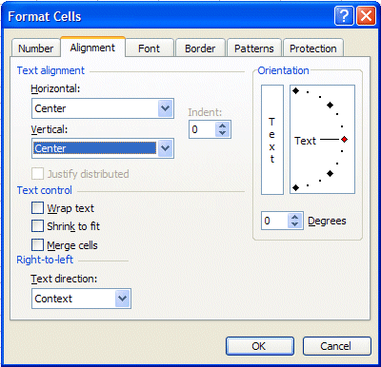

When the Format Cells Menu appears, click-on the – Alignment Tab and then click-on -- Horizontal - Center --Vertical - Center -- then click OK. Try it.

This is how you can align words for neatness. You can also point to several cells you want aligned and do this. We'll try that next.

Now type the below text in the cells indicated.

D3 OCT
E3 NOV
F3 DEC
G3 MONTHLY TOTALS (tap the Enter key and then widen the width of
Column G)

Next we’ll highlight cells C3 through G3. To do this, point to C3 and click the Left
mouse button. Then, holding down the left mouse button, drag (move) the mouse to the right through G3 – when the cells are highlighted – take your finger off of the left mouse button.

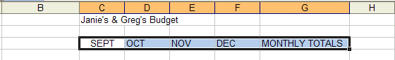

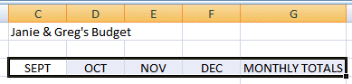
Then point to the group of cells and click the RIGHT mouse button to bring up the Format Cells menu. Click the Alignment Tab and choose Center (vertical & horizontal). Then point to OK and click the left mouse button. All of the cells will be as centered. You could also click the Center button as you did before.

Don’t forget to widen Column G and MONTHLY TOTALS. You know what to do. Move the cursor over the line between cells G and H and drag the line to the right to widen the G column, just like you did a few minutes ago.

Saving Spreadsheets

We have done quite a bit of work so now is a good time to save your spreadsheet.

If you have used previous versions of Microsoft Office, 2007 Office will be quite different - in many ways. You’ve already noticed the Tabs and Ribbons, and that there is no File choice in a Menu Bar. Many “selections” have changed significantly in 2007 Office. This is one of them.

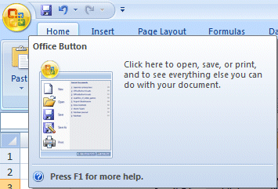
Microsoft Office Button
The Microsoft Office Button has replaced File in the Menu Bar. In the upper left corner of your Excel 2007 screen you will see a button similar to the image on the right. This is the Microsoft Office Button.

Click the Microsoft Office Button.

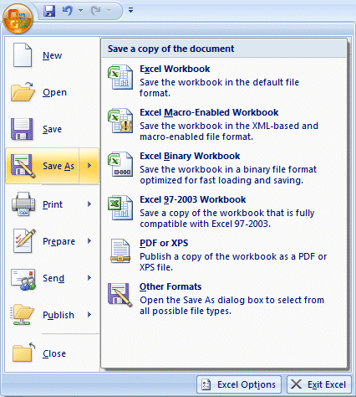
You will now see the Excel 2007 Microsoft Office Button selections.

First, notice that many of the “old” File-Menu Bar choices are included in this menu (they are all here – we’ll show you.)

When we move our cursor over Save As an expanded menu of Save choices appear on the right.

Notice that You can save your spreadsheet in many different formats.

If you save as Excel Workbook, it will save your spreadsheet in an .xlsx format. This will save your spreadsheet in an Extensible Markup Language (XLS) format. This format requires less storage space and makes the spreadsheet more “shareable” with others. However, folks using previous version may have a problem opening your spreadsheet (and may have to download a special program to assist them).

Many folks really like to save their files in Portable Document Format (PDF). One of the neat new features of 2007 Office is the ability to save applications as PDF.

For this introductory Excel tutorial, we’d suggest that you save in the Excel 97-2003 Workbook format.

It’s your choice, so you select the format you desire.

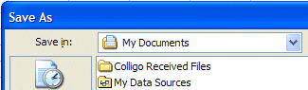
Notice in the upper left corner that there is a “box” to the right of Save In: with a down pointing arrow to the right. Click-on the arrow. This will show you all of the “drives” and “folders” where you may save your work.

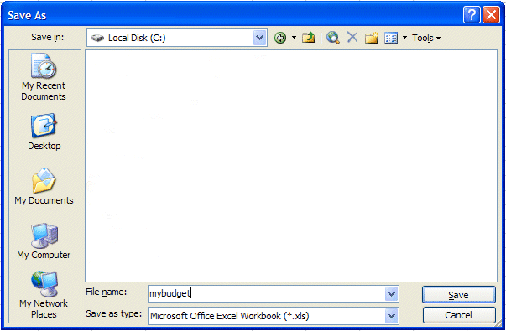
When you see the drop-down list in the Save in: area, choose the drive where you want to save your file. If you are going to use a diskette, put a formatted 3 ½ diskette in the A Drive, then click-on the 3 ½ Floppy (A):. We are going to save our file on the Local Disk (C:) – our hard drive, so we chose that drive in the image above (see top arrow).

To the right of File name:, delete the information (which is in the box) and type-in MYBUDGET (see lower left arrow above). This is the name under which you are saving your file. (In the future you will choose logical names for your spreadsheets as you save them.) Now point to Save and click the left mouse button (see lower right arrow above).

Exiting Spreadsheets

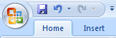
Anytime you need to leave your spreadsheet, click the Microsoft Office Button in the upper left corner of your Excel screen, then click Exit Excel. If you have not saved your spreadsheet, a reminder box will appear asking you to do so.
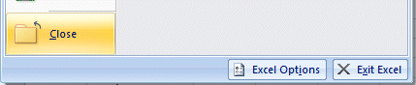

Notice the Excel Options button to the left of Exit Excel. Earlier, we indicated that all of the choices under File in the Menu Bar are still available using the Microsoft Office Button. Click the Excel Options button. The Excel Options menu screen (below) will appear. As you can see, all of the choices available under File in the menu bar are here – as well as many more.
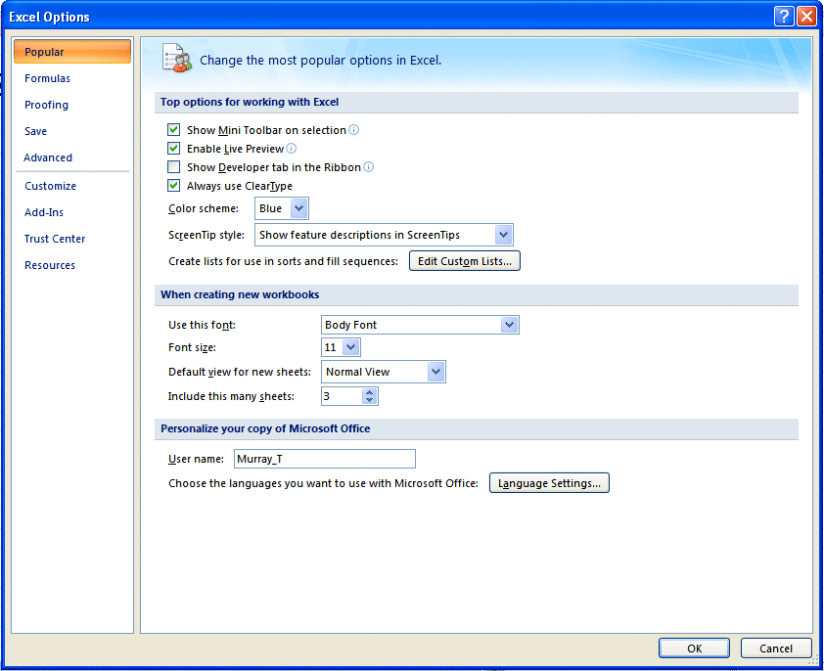

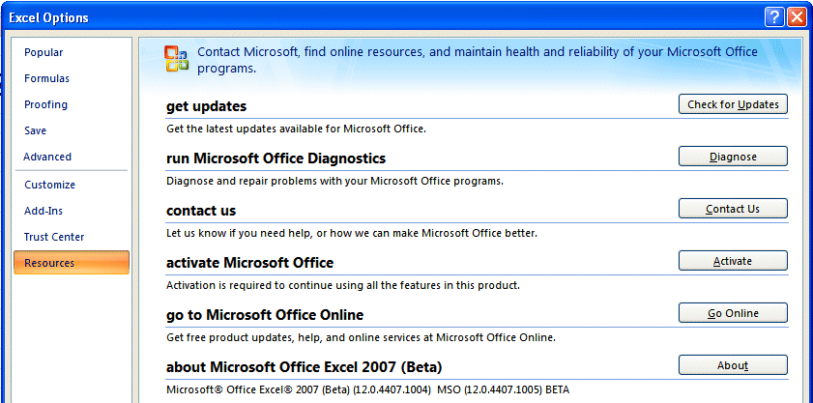
If you click the Resources selection in the Excel Options menu, you will see some great on-line resources available to assist you with Excel.

Retrieving Spreadsheets

When you need to return to a spreadsheet, open Excel, as you did on Page 1. When Excel opens, click the Microsoft Office Button in the upper left corner of the Excel screen.

When you click the Microsoft Office Button you will see, on the right of the Microsoft Office Button menu screen your spreadsheets (Recent Documents). Your MYBUDGET should be on the list. Click on MYBUDGET and your spreadsheet will open.

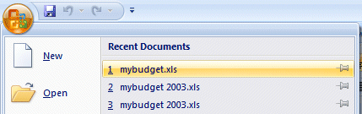

If you do not see your spreadsheet, click the Open button and follow the steps you used to save your spreadsheet (on Pages 9-11) – except choose Open.
Adding Numbers

Next we want to learn how to add numbers. There are several ways to do this. Each method has its advantages and disadvantages.

Begin by moving your cursor to cell C9, and clicking-on cell C9.

Always move to the cell where you want the answer
to be located.

TYPE-IN METHOD

We want to add the three numbers in cells C6, C7 and C8. To use this method type-in (using the keys on the keyboard) the following formula in cell C9:

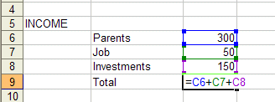
= C6 + C7 + C8

Your spreadsheet should look like the image to the right as you are typing in this equation. Note: you don’t have to use capital (upper case) letters – we only did this because they are easier to “see” in the tutorial.
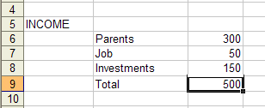

Now – tap the Enter key. Then, click on cell C9 again. The total of these cells will now appear in C9.

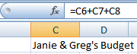
When you have completed typing your equation, you will see this formula in the area below the menu bar.

Change the number in cell C6 to 500 (and tap Enter). See how the total AUTOMATICALLY recalculates!!!

THIS IS THE TRUE POWER OF THE SPEADSHEET !!!

Whenever a number is entered in a cell the entire spreadsheet will automatically recalculate.

Something happened here. Notice: you typed an (equal sign) = before the cell location. If you had typed in C6 + C7 + C8, Excel would have thought this entry was a word (text) and this entry would have shown as you typed it.

Try this if you want. Any time you “create” an error in Excel, you can simply re-type or edit the formula to correct the error.

The Type in Method is really easy if you have a few numbers and can see their cell locations on the screen. If you have a lot of cells in the formula, which are on several screens, this is not such a great method. The next method will work a lot better for numbers “all over the place.”

Subtraction, Multiplication, and Division

You can type a (minus) - for subtraction, (asterisk) * for multiplication, and (slash) / for division. As you become more skilled we'll, build some effective formulas – using these features.

Point Method

Move to cell C9 again and click-on it. We'll now add the numbers a second way. Tap the Delete key on the keyboard to delete the current formula.

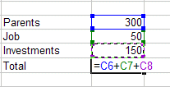
First, tap the = and then POINT (move) the cursor over cell C6 and tap the LEFT mouse button on cell C6 (you will see a marquee box go around the cell). Now tap a + and move cursor to C7, tap the left mouse button, and tap another + and move the cursor to C8 and tap the left mouse button (notice how as you " + and point " the addition formula is being built in cell C9), now tap Enter. The same formula can be built using the arrow movement keys on the keyboard (except that you don’t have to click each cell as the cell is marked - when you move with the arrow keys). Notice, as you are entering the cell addresses, that as you place another + in the formula, that the cursor “returns” to cell C9. Also notice, as you point to each cell that it is highlighted by a “marquee box.” This “tells” you what cell you’ve pointed to. Pretty neat!

This method is good when you need to move to numbers that are spread out all over the place. Some people like it best and use it all the time -- it's your choice.

Function Method

Move again to cell C9 and Delete the formula by tapping the Delete key.

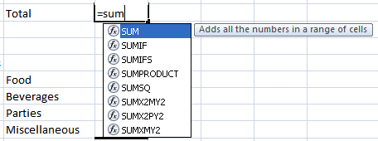
Now type in the following: =SUM(

[This tells Excel that we are going to sum some numbers in a RANGE which will follow the =SUM(]

Notice – a new feature in Excel 2007: As you are typing SUM in cell C9 that a pop-up menu appears under the cell. What you see are mathematical functions. One of these is SUM. As you become more comfortable with numbers in Excel, you can select the functions you need without typing in the entire function. We’ll get into this a bit more later.

There are two ways to put in this range:

Arrow Key and Anchor Method: With the keyboard arrow keys, move the cursor to cell C6. As you move you will notice that the cell where the cursor is located appears after the =SUM(. When you get to C6 tap the . (Period) Key. This is called an ANCHOR and holds one end of the RANGE in place. You will notice that a C6:C6 appears in the formula area under the button bar. This is a one cell range. Now move, with the arrow keys, to cell C8. See how cells C6, C7 and C8 are highlighted. This indicates the Range is C6:C8. Excel assumes, logically, that these are the numbers you want to add. Now tap Enter. The numbers still add, but now the formula reads =SUM(C6:C8) instead of =C6+C7+C8 like it did before.

Mouse Method: Move again to cell C9. Delete the formula in cell C9 by tapping the Delete key. Type in =SUM( as you did before. Point to Cell C6 – with your mouse cursor. Click and hold down the left mouse button and move/drag the cursor down to Cell C8 (Cells C6, C7 and C8 should be highlighted) – take your finger off the left mouse button. Tap Enter.

This =SUM Function is a great way to add a lot of numbers, or a block/range of numbers. By simply anchoring, and using page downs, or using the mouse, you can highlight lots and lots of numbers to add quickly. However, since it only sums you can't do subtraction, etc.

Point to cell C9 again. Tap the Delete key to remove the formula currently in cell C9. This is a really important DELETE, since what we’ll explain below won’t work correctly if you do not delete the formula in cell C9.

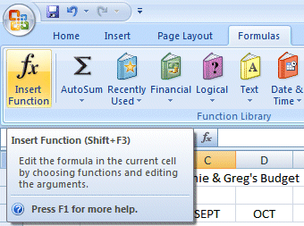
Functions

There are a number of formulas built into Excel, like Sum. These formulas are called Functions.

Another new feature of Excel 2007 – Tabs/Ribbons. Look at the top of your Excel screen and click on the Formulas Tab. The Formulas Ribbon will display.

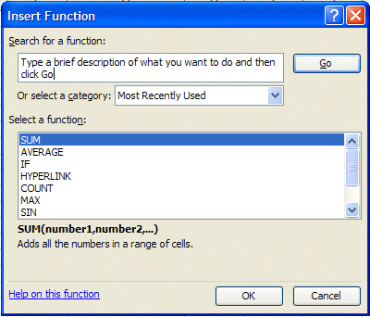
On the left of the Formulas Tab/Ribbon is an Insert Function button. Click the Insert Function button.

The Insert Function menu screen will appear (image at right).

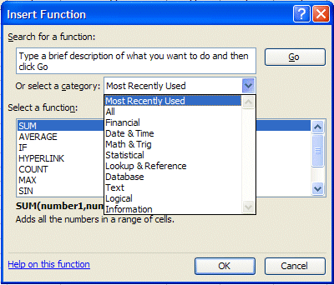
Let’s work with the Insert Function menu screen. Click the small down arrow to the right of Or select a category: (see arrow at left).

In the drop down menu that appears you can see that there are all kinds of formulas (functions) that come with Excel spreadsheet (e.g. statistical, mathematical, financial, etc.). Instead of having to go to math, financial, or statistical tables in a book, you can enter data from your spreadsheet into the formulas and receive answers.

This is a really great, timesaving feature. We’ll now show you how to use the Help features of Excel 2007 to work with, and understand, these functions.

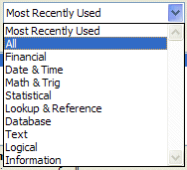

Click All in the drop down menu.

The Select a function menu will look like the image below.

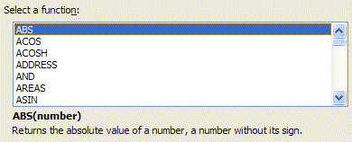

Look at all the functions (formulas)! We’ll just go through how to use the addition formula (SUM) in this tutorial. If you need these formulas in the future, you’ll know they’re here.

Use the elevator bar on the right side of the Select a function menu screen to move down the list until you see SUM. Click SUM.

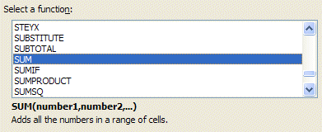

Then click OK.

Remember, you clicked-on Cell C9 – which was “empty” because you deleted the formula in that cell.

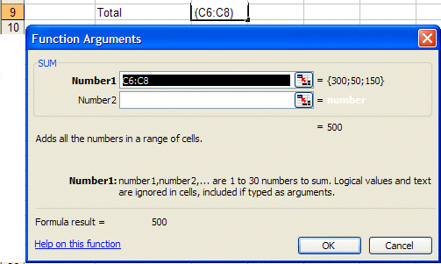

When you clicked OK, the Function Arguments menu screen (above) appeared. If you look at the top of the screen in the SUM area, you’ll see that Excel 2007 has “guessed” that you desire to add the numbers above cell C9 – where you clicked in your spreadsheet. Smart Excel! Notice that it indicates that cells C6:C8 will be added (sum cells C6 through C8 – the colon (:) means “through.” It also indicates the numbers in cells C6, C7 and C8 and gives you the sum {300;50;150} = 500 (right arrow above).

But it’s a little unclear how Excel did this. The Help on this Excel Function is excellent. So, to see how this SUM equation works, we’ll go to Help. To do this, click Help on this function in the lower left corner of the screen (see lower left arrow above).

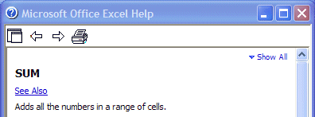

You will see a Microsoft Office Excel Help window appear (similar to the one above) that will show you how to use this SUM function (or any function).

One of the really neat things about these Help windows is that there are examples for each function. We moved down the SUM help screen using the elevator bar on the right of the help screen. The bottom of the screen looks like the image below. Spend a few minutes looking at the SUM Help window and notice all of the features.

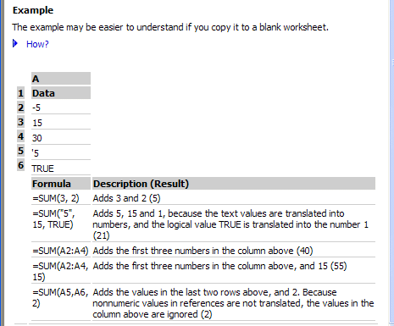

The bottom of the SUM help screen looks like the image on the left. Notice that it gives you examples from a small spreadsheet that has data in cells A1 through A6. It uses these numbers in the examples at the bottom of the help screen.

When you have reviewed all of the help you care to see, carefully click the X at the upper right corner of the Microsoft Office Excel Help blue bar to close the Microsoft Excel Help window. If you accidentally close the spreadsheet, simply reply yes to Save, and then re-open the spreadsheet as you did on Page 13.

The Function Arguments menu screen will still be on the screen.

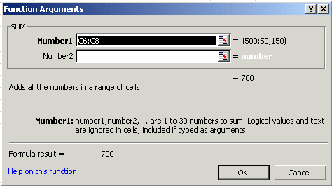

As you can see, in the area to the right of Number 1, the “Wizard” has “guessed” that you want to add the numbers in the range C6 to C8 - (C6:C8). Now that you are becoming skilled with Excel, we’ll try something special. Carefully, point to some “plain part,” in the gray area above. Click and hold down the left mouse button, and drag the above SUM box “away” so that you can see your numbers in C column cells. When you have done this, release the mouse button. Now click-on the “small box” on the right edge of the Number 1 area (see arrow above). It has a little red arrow in it.

The below Function Arguments window will appear.

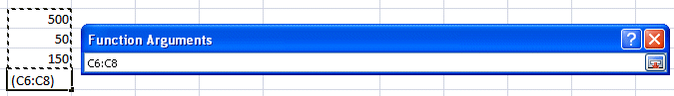

Highlight cells C6 to C8 in the spreadsheet (click-on C6, hold down the left mouse button, and drag until the three cells are highlighted). A “marquee” will begin to flash around the cells, indicating they are highlighted (left arrow above). The Function Arguments area will appear as above. Now click the small button on the right of the cell (see right arrow above). The numbers will show in the area to the right of Number 1. Click OK at the bottom of the Function Arguments menu screen. You’ll see that the SUM formula [=SUM(C6:C8)] shows in the formula area at the top of the screen. This is a really handy method to highlight a “group” of numbers you want to add.

AutoSum METHOD - ∑

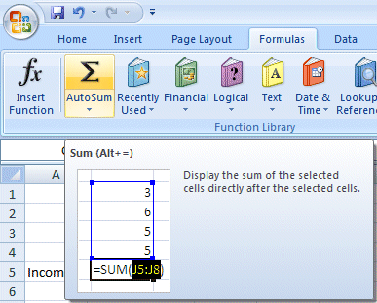
Since we add numbers more than any other operation in spreadsheets, Excel spreadsheet has an additional feature - Auto Sum. Move to cell C9 again and tap the Delete key to erase your last formula.

You should still be on the Formulas Tab/Ribbon. Notice ∑ Auto Sum button. Click the AutoSum button.

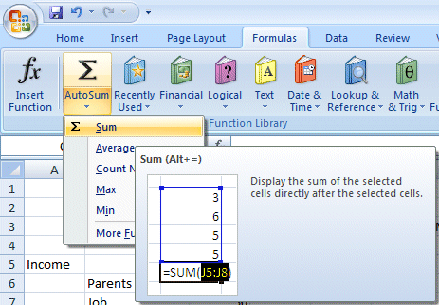

An image similar to the one on the left will appear.

Click ∑ Sum.

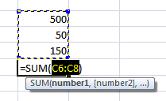
WOW !! Automatic addition!! Notice that the cells, you’d logically desire to add, have a marquee around them and that the SUM function is displayed in cell C9. You’ll need to confirm that this is the correct formula. So, tap the Enter key, and the SUM function will now be set in cell C9. Any time you want to add using this method just click-on the cell where you desire the total to be and click ∑ Sum.

This would be a good time to save your work.

PERIODICALLY SAVE AND REPLACE YOUR WORK IN CASE YOU LOOSE POWER TO YOUR COMPUTER

Now move to cell C17 and add the total Expenses in cells C13 to C16 - using each of the four methods.

While you are in cell C17, go ahead and place a line at the top of cell C17 using the format cells – border method that you learned on Page 5.

Subtraction

In cell A19 type-in Net Income. Next, adjust the width of column A (Page 6).

Click-on cell C19.

In cell C19 we want to subtract ( - ) the amount in for Expenses in cell C17 from the amount for Income in cell C9. This can be accomplished by using either the Type-In Method or Point Method. Go ahead and do this. Don’t forget to tap the Enter key to confirm your formula.

The formula should look like =C9-C17

More Cell Formatting

We want our numbers to look better. To do this we'll include dollar signs and decimal points in our numbers. This is done by using the mouse. Point to cell C6, hold down the left mouse button and drag (move) down slowly to highlight cells C6 through C19. Your screen should look like the image below.

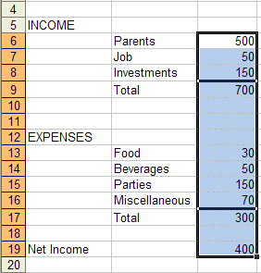

Now point anywhere in the highlighted area and click the RIGHT mouse button. A pop-up menu will appear. Click-on Format Cells (like you have done before).

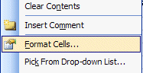

Your Format Cells menu screen will appear – similar to the image at the top of the next page.

Click-on the Number “Tab” at the top of the Format Cells menu screen. Point to Currency and click-on Currency.

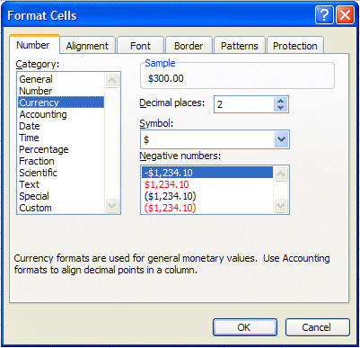

Notice several things. The right side shows the number of decimal places. The 2 is the default for cents. We'll use 2. Notice above the Decimal Places that there is a sample of what our number will look like. At the lower right it shows how negative numbers can appear, depending on your choice. When a negative number is calculated, it will appear with your choice. Now click-on OK. All the numbers now have $. If you have large numbers that are "too wide" for the current column width you will see some ######## in the cells where these numbers are located. If this occurs in your spreadsheet, go ahead and widen the columns as you did previously (Page 6).

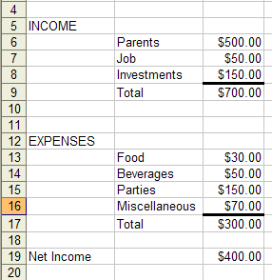

Your spreadsheet numbers should now look like the one on the left.

Division

Now move to cell A21 and type in the word Percent. We're going to calculate a fun percentage to show you how division works and give you some more practice with numbers.

Now move to cell C21. Using either the Type-In Method or the Point Method, divide ( / ) the amount for Income in cell C9 by the amount for Expenses in cell C17.

[The formula should look like =C9/C17]

This will give you a horrid number so why not put a percent symbol with it. Now we’ll repeat what we did above to format our $$$$ (Currency).

Percentages

Point to cell C21 and click the right mouse button. Point to Format Cells, then click the Number tab, then click-on Percentage. Select zero ( O ) Decimal Places. Click OK.
Ta Da !!! A %.

Your spreadsheet should look similar to the image below.

Copying

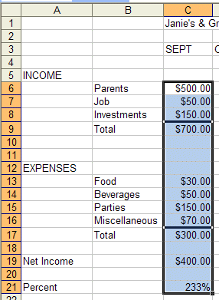

We could repeat what we did to this point and fill in the Income and Expenses for each of the remaining columns (months). There is a simpler way to do this. Assuming our income and expense amounts are about the same, throughout the months, we want to copy the amounts in Column C to Columns D, E and F. This will require TWO “steps.”

First: Move your cursor to cell C6. We'll highlight what we want to copy; second, we'll tell the spreadsheet where we want to place what we've copied. So, point to C6, hold down the left mouse button and drag (move) down the column until cells C6 through C21 are high-lighted. Your highlighted area should look like the one on the left.

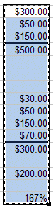
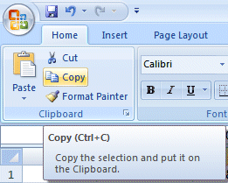

Click the Home Tab then click the Copy button.

You will notice that once again, when you highlight an area, a marquee of running lights moves around the copy area. So, you’ll know you highlighted the correct area (image on right).

Now we'll tell Excel where to copy the data. Point to cell D6, click and hold down the left mouse button and drag down and to the right to cell F21 (This will highlight three columns -- OCT, NOV, DEC -- to copy to.). When you have finished your highlighting, your screen should look like the image below.
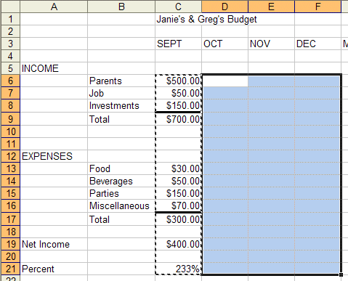

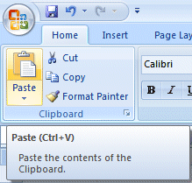

Make sure you are still on the Home Tab and click the Paste button. Wow !' All those numbers and dollar signs and formulas - EVERYTHING - was copied in a flash!! That sure saved us a lot of time.

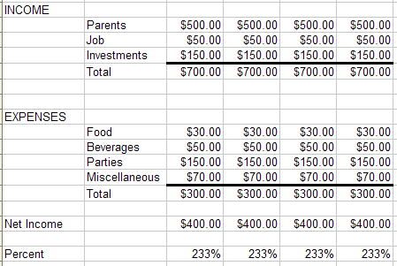

Your spreadsheet should look similar to the image on the right.

Click on a cell away from the area where the numbers are located. This will “turn-off” the highlight. Tap the Esc key and the marquee will also disappear.

Change a few numbers in each of the months in both the income and expense areas to see how the spreadsheet works.

Notice how all of the formulas, totals, and percentages change – AUTOMATICALLY!!! This is the POWER of a spreadsheet!!!!

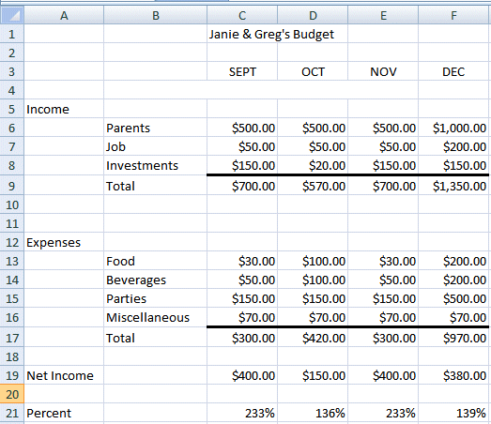
(This will make the graphs we’ll create more realistic when we create them later in the tutorial.)

Our spreadsheet now looks like the image on the right.

This would be a great time to Save again.

Now for something to do on your own.

Entering formulas in the Monthly Totals Column

Click cell G6 (under the title Monthly Totals). Choose one of the formulas you learned earlier to add the four monthly amounts in the Parents row. Use any of the four methods you desire. Your spreadsheet should look similar to the image below:

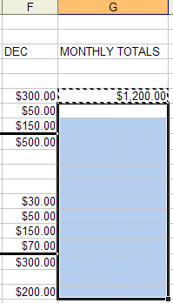
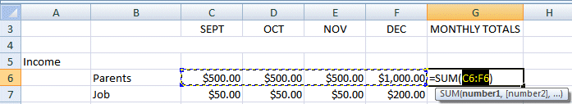

After you have added the four columns in cell G6, you’ll copy the formula in cell G6 to cells G7 through G19. Click on cell G6 and follow the Copy process you did on Page 26.

Next, click on cell G7, hold down the left mouse button, and drag down through cell G19. Your spreadsheet should look like the one to the right.

Now follow the Paste process you used on Page 26 to paste the formula from cell G6 to cells G7 through G19.
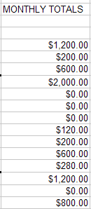

After you Paste your formula, you will see some "stuff (zeroes)" in cells G10, 11, 12, and 18. This is because there was "nothing there" to add. So, go in and “clean-up” these cells by deleting the zeros in these cells.

Go to cells G9 and G17 and underline like you did on Page 5.

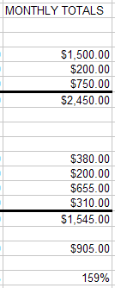
Copying the Percentage Formula

Notice that we didn’t copy the percentage formula when we did the last copying process. If we had copied a SUM formula, it would have added the four percentages. We don’t want the sum of the percentages. We want a percentage of only applies to the overall Monthly Totals. So, we need to copy the percentage formula separately. Click on cell F21, copy the percentage formula in cell F21 to cell G21. This is the average percentage that Income is greater than Expenses.

Now put a $ in cells G6 through G19 (like you did on Pages 23 and 24) , and a % in G21 (Page 25). Your spreadsheet column G should look something like the image on the right

This would be a great time to Save again.

Absoluting (and multiplication)

There are times, when we are working with a spreadsheet, that we do not want a cell to "roll" to the next column when we use the copy feature of the spreadsheet – like it did in our last copying exercise. To stop the cells from “rolling” we utilize something called absoluting. The following is an illustration of absoluting.

Go to cell A23 and type-in Number. Go to cell A25 and type-in Result.

Go to cell C23 and type in the number 2 – then tap the Enter key.

We'll now create a formula to multiply our number times Net Income. You may use either the Type-in or Point method. Go to cell C25, and type-in a formula to multiply cell C23 times cell C19.
The formula should look like: =C23*C19

The result in C25 should be two times the net income in cell C19.

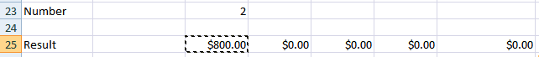
Now copy the formula in cell C25 to cells D25, E25, F25 and G25. Your row 25 should look similar to the one below.

Uh Oh!!! Where did all of those "0's" come from?

Point to each of the cells D25, E25, F25 and G25. Notice, as you click on each cell, and look at the screen, how C23 (the cell with the 2) "rolled" and became D23, E23, F23 and G23 (which are blank - this caused the "0's"). A blank times a number is a “0.”We want the 2 to be in each formula and not to "roll".

To do this we utilize something called Absoluting or Anchoring.

Go back to cell C25. Now we'll enter the formula again, but a little differently (to anchor the 2).

Type-in a =C23 (or you could type = and point to C23). NOW, tap the F4 function key. Notice, in cell C25 and the Edit bar at the top of the screen, that the =C23 changes to: $C$23. (This tells you that cell C23 is absoluted or anchored. The "$'s" indicate the absoluting.) Now finish the formula by typing in or pointing *C17 as before. Tap Enter.

The formula in cell C25 should look like: =$C$23*C19

Now copy the formula in cell C25 to cells D25, E25, F25 and G25 again. Your row 25 should look similar to the image below.

The numbers should now be correct. Point to cells D25, E25, F25 and G25 (like you did before). You will notice the "$'s" have copied the =$C$23 to each cell (absoluting) and the Net Income figures (Cells D19, E19, F19 and G19 have “rolled” as they should. Absoluting is something you should know and understand.

Pause and reflect -- Look at all you have accomplished. If you want go in and change some more numbers or change the income and expense titles to something you feel is more fun or appropriate, please do so.

This would be a great time to Save again.

The next important lesson is to learn how to print. This done with a few easy steps.

Printing

First, click cell A1.

All of the Windows spreadsheets try to figure out what you want to print. Sometimes they're right,
sometimes they're wrong. So........

The most important thing with printing is to tell the printer what to print.

Unlike a word processor, you may need to highlight what you want to print. For the moment, we’ll assume that Excel 2007 will “guess” correctly, and that you have not “clicked” somewhere that will cause a problem. If you do have problems, which we’ll know in a second, we’ll show you how to take care of the problem - a bit later.

It's usually a good idea to see what our printout will look like – before you print it. First, we’ll use a Print Preview to “see” what our spreadsheet looks like.
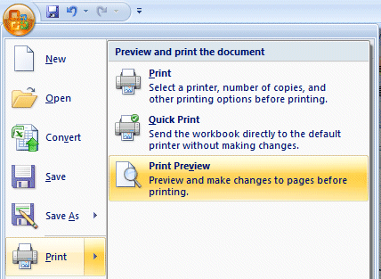

Click the Microsoft Office Button.

When the menu screen appears, move your cursor over Print and then click the Print Preview choice.

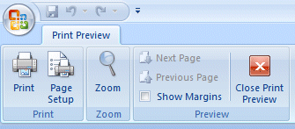
At the top of the Print Preview screen you will see the Print Preview Tab.

We’ll these buttons to assist us with our printing.

Notice: the Next and Previous buttons are not highlighted – they are just gray. This means that the buttons are not “active.” This indicates that we are OK with our spreadsheet – it is all on one page. If we saw that the Next button was active, this would mean that there are other pages to our spreadsheet. If you’ll look at the lower left corner of the Print Preview screen you’ll see: Preview: Page 1 of 1. This confirms that our spreadsheet is on one page. If you do not see this “combination,” we’ll show you how to take care of it later.

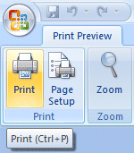
If you do see this combination, click the Print button. Then, Click-on OK in the Print menu screen that appears.

Label (write on) this printout: Default Spreadsheet Printout.

A picture, of what the printout will look like, appears below.

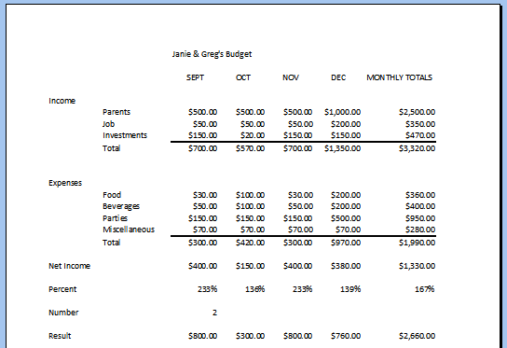

The “image” above should also look similar to your spreadsheet.


If you move your cursor over the spreadsheet, you’ll notice that the cursor changes from an arrow to a tiny magnifying glass. If you click the left mouse button, your magnifying glass will “zoom-in” on the exact spot where the magnifying glass is located. If you click-again, it will zoom-out. Try this a couple of time. It is a really handy feature.
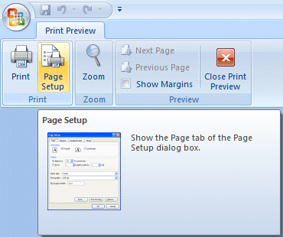

Now click the Page Setup button on the Print Preview Tab.

The Page Setup menu screen at the top of the next page will appear.

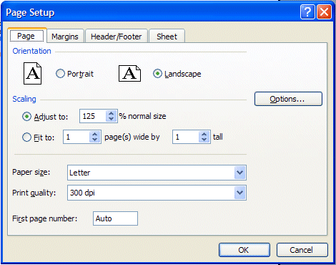

Notice that the Page Setup menu screen indicates that you are in Portrait view. Now we’ll enhance the spreadsheet to make it a bit more presentable. In the Orientation area click-in the small circle to the left of Landscape (see arrow above). The spreadsheet will now print on the page as indicated. Next, in the Scaling area, click-in the box to the left of % normal size. Using either the “up/down” arrows, or by typing in the information, change the size to 125. Then click OK.

Your spreadsheet will now be larger and fill the paper more appropriately. Click-on Print and when this spreadsheet comes out of the printer label it: Landscape – enlarged to 125 %.

Go ahead and adjust the “size” of your spreadsheet so that it becomes too large to fit on a single page. Set the Scaling to 200 and click OK. When you return to the Preview screen, the Next and Previous buttons at the top left will now be active, and you’ll see 1 of 3 or 4 pages in the lower left corner of the screen. Go ahead and click the Next and Previous buttons to get a “feel” for the “size” of your spreadsheet. If you click-on Print (please don’t do it), you’ll get these 3 or 4 pages. If you made a mistake when you created the spreadsheet, you might see that you have 58 (or some big number of) pages in your spreadsheet!

Now, click-in the small circle to the left of Fit to 1 page(s) wide by 1 tall in the Scaling area and make sure that 1 page is set. Excel 2007 will now return your spreadsheet to one page. Try other things here. Work with the Margins, Header/ Footer, and Sheet tabs at the top of the Page Setup menu screen. Any time you desire to print, go ahead and do so. This will give you a feel for how the spreadsheets will print. When you are finished, simply click OK or Cancel and you will return to your spreadsheet.

Many people ask how to center a spreadsheet on the page. This feature is located on the Margins Tab at the bottom left of the Margins screen.

Many users also ask how to place gridlines and show the row and column headings (A, B, C and 1, 2, 3) in their spreadsheet printouts. This feature is located on the Sheet tab in the Page Setup menu screen.

When you are finished working with Print Preview, click the Close Print Preview button. When you return to your spreadsheet you will see “dashed lines” around your data. Print Preview added these to assist you in knowing where the “edges” of your printed data will be on paper. We’ll show you a nice new feature that assists even more in a minute.

Cure for the problem – if you have too many spreadsheet pages.

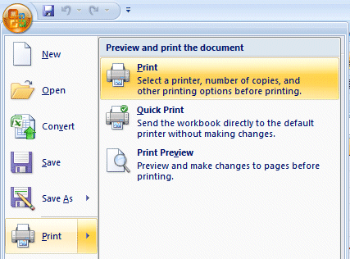
Click cell A1 and highlight your spreadsheet down through cell G25.

After you’ve highlighted A1 through G25, click the Microsoft Office Button and then click Print. In the Preview and print the document area (on the right) click Print

A Print menu screen will appear.

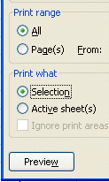

In the lower left corner of the Print menu screen you will see an area that looks like the image on the right. Click-in the small circle to the left of Selection. This indicates to Excel that you only want to print the area you’ve highlighted. Click OK. Only the section that you’ve highlighted will print. You can still modify your spreadsheet if you desire. Once you’ve clicked Selection, you may click-on the Preview button to see a preview of your highlighted area. Follow the instructions above to modify as you desire.

Page Layout View

Now that you have a “feel” for printing your spreadsheets, we’ll look at a neat new feature in Excel 2007 – Page Layout View. In the lower right corner of your Excel screen you’ll see the Excel 2007 Toolbar.
Zoom
Page Layout View

The Excel View Toolbar looks similar to the image on the right.
Normal View
Page Break View

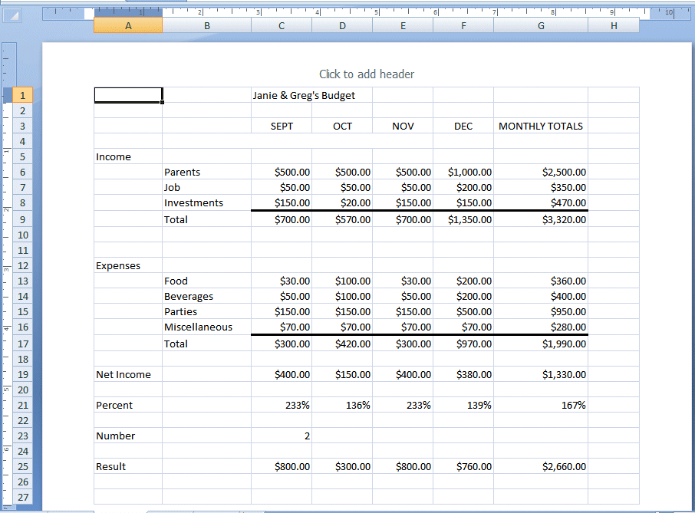
You are currently in Normal View. Look at your screen and then click the Page Layout button (as shown above) on the Excel View Toolbar. Your Excel screen should look similar to the image below. Wow! Your screen now has all the settings you entered in Print Preview. Notice the Rulers at the top and on the left – just like Microsoft Word! So you now have a very accurate Print Preview as you are working.

Spend a few minutes using the Elevator Bars on the Right side and Bottom of your Excel spreadsheet to move up and down and left to right. As you move you’ll see the Page Breaks and Pages as they’ll Print!

Headers and Footers

Look at the top of your spreadsheet and you’ll also see an area which indicates: Click to add header.

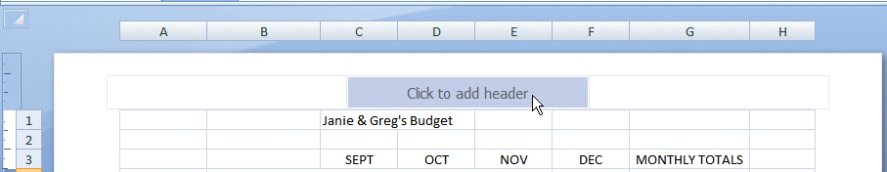

If you desire a Header (or Footer) on each spreadsheet page, you can now create them in this view! Notice (above) we’ve moved our cursor over the center Header area (the Footer area is at the bottom of the page). When we did it turned light blue. If you move your cursor over the left and right Header areas, you will see that they’ll turn blue as well. If you then click on one of these areas you’ll see a Header & Footer Tools Tab – with a Design Tab below. In the Design Ribbon you’ll see that this Tab/Ribbon is “tailored” to work with creating your Headers and Footers. This is one of the great new features in 2007 Office and Excel.
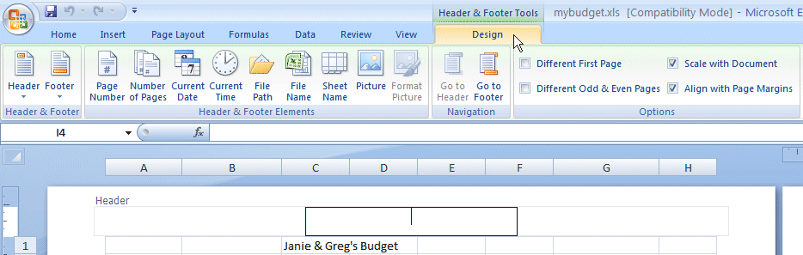

Go ahead and experiment as you desire. This new feature really makes working with Headers and Footers really easy.

Print Preview Button in Quick Access Toolbar

Since you’ll be using the Print Preview feature frequently, it would be nice to have a button in the Excel Quick Access Toolbar, so you won’t have to do all that “clicking.”

To add a Print Preview button click the Microsoft Office Button - like we did to open our Print Preview..

When the menu screen appears, move your cursor over Print and then move the
cursor over the Print Preview choice.

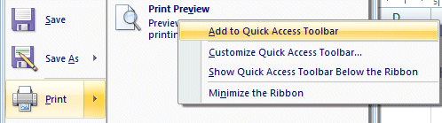
When the Print Preview selection “turns orange,” click the RIGHT mouse button and a pop-up menu will appear.

Move your cursor over the Add to Quick Access Toolbar selection and click the left mouse button.

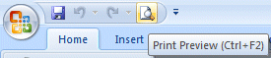
As soon as you “click” you’ll see your Print Preview button added to the Excel Quick Access Toolbar! Now, anytime you desire to Print Preview your spreadsheet, all you’ll have to do is click the Quick Access Print Preview button.

As you see other buttons you would like to add to your Excel Quick Access Toolbar, simply follow the instructions above.

Graphics

This will be a lot of fun. We are now going to turn your spreadsheet numbers into graphics - bar charts, pie charts, etc. This will greatly assist you when you display and explain your work. A new – really awesome – feature in Excel 2007 is Conditional Formatting. We’ll begin with Conditional Formatting and them move to full page Charts.

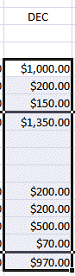
Conditional Formatting

Conditional Formatting will let you show graphics in your spreadsheets! The best way to describe this amazing new feature is to show you how it’s done.

First, you’ll need to highlight some of the data on your spreadsheet. We highlighted the Income and Expense numbers for the month of December for our image. Our Conditional Formatting graphics will appear in this column.

Now, look at the Tabs at the top of your Excel screen and make sure you are on the Home Tab. Under each Tab is a Ribbon made up of Groups (Clipboard, Font, Alignment, etc.). Over to the right is a Conditional Formatting selection in the Styles Group.

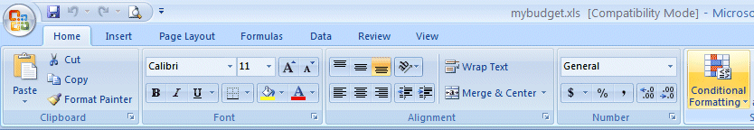
Groups
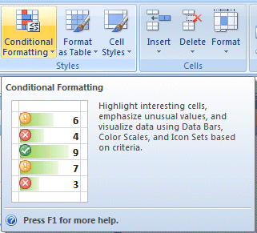

When you move your cursor over the Conditional Formatting button, an image similar to the one on the right will appear. We’ve enlarged the image so you can get an idea of how this feature will work.

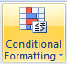

In the lower right corner of the Conditional Formatting button is a small down arrow. Click on this arrow.
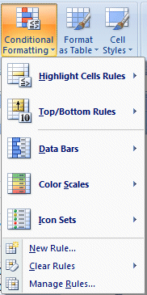

When you click the down arrow the image on the right will appear. Notice the Data Bars, Color Scales and Icon Sets choices.

As you move your cursor over these selections you will see that a number of choices are available with each option.

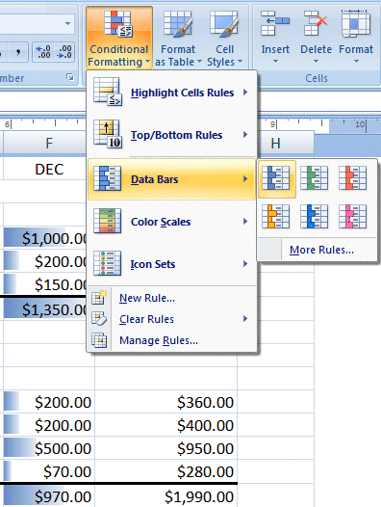

To show you how
this works we
moved our cursor
over Data Bars.
Then, we moved our cursor over the Blue selection on the right.

Notice, our December
Column data is now
highlighted in blue.

Also notice that the
larger numbers have a
longer blue bar
highlight with them.

This is really a neat new feature. Go ahead and look at Color Scales and Icon Sets as well. Experiment as you like. If you click a selection it will show that graphic on your spreadsheet. If you go to Print Preview, you will see that effect. Now you can print spreadsheets that have not only data numbers, but a graphic to show their size!

If you don’t like the Conditional Formatting effects, you can use the Undo Arrow (in the Quick Access Toolbar) to remove them.

Charts

Before we work with Charts, there are a couple of essential steps we have to do. First, we have to tell Excel 2007 what we want to see in our chart and then were we want the chart to go.

First: in cell B9 type-in Income (to replace the word Total). Next, type-in Expenses in cell B17 for the same reason. You’ll see why we do this when you see your chart.

VERY IMPORTANT………. But Tricky!

Something new.... Hold down the left mouse button and highlight cells B3 to F3. Next, HOLD DOWN a Ctrl key at the bottom of the keyboard and, while you are holding Ctrl down, highlight cells B9 through F9. You will now see two "ranges" highlighted. Hold down the Ctrl again, and highlight cells B17 through F17. These three ranges will make up your chart. The x-axis will be made up of cells B3 through F3. And, the two sets of bars – Series - will show Income and Expense. When you complete the above instructions, your screen should look like the image below.

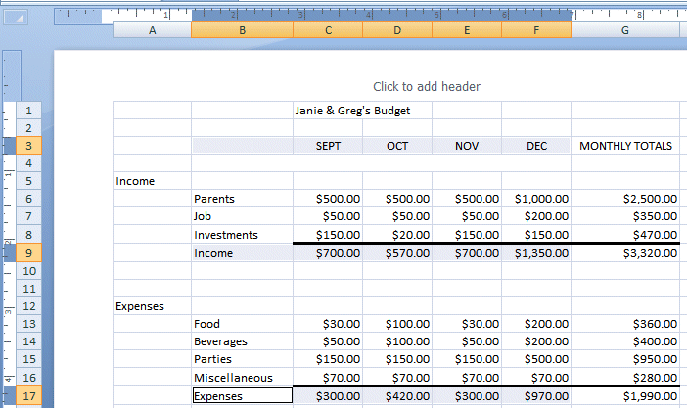

If your spreadsheet does not look exactly like the one above, please try again. This is a bit tricky and it often takes (even experienced spreadsheet users) a couple of “tries” to get the highlighting just right.

What we are about to do is entirely new in Excel 2007. So, if you have used previous versions of Excel – hang on – this is awesome!

Click the Insert Tab at the top of the Excel screen. When you do you’ll see that one of the Groups in the Insert Tab/Ribbon is Charts.

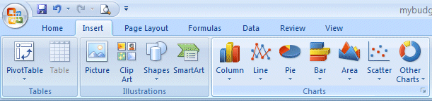
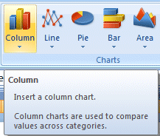

For our first chart, we’ll use a Column Chart. Move your cursor over Column and an image like the one on the right will appear.

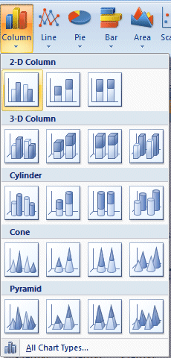

Click the Column button and you’ll see an image like the one on the left. As you can see there all kinds of Column Charts. We’ll begin with a simple two dimension 2-D Column chart. You’ll be able to change this later, if you desire – to another Column Chart of one of the other selections.

Click on the 2-D Column chart indicated by the arrow on the left.

As soon as you click, because you highlighted your data, an image similar to the one below will appear. Don’t worry that the Chart is covering your data – we’ll take care of that in a minute.

Notice that when we highlighted cells B3 to F3 this created the X-Axis labels (SEPT, etc.). When we highlighted cells B9 to F9 and B17 to F17 this created the two Income and Expense bars for each month. And, when you typed Income into B9 and Expenses into F9 this created a Legend on the right side of your chart.
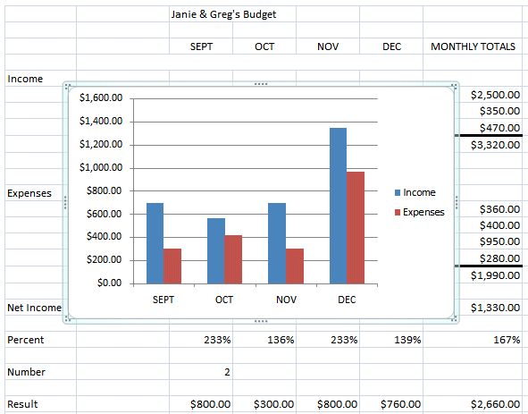

Now, let’s move our chart to a page of its own – so it will be easier to work with and not cover our data. Click anywhere on your chart and you will notice that a new Tab appears at the top of your Excel screen – Chart Tools. Click the Chart tools Tab and the Chart Tools Tab/Ribbon will appear like the image below.
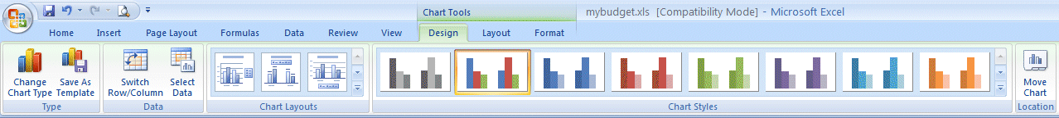
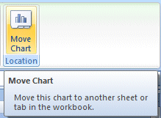
Notice, on the right end of the Chart Tools Tab/Ribbon is a Move Chart Location button. Click the Move Chart Location button.

When you click the Move Chart Location button a Move Chart menu screen will appear (like the image below).
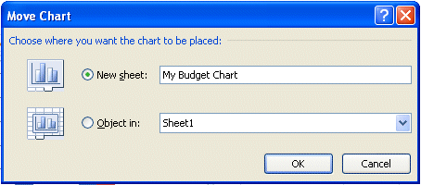

Click on the small circle to the left of New Sheet and change Chart 1 to My Budget Chart – as indicated above. Then click the OK button.

Look at the bottom left of your Excel screen. You will see a new Tab – My Budget Chart! Your data is on Sheet 1. We’ll rename it when we have finished working with our chart.

You should be on you’re My Budget Chart Tab. If not, click this tab. Your chart should now fill the Excel screen. Click in one of the outside corners of your chart.

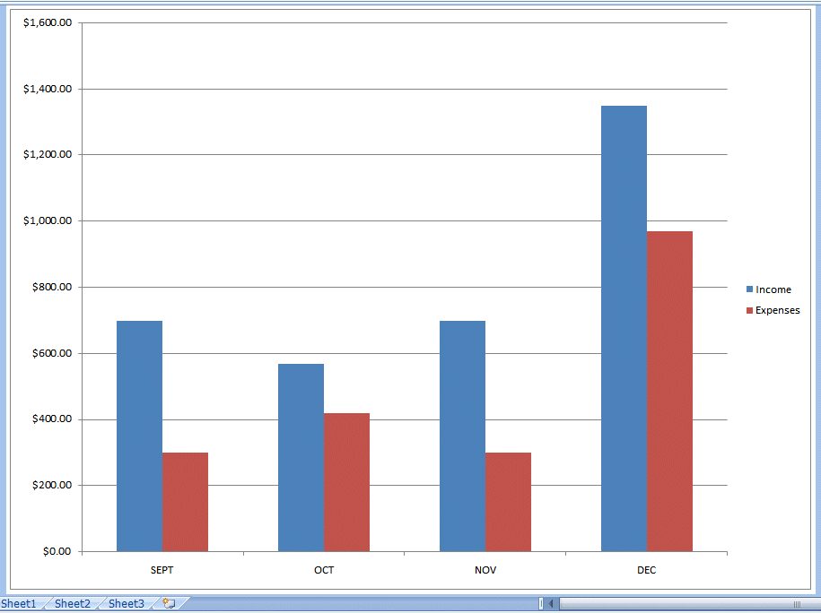

Chart Tools

Make sure that you can still see the Chart Tools Tab/Ribbon. If not, click the Chart Tools Tab.

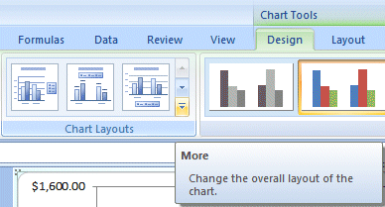

Notice that there is a Chart Layouts Group in the Chart Tools Ribbon. There are many different Layouts you can choose to enhance your chart.

Click the More down arrow in the lower right corner of the Chart Layouts Group.

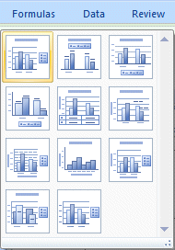

When you click the More arrow an image similar to the one on the right will appear. We’ll choose the Layout in the upper left corner. We’ll click on this choice

As you become more experienced with Charts, you choose the Layout that will best display your data.

You can also enhance the colors of your chart bars and backgrounds in a similar manner. To the right of the Chart Layouts Group is the Chart Styles Group. To see these styles, click the More down arrow on the lower right of the Chart Styles Group.
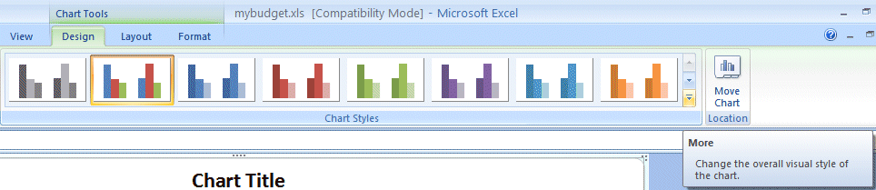
Chart Styles

A Chart Styles menu screen (similar to the one below) will appear. You can click the various choices as you desire. Each time you click, you’re My Budget Chart will change to the Style you chose.

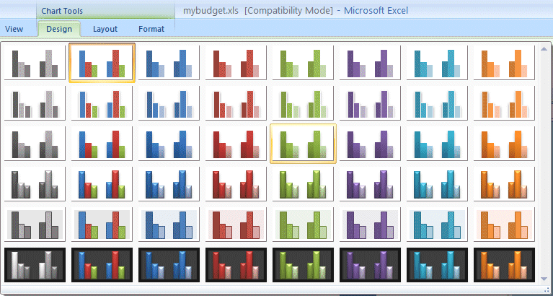

If you don’t like the Chart Styles, you can use the Undo Arrow (in the Quick Access Toolbar) to remove them.

A note – as you choose different Chart Types, you will see the Chart Styles menu (above) change to that new Chart Type.

We’ll show you another way to enhance the colors of your bars in a moment.

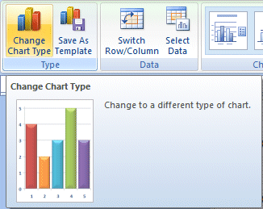

If you would like to change your Chart Type – look in the upper left corner of the Chart Tools Ribbon. You’ll see a Change Chart Type button.

Click the Change Chart Type button.

A Change Chart Type menu screen (below) will appear. Currently it is “on” our
2-D Column Chart. We’ll change it to a 3-D Clustered Column chart next.
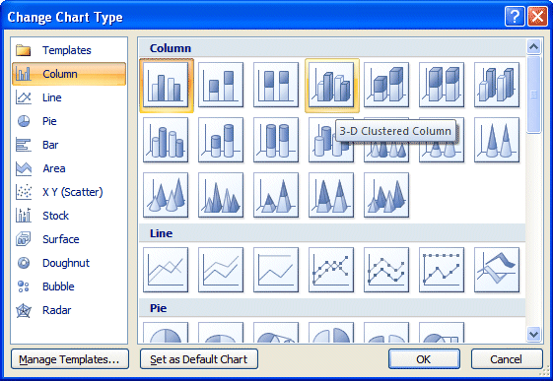

We’ll click the 3-D Clustered Column choice and then click the OK button. As soon as we click the OK button our entire chart changes to a 3-D Chart.

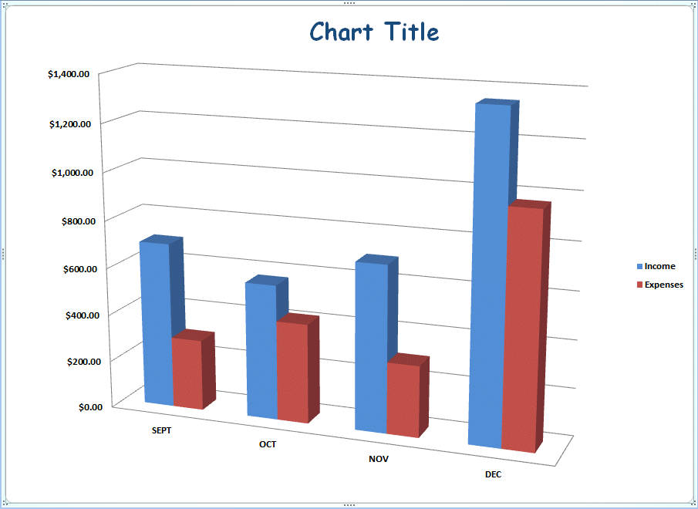

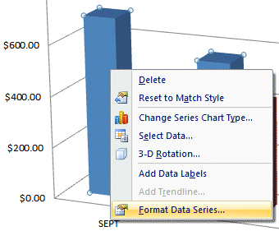
Another way to change chart colors

On Pages 44 & 45 you saw how you could change the colors of the bars in your chart (Chart Styles). Here is the second way to change colors that we promised.

Move your cursor over one of the bars in your chart and click the RIGHT mouse button. When the pop-up menu appears, click the Format Data Series… selection.

A Format Data Series menu screen (like the one below) will appear “over” your chart. In our original chart the Income bars were blue. We think green would be a better color for our Income bars. So, we clicked the Fill choice on the left. When the Fill menu appeared on the right, we clicked the small circle to the left of Solid fill and then clicked the down arrow on the right side of the Color button. Then we clicked the green color choice (if you would like to see a lot more colors you can click More Colors…). As soon as we clicked our Income bars changed to green.

Notice the other choices in the Fill menu area. Experiment with the other choices as you desire. You can really get some neat effects with Gradient and Picture or texture fill.
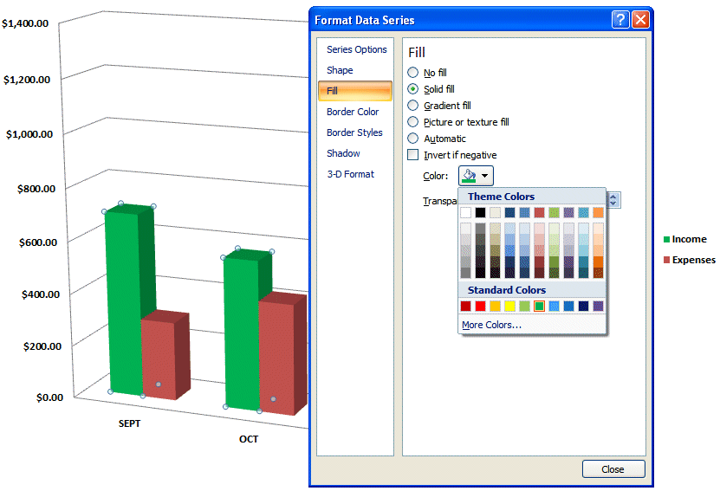
When you are finished, click the Close button.

Changing Text

To change text in Excel 2007 you need to click on the text, the Legend, or the axis on which the text is located.

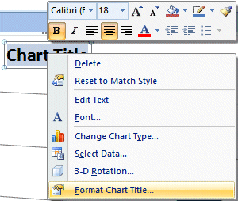

We RIGHT clicked on our Chart Title and two menus appeared. The upper menu is another new, great feature in Excel 2007. It’s called the Mini Toolbar. The lower menu is the standard menu that appeared previously.

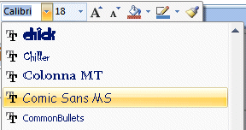

We clicked the down arrow to the right of Calibri and a drop down menu of font choices appeared. We moved down the list and clicked-on Comic Sans MS. You move down the menu and choose a font you like.

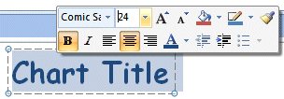
As soon as we clicked our font choice, our Chart Title changed to that font.

You can also change the Font size, Bold, Color, and more using the other Mini Toolbar selections. Experiment as you desire


Now we’ll change our Chart Title to something more meaningful. Move your cursor over Chart Title and click the left mouse button three times quickly. This will highlight all of the title – just like Microsoft Word. Or, you can click and drag your cursor of the title to highlight Chart Title.

Type in a title for your budget. We typed in the title you see below. When you have finished typing your title, click the left mouse button in an “open” area of your chart (to turn-off and confirm the title)


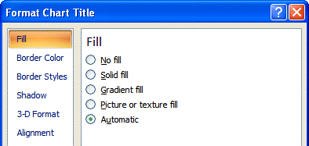

If you desire to enhance your text some more, RIGHT click on the title and the Format Chart Title menu screen will appear. You can use this menu to augment your text.

Now it would be a good time to Save again.

In Excel 2007, when you save your spreadsheet, you also save your graph. Your graph is saved wherever you are working in the graph.

Changing (Renaming) Excel 2007 Tabs

If you would like to have logical names for your Excel 2007 spreadsheet tabs – rather than Sheet 1 and Chart 1, we’ll show you how to do this.

At the bottom of your spreadsheet you will see you tabs (like the image on the below). To change the name of one of the tabs, place your cursor over a tab and click the RIGHT mouse button.

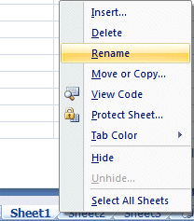
We’ll change the name of Sheet 1 first.

RIGHT click on Sheet 1and the drop down menu screen to the right will appear. Choose Rename.

When you choose Rename, the Sheet 1 tab will “turn black” – like the image on the right. As soon as you see this, type in the name you want for your chart. We typed in Budget Data.

As soon as we began typing, the tab name changed. When we finished, the Tabs for our Chart and Data looked like the image on the below.

So, anytime you need to change Tab names, all you have to do is Right Click and Rename.

Some additional Charting

Sizing your Graph Area - Click-on the upper right corner of your chart area. You will see little circles now appear at the four corners and sides of the graph area. Point to the upper right corner circle and move the cursor until you see an arrow with two heads ↔ . Click and hold down the left mouse button and drag down and to the left then let go. Your graph will get smaller. You can make the graph area of your chart smaller or larger as you desire.

Legend Area - Click-on the Legend on the right (box with Income and Expenses). When you see the corner “grabbers,” make the Legend box a bit larger. Then click right in the Legend area. When the Quick Toolbar appears, make the font bold and size 14.

Printing Charts - Now let's look at your graph and then print it. Click the Print Preview button you placed in the Quick Access Toolbar. If you like what you see go ahead and print the graph. If not, close Preview and make some more graph changes. If you have a color printer, your graph will print in color.

Whenever your graph is visible, you can point to any area of the graph, and click the right mouse button on the area, and edit that particular area. You can also click-right in the chart itself.
You can really go “wild” at this point. If you make a mistake, simply click the undo button at the top of the menu screen and try again.

Note: No matter what type of printer you have, graphs take awhile to print. Be patient.

Well that's it Excel 2007 fans! Go for it!

Microsoft Office Tutorials

In addition to this tutorial, other Office tutorials are available at:

http://www.officetutorials.com

This site is updated frequently with tutorial revisions as well as tutorials from a number of collegiate institutions. Please feel free to visit and down load as you desire.

This has been an introduction into the basics of Excel 2007. If you have any questions about Excel 2007, or comments on this tutorial, please contact:

murray.t@lynchburg.edu

Thank you for your patience and good luck.

