Introduction to
Microsoft Outlook 2007 Calendar

Accessing the Outlook 2007 Calendar

You should be “in” Outlook Mail 2007. On the left side of your screen, there is a long column called the Navigation Pane.

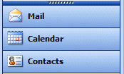

Look at the bottom of the Navigation Pane and you will see a Calendar button.

Click the Calendar Button. A Calendar screen, similar to the one below, will appear.
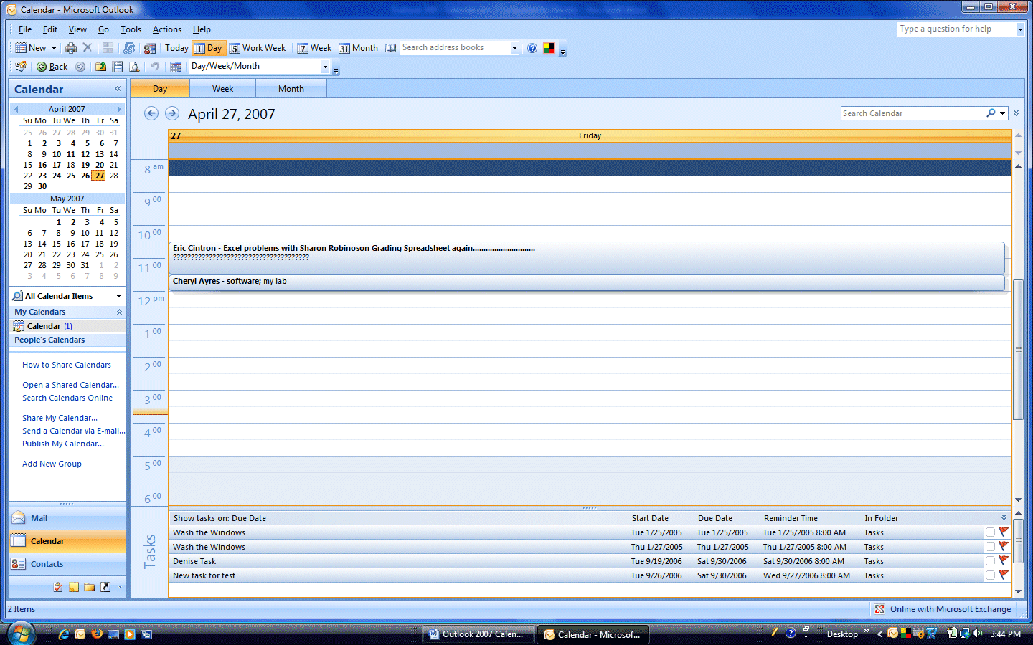

Notice, at the top of the calendar, a small area that looks like the image above. The default for Outlook 2007 is a single day. You can change this to view a 5 day work week, a 7 day week, or a full month. We’ll now view each choice.

When you click the 5 Work Week button, an image similar to the one below will appear.

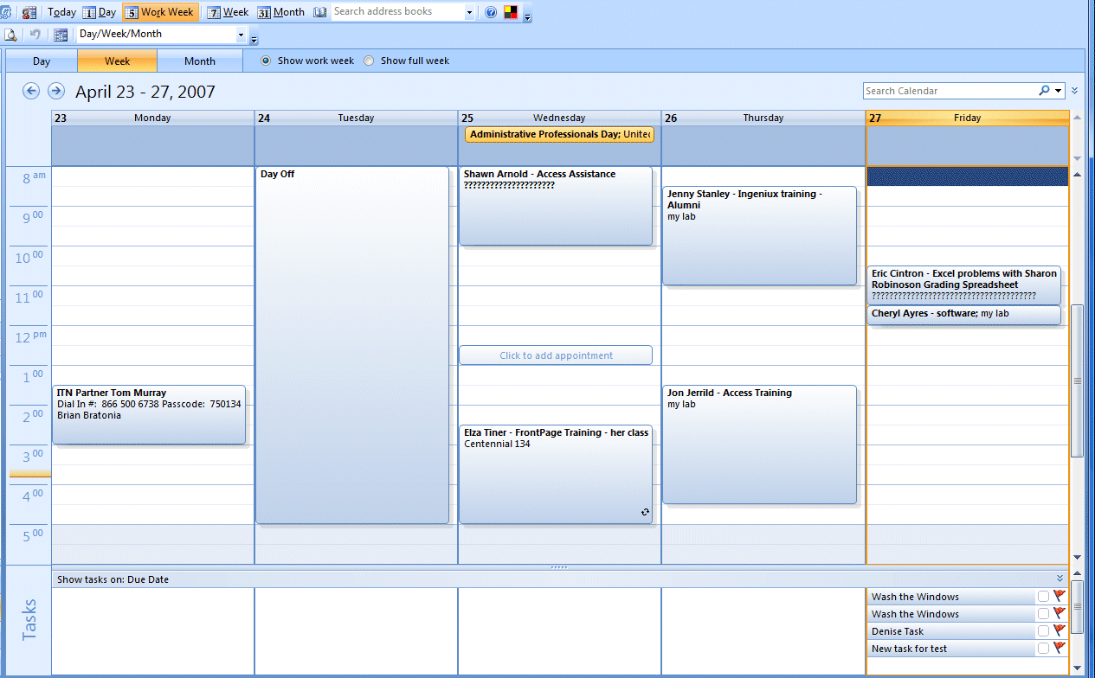
When you click 7 Week, the image at the top of the next page will appear.

Left Mouse Button

In this tutorial, whenever we indicate that you need to click a mouse button, it will mean to click the left mouse button – unless we indicate that you should click the right mouse button. So, always move the cursor over the “place” we indicate and “click left” unless we tell you otherwise.

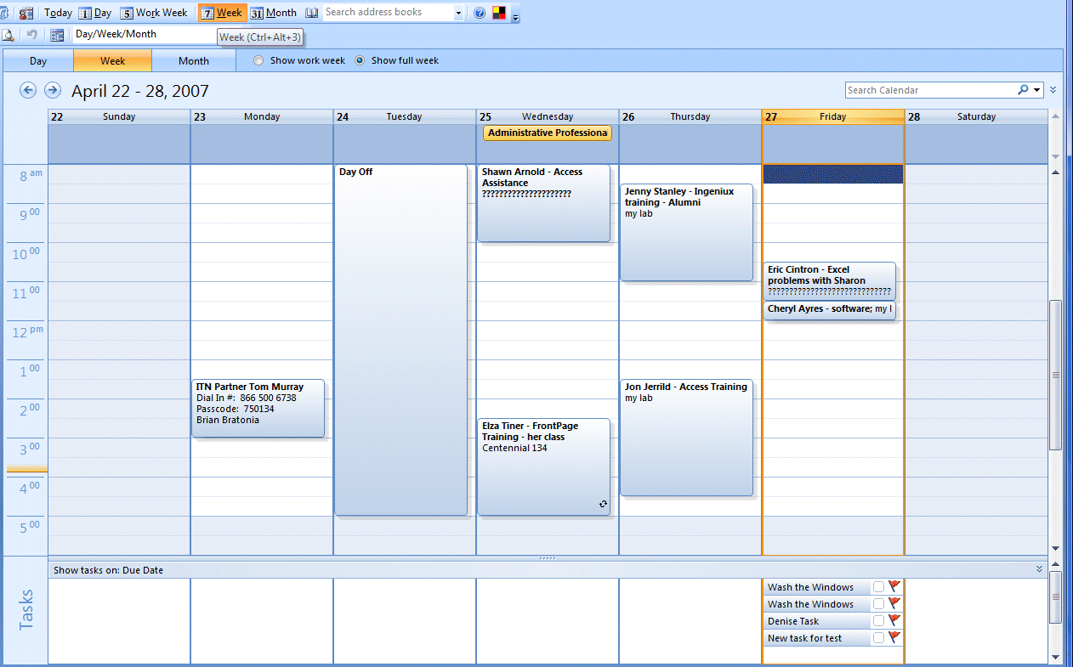

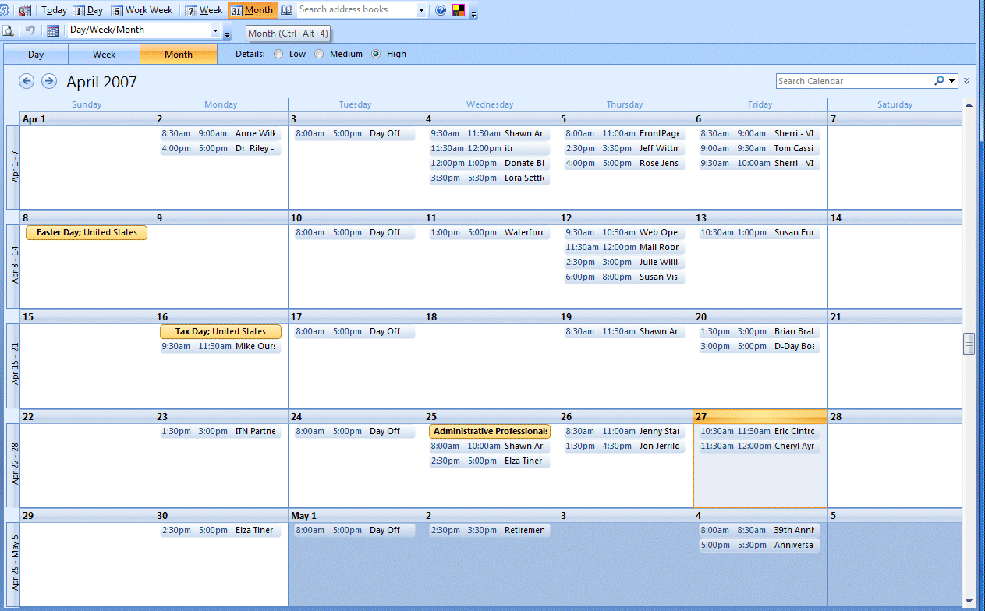

When you click
31 Month, an image similar to the one on the right will appear.

You choose the view that you prefer. For this tutorial we’ll use the 5 Work Week calendar.

Making an Appointment

There are several different methods for creating an Appointment in Outlook Calendar 2007.

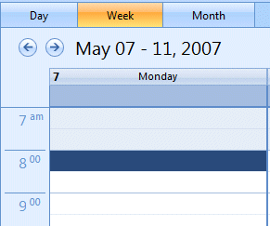
Probably the quickest way to create an appointment is to go to the calendar day/time for the appointment, and DOUBLE CLICK QUICKLY on the Time and Day for the appointment (we are in the 5 Work Week Calendar).

We want to make an 8:00 to 9:00 AM appointment on Monday, 7 May. So, we double click quickly on 8:00 AM (see image on right).

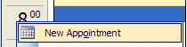
We could also RIGHT click on this time and date. A drop down menu with New Appointment will appear. Click New Appointment.

Both of the above methods will open an Untitled – Appointment menu screen like the one below.
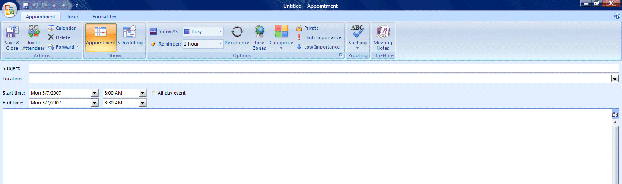
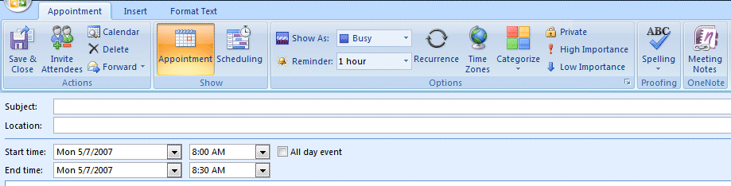
We’ll now enlarge the top portion of the Untitled – Appointment Menu Screen (below).

Notice that the date and time we chose are indicated in the Start time: area of the screen. We’ll now enter additional information on our meeting in the appropriate areas of this screen.
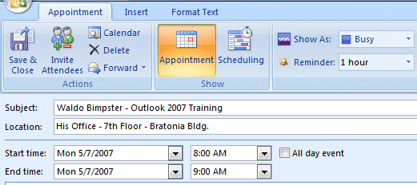

In the image above, we entered the information on the person with whom we are meeting in the Subject: area (see top arrow on left) and then the place where we are meeting in the Location area (lower arrow on left). Once you enter this information, you’ll see the “name” of the appointment change to the data you have entered in the Subject area. We then clicked the down pointing arrow to the right of End time and moved the time to 9:00 AM (lower right arrow).

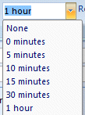
Notice, above and to the right of End time, there is a Reminder (upper right arrow). If you have speakers with your computer, and desire a sound to play (as a reminder) before your appointment, leave this as you see it. To the right of Reminder it indicates 1 hour – this is how many hours/minutes before the meeting the reminder will sound. To the right of 1 hour is a down arrow. If you click this down arrow, you can change the time to any time you desire (to be reminded of your coming meeting).

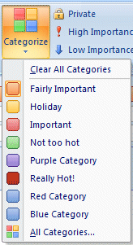

On the right side of the Appointment Tab/Ribbon, you’ll see a Categorize button. If you click the Categorize button, a drop down menu will appear with different meeting categories and colors. You can choose a meeting label and color if you desire. We chose “orange” and “Fairly Important” for our meeting.

If you desire to edit the current choices, or create some of your own, simply click the All Categories button and follow the instructions.

Below the Subject/Location/Time/Date area you will see a blank white area. This area is a “text box” where you can type additional information on your appointment if you need to do so. Also notice that when we selected the “orange – Fairly Important” choice that this now appears at the top of our appointment screen.
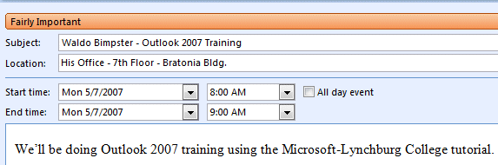

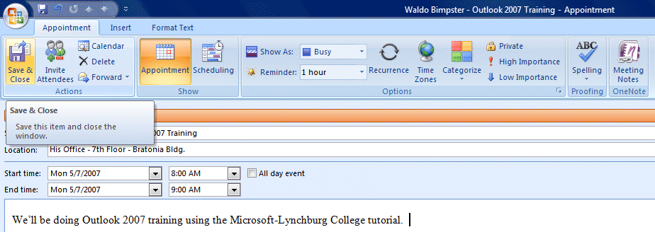
Your final appointment screen should look something like the one below. When you have everything the way you want it, click the Save and Close button on the left of the screen.

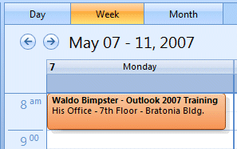

You will now return to your calendar. Depending on which “day view” you chose, you should see something like the image on the right – we are in 5 Work Week.

If you need to change something on your calendar it is fairly simple. Simply click the left mouse button twice quickly on the appointment, and it will open the Appointment Screen for you to make any changes you desire.

Recurring Appointments

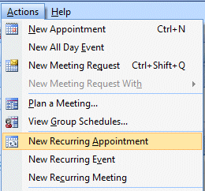
Many times you will have a recurring meeting or appointment that repeats throughout the year, or for several months. Outlook Mail Calendar 2007 has a feature that will allow you to schedule recurring meetings and appointments.

Again, there are several ways to access this feature. You can double click quickly on the first recurring meeting time and date and the Appointment screen will appear. Or, you can click on the Actions tab in the Menu Bar and then select either New Recurring Appointment or New Recurring Meeting (they both do the same thing).

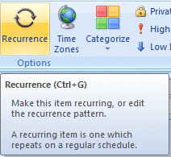

If you double click a time/date, you will have to click on the Recurrence button in the Appointment screen Tab/Ribbon.

The Recurring Meeting/Appointment is accomplished in two steps. First, you have to enter what dates, days, hours, weeks, etc. that you will meet, and then enter the normal appointment data about the meeting. We’ll start with the Appointment Recurrence menu screen and then finish with the normal Appointment menu screen. Once you click as indicated on the last page both the Appointment Recurrence and Untitled - Appointment screens will appear as shown in the image below.
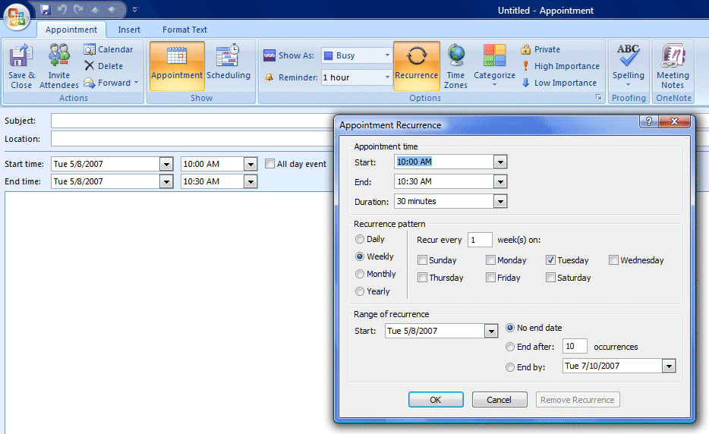

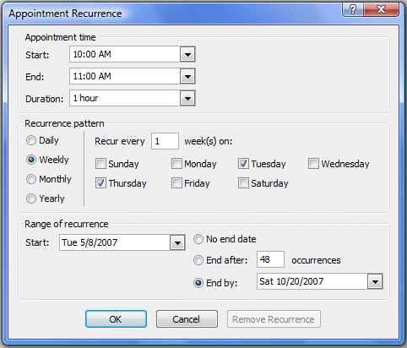
For this tutorial we’ll use the example of a meeting that will be held twice a week for the next several months. Our meeting will be from 10:00 to 11:00 AM, Tuesday’s and Thursday’s from 8 May 2007 through 18 October 2007. First we’ll complete the Appointment Recurrence menu screen. Our screen, when finished, looks like the image on the right.

To complete your Appointment Recurrence screen, click the down arrows to the right of Start and End and select your meeting times, then click in the circle for your Recurrence pattern (Daily, Weekly, Monthly, Yearly). Select the days on which you will meet by clicking in the small check boxes to the left of the days (Sunday, Monday, etc.). Please see the image at the bottom of the last page (Page 8) and the arrows that indicate our selections.

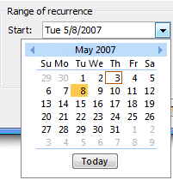
In the lower left portion of the screen, in the Range of recurrence area, click the down arrow to the right of Start and a neat thing will occur – a miniature calendar will let you choose your specific date. Simply click the date you desire and it will appear in the Start area.

If you need to move to another month, the right and left pointing triangles on either side of the Month (August), will move you ahead or back one month.

Repeat this process in the End by area in the lower right area of the screen.

When you have entered all of your data, click the OK button. This will take you to the Untitled – Appointment menu screen. Fill-in your information as you did on Pages 4 to 6 and then click Save and Close. If you need to make changes later, you simply click the Recurrence button and make any changes as outlined above.

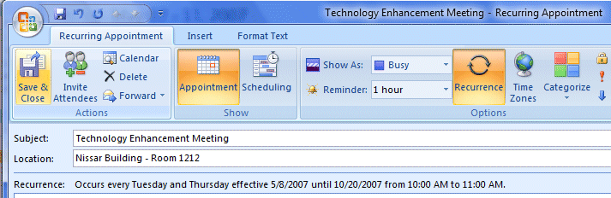
Our screen looks like the one below.

After we clicked Save & Close, we changed our calendar view to 31 Month, and moved to the month of September 2004. You can now easily see, in the image at the top of the next page, that each of the meetings is schedule for the entire month. If you moved to October, you would see the last meeting occurring on the 18th as entered.

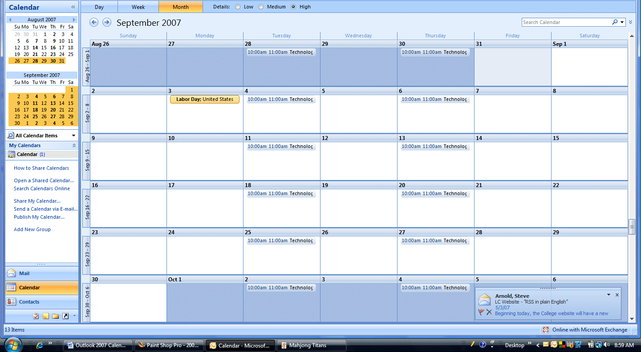

Creating Appointments/Meetings and Inviting Others

Another feature of Outlook Mail Calendar 2007 is the ability to invite others to a meeting you are scheduling. You’ll have to check with your campus/business technology staff to determine if this is feasible. In many places, if the staff does not maintain a personal Outlook calendar, this will not work, as you would not be able to “see” their “busy appointment times.” We’ll go through the process, assuming that the persons selected maintain an Outlook Calendar.

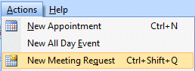
We’ll show you the method we like best. As you become familiar with Outlook Mail Calendar, you may discover a method you like better. Click the Actions tab in the Menu Bar and then click New Meeting Request.

The Untitled – Meeting menu screen will appear (similar to the one below). We have already selected several staff members to determine if the day and time we propose is available for them to meet – we’ll show you how we did this. You can see from the image below that we have selected several people for a proposed meeting from 11:00 AM to 12:00 noon on Thursday,
3 May 2007. The blue lines you see below indicate the times that these staff members are currently busy and could not attend a meeting. We used an AutoPick Next button to select the time you see below between the green (Start) and red (End) lines for our meeting. Now we’ll show you how we did this.

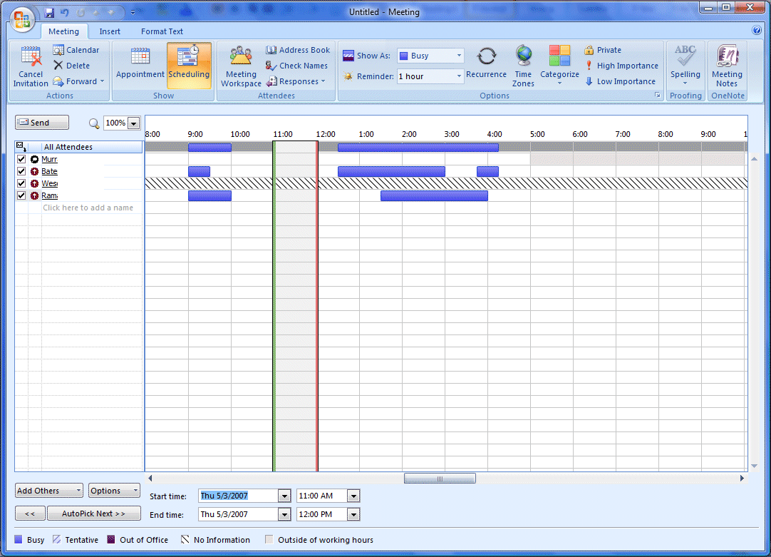

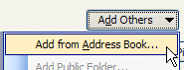
In the Untitled - Meeting menu screen we clicked the Add Others button (see arrow above). When we clicked, the Add from Address Book selection appeared. We clicked on Add from Address Book.

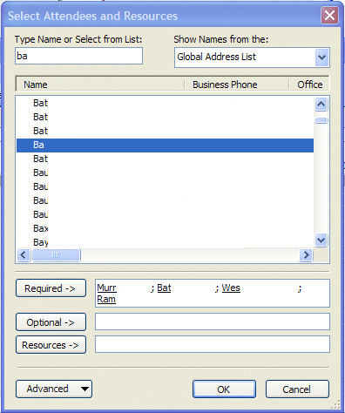
When we clicked the Add from Address Book button, the Select Attendees and Resources menu screen appeared.

In the Type Name or Select from List area we typed the name of a person we are inviting to the meeting.

We then clicked on the Name of that person.

Next we selected Required (as this person is essential to our meeting). We could also have selected Optional.

We repeated this selection process for the remainder of the staff we desired to invite.

When we completed our list we clicked the OK button.

When we clicked the OK button we were returned to the Untitled – Meeting menu screen in the middle of the last page (Page 11). If you look back at the last page, you will see our four names and blue lines to the right of each name. At the bottom of the Untitled – Meeting screen you will see that the color blue indicates the person is busy on some other appointment or task.

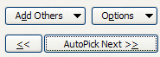
Outlook Calendar 2007 has a nifty button which will assist you in finding “open” times for your group during which you can arrange a meeting. At the bottom left of the Untitled – Meeting menu screen is the AutoPick Next >> button. We clicked this button and a green and red “band” appeared on our calendar and found the first “open” time.
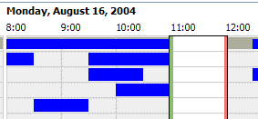
If you agree with this selection, you are ready to complete the scheduling by returning to the Appointment portion of the Untitled – Meeting menu screen. If you are not satisfied with this selection, continue to click the AutoPick button.

You will notice the AutoPick begins by assuming you desire a half hour meeting. You can change this in two different ways. You can place your cursor on the green or red lines (that outline the meeting), hold down the left mouse button and “drag” the line to expand the time. From then on, Outlook Calendar 2007 will assume you desire the longer meeting time selected.

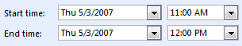
Or, at the bottom of the Untitled –Message screen you can use the Meeting start and end time areas to select a length for your meeting.

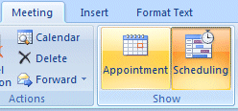
When you have everything just as you desire, click the Appointment button at the top of the Untitled – Meeting screen. This will take you to the Untitled – Meeting menu screen where you will describe the meeting (as you did on Pages 4 -6). When you have completed this screen, Outlook Mail, will send an e-mail message to each of the participants asking if they desire to attend the meeting. The completed screen will look similar to the one below.

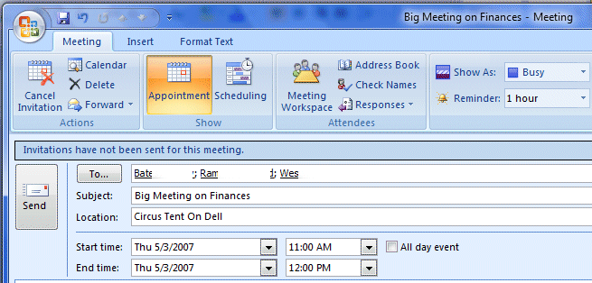

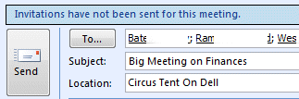
Once you have completed everything, click the Send button at the top of the Meeting menu screen.

As soon as you click the Send button, each person you invited to the meeting will receive a message asking them to either Accept (attend the meeting), Decline (unable to make the meeting) or to accept Tentatively (maybe can make the meeting). Their incoming message will look similar to the one below.

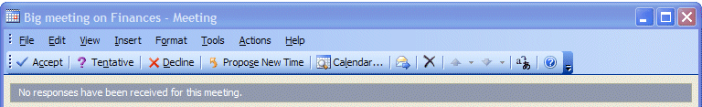

If they accept your invitation, their Outlook Calendar will automatically post this meeting to the Calendar. If they reject the meeting Outlook Calendar will not post the meeting. If they accept tentatively, outlook calendar will post the meeting with tentative colors. You will receive an Outlook message indicating the response of each person invited to the meeting.

Allowing other Outlook Mail Users to View your Calendar

You can allow other Outlook Mail users to view your Outlook Calendar (regardless of the version of Outlook they are using). Make sure you are in your Calendar.

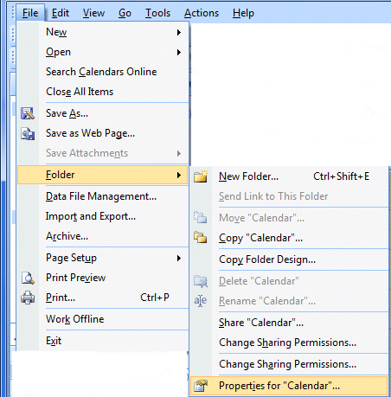

If you desire to do this, click the File tab in the Menu bar, then click Folder and then select Properties for “Calendar”….

The Calendar Properties menu screen at the top of the next page will appear.

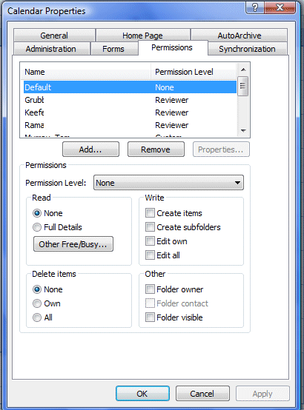

You should be on the Permissions tab in the Calendar Properties menu screen.

To allow someone to view your calendar, click the Add button.

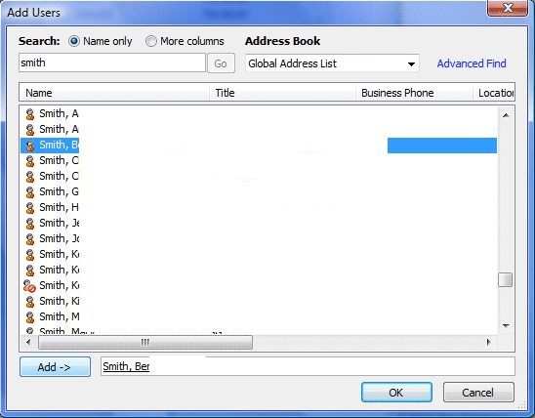
The Add Users menu screen (which you have used several times before in this tutorial), will appear.

Type in the name of the person you desire to view your calendar in the Search area (top left arrow).

Next, click on the name in the Name area. It will turn blue.

Then click the Add button.

Finally, click the OK button.
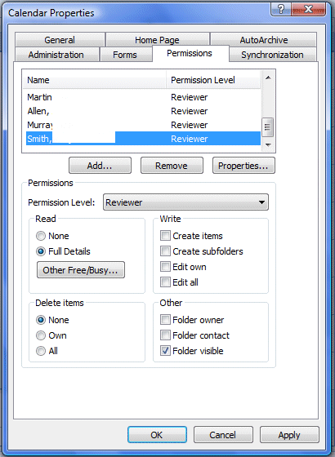
The Calendar Properties menu screen will appear (similar to the image on the right).

You will see the name you entered highlighted in blue.

Below the Name you will see a Permissions area. It is in the Permissions area that you allow the person you entered to view as much, or as little of your calendar as you desire. You can see that you can give them very limited or complete access to your calendar. You select the items that you desire (by clicking in the squares and circles).

Then click the OK button.

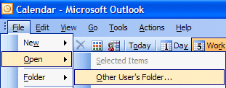
The person to whom you gave permission to view your calendar may now access your calendar, in their Outlook Mail account, by clicking File in their Menu Bar, then clicking Open and then selecting Other User’s Folder.

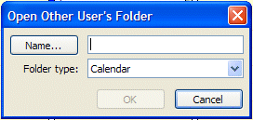
They will now see the Open Other User’s Folder menu screen. They can either click the Name button and select your name from the Select Name menu screen (see Outlook 2007 Mail tutorial), or they can type your name in the area to the right of Name...

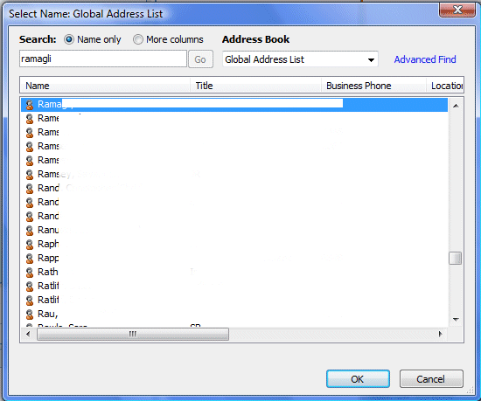

If they type in the person’s name, the Check Names menu screen will appear. They should click the name they desire (it will turn blue), and click OK.

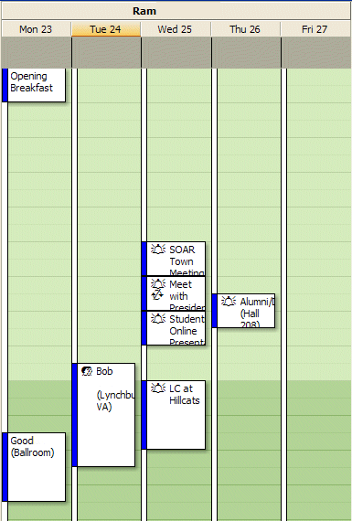

The person you allowed to view your Calendar will now see your calendar. Their screen should look similar to the one on the right.

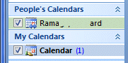
Once the above process has been completed, the next time the person desires to see your calendar, they will see a screen with your calendar available (similar to the image on the right). They can now place a check mark by your name, and your Calendar will appear. To remove your calendar from view, they simply “uncheck” the box by your name.

Microsoft Office Tutorials

In addition to this tutorial, Outlook tutorials for Outlook Mail, Outlook Folder Size, and Outlook Web Access, as well as other Office tutorials, are available at:

http://www.officetutorials.com

This site is updated frequently with tutorial revisions as well as tutorials from a number of collegiate institutions. Please feel free to visit and down load as you desire.

This has been an introduction into the basics of Outlook 2007 Calendar. If you have any questions about Outlook 2007 Calendar, or comments on this tutorial, please contact:

murray.t@lynchburg.edu

Thank you for your patience and good luck.

