Creating a PowerPoint 2000 Presentation
Using Windows 95/98/2000

Revised: 11 November 2002

Starting PowerPoint 2000


Double click on the PowerPoint 2000 icon on the Windows desktop (see right), or click-on the Start button in the lower left corner of the screen, then click-on Programs, and then on Microsoft PowerPoint.

In the PowerPoint menu window below, click-in the small “circle” to the left of Blank presentation, and then click-on OK.

In this tutorial, whenever we indicate that you need to click the mouse, it will mean to click the left mouse button – unless we indicate that you should click the right mouse button. So, always “click left” unless we tell you otherwise.

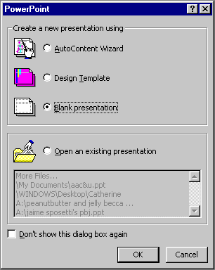

NEW SLIDE

Now a New Slide menu screen will appear (like the one below) that shows you slide layout options. Click-on each of the slide layouts. You’ll notice that as you click on a slide a “blue border” outlines your selection. Highlight each one and notice, in turn, the type of slide shown in the box in the lower right hand box of the menu screen. We’ll start with a Title Slice, so return to the upper left corner of the New Slide menu and highlight the first slide (Title Slide) by pointing cursor and clicking once. Then click on OK to select a Title Slide.
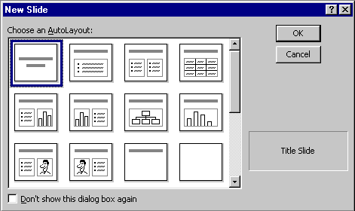

Beginning the presentation

Slide 1

You will notice, in the lower left corner of the screen, that it indicates Slide 1 of 1. You will also see that your screen looks like the one below.

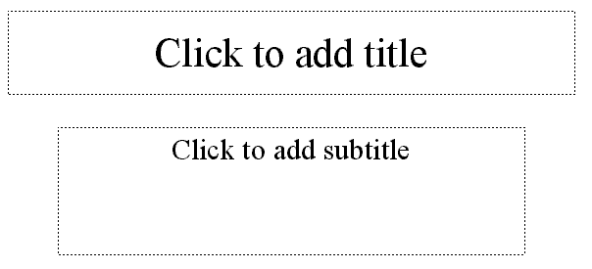

Now we’ll have some fun and create a PowerPoint 2000 presentation on how to make a Peanut Butter and Jelly sandwich.

Point cursor in the “Click to add title” box and Click the left mouse button. Enter (type-in) the title: How to Make a Great PBJ

Click on the second box “Click to add sub-title” and type:

A Gourmet Recipe
From
(your name)

New Slide Button

Now it’s time to go on to the next slide in your show. To do this we’ll need to find the New Slide button.

At the top of the screen, in the top button bar you will see a New Slide “button” which looks like this (see the button on the right):

When you move your cursor arrow over the button you will see that a Microsoft Help Text box appears that says New Slide Button. Click-on the New Slide Button to create your next slide.

Slide 2

You will once again see the New Slide screen. Notice that it defaults to the second slide in the top row; Bulleted List. This is logical since you already have a main Title slide. The Bulleted List is the choice you want, so click-on OK.

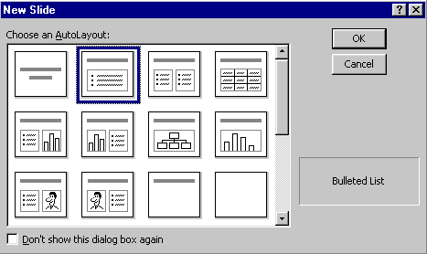

The next slide will look like the screen below:

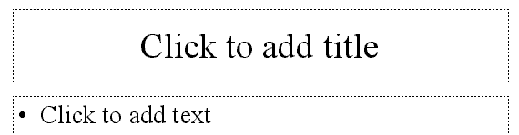

.

Click in the Click to add title box and type: Ingredients.

Click in the • Click to add text box and type:

Crunchy peanut butter (tap Enter)
Homemade strawberry jam (tap Enter)
Two slices of white bread (tap Enter)
Milk

Notice how each line appears with a “bullet” ( • ) in front of it.

Click on the New Slide button again.

Saving your work

Now would be a good time to save your work for the first time. Point to and click-on File in the Menu bar. Next, click-on Save in the Drop Down Menu that appears. You will now see a Menu Screen like the one on the next page. In the upper left corner of the Menu Screen that appears, you will see a Save in:. Click-on the small triangle on the right and it will show you the various disk drives available on which you can save. Point to the one you want, and click-on it. If you choose the 3½ Floppy (A:), make sure you have a formatted disk in the A drive. If you choose the C:, choose the folder in which you want to save by double clicking on the folder.

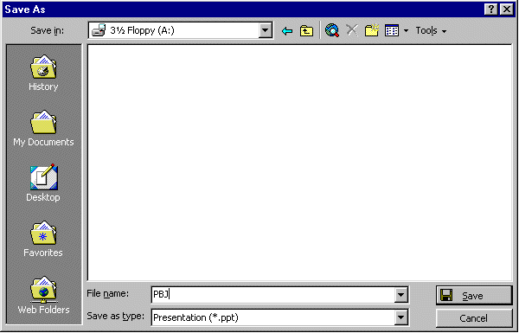
Now click in the box to the right of File name: and delete everything in the box. Then type in pbj and click-on Save.

Since PowerPoint 2000 does not have an auto-save feature we think it’s a good idea to save your PowerPoint presentation after each slide. So we’ll remind you to do this.

Other Slide Views

You probably noticed, as soon as you saw the PowerPoint view screen, the area running down the left side of the screen, which contained “little” views of your slides as you were creating them. This first “default view that you see is called Normal View.

In the lower left corner of the screen you will see some “buttons” the look like this:

Slowly point (move) your cursor arrow over each box and pause a moment (don’t click-on any of the box’s yet). Note what the Text Help boxes indicate. The first box (which looks “depressed”) indicates: Normal View. The next: Outline View. Then Slide View and Slide Sorter View. And, finally, Slide Show.
Click-on Outline View, then click-on Slide View, then click-on Slide Sorter View. Each one has its own unique use.

The Normal View gives you a view of the entire slide as well as the “mini-previews” of each slide in the area on the left. This is the one we have been using so far. You’ll also notice a Click to add notes section at the bottom of the Normal View screen. In this area you can type “speaker notes” for each slide in the lower portion of the screen. When we get to printing you will see that there is a print selection so that you can print your notes for each slide so that you can refer to them later while you are making your presentation.

The Outline view shows you an “outline” of your slides. You may edit each slide, just as you did in Slide View. Since you can see “so much” in this view, many people use this view to create their initial slide show and then go back to Slide View to put in Clip Art and other effects (sound, transitions, etc.). You will also see a small preview of your slide in the upper right corner. As you edit your text and make changes you will see them “reflected” in the small slide. This view is great for adding and editing text, but you’ll need to go to either the Normal View or Slide View to enter graphics, etc.

In Slide View you see the “whole” slide just like you did in Normal view. However, the “mini-preview” area to the left is much smaller so that you can see more of your slide.

In Slide Sorter View you can see small versions of your slides. In this view you can left click-on a slide and, holding down the left mouse button, drag your slide to any position in your show that you desire. This view assists you in arranging your slides in the order that you desire for your presentation. This view is sort of like the old round 35mm slide show trays where you pulled out and stuck in slides in the order you desired.

Save your work!

The Undo Button

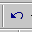
One of the really handy “things” about most Microsoft programs is the Undo Button (it looks like the image on the right). If you make a mistake – no need to panic – click the Undo button and this will remove your mistake. Then you can try again. The Undo Button is found in the middle of the Button Bar on the top of the screen. Each time you click-on the button PowerPoint will “go back” one change. If you want to try it out – go ahead – it’s really neat.

Slide 3
Click on New Slide button once again.

Point cursor to the first slide in the third row (Text & Clip Art). Click-on it, to highlight the slide, and then click- on OK.

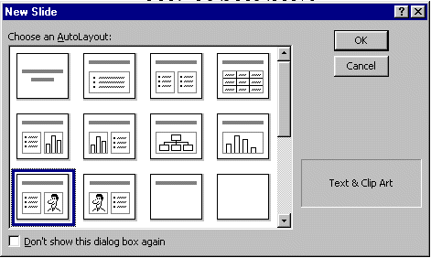

The following screen will now appear:

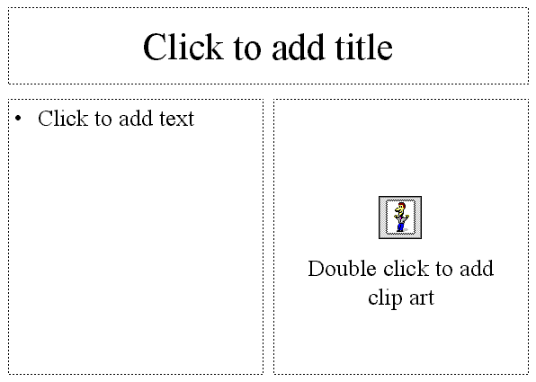

Click-in the Click to add title box and type: Tools Needed

Click in the • Click to add text box and type:

Knife (tap Enter)
Spoon (tap Enter)
Plate (tap Enter)

Glass

Now, Double-click in the Double click to add clip art box. A Clip Art Menu Window will now appear similar to the one below. In the main part of the menu screen you will see various categories of Clip Art (Favorites, Academic, Animals, etc.). Click-on one of the Categories you like. There may not be one you easily associate with a peanut butter sandwich, so choose one you like. Then click on one of the images in your category. Just for the heck of it we’ll choose Animals.

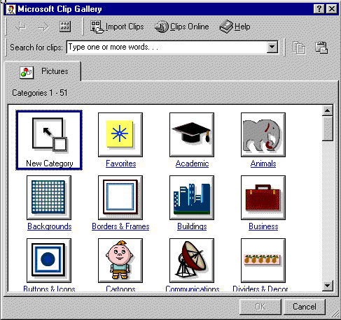

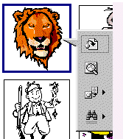
Everyone knows that lions love peanut butter (even though it sticks to the top of their mouths), so we’ll choose a lion as our picture. Click-on the lion. When you click on the lion, a “button menu” will appear similar to the one on the left. Slowly point (move) your cursor arrow over each box and pause a moment (don’t click-on any of the box’s yet). Note what the Text Help boxes indicate. The top box indicates Insert Clip, the one below Preview Clip, then Add clips to Favorites or other category, and finally Find similar clips. Click again on the clip art image you selected and then click on the top Insert Clip button. The Clip Art now appears in your third slide. If you don’t like that choice, double-click on the picture in Page 3 again and select another image.

Note: if your clip art selection does not appear, and you receive an error message, please read on below where an explanation is given.

Microsoft Clip Art 2000

As you’ve just noticed, Microsoft Clip Art 2000 is a lot different than “old” Microsoft Clip Art. There are a lot more pictures and some other unique features.

Just for the heck of it let’s say we want a better image that has more to do with our peanut butter sandwich. So, logically, we’d rather like to have something other than a lion, or whatever you chose. If you’ve closed your Clip Art, open it again by double-clicking on the image in your PowerPoint slide. Notice at the top of the Clip Art screen an area similar to the one below.

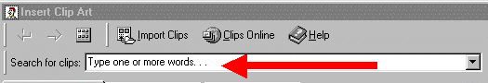

Notice that there is an arrow in the Search for clips: area pointing to Type one or more words…

Click-in the Search for clips: area on Type one or more words… and you will see all of the words turn blue. When you see this, type in the word: sandwich and then tap the Enter key. You’ll now see a lot of clip art that shows images associated with sandwiches in some manner. If you see an image that you like even better than the one you selected choose it and attempt to insert this image.

Notice the graphic below. We clicked on the image you see to the right, then clicked the top button and got the error message below. (If you or someone else who installed the clip art on your computer did not install all of the clip art images on your hard drive then you would get an error message indicating the clip art that was not installed on your hard drive? We’ll, this is the error message you get.)
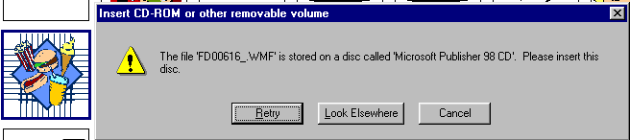
If you get this message you can click on Cancel, or continue trying until you are able to insert an image.

Another “WOW” feature in Microsoft PowerPoint 2000 – Animated Images!

In PowerPoint 2000 you can now have images that “move!” These are called animated images. On any slide you can insert a Clip Art image. You can do as you did above, and the image will “fill” the area where you double-clicked. Most of the time, however, when you get comfortable with PowerPoint, you’ll want to insert an image and then move and size the image as you desire. To do this you’ll need to click-on Insert in the Menu Bar, and then on Picture in the drop down menu, and them move over Clip Art and click on Clip Art. Your screen should look like the one below.

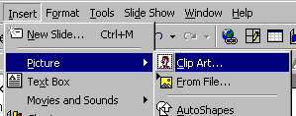

A menu screen similar to the one we just used will appear, but it has two additional features, as you’ll see below.
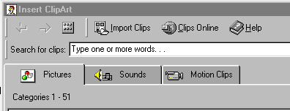

We’ll “get into” sounds later, but now is a good time to learn about Motion Clips. Click-on the Motion Clips “tab” and you’ll see your Insert ClipArt screen change slightly. The Category buttons don’t look any different, but you’ll notice that the Motion Clips tab is now “on top.” We’ll click-on the Animals Category again – so our screen will look like the one below.

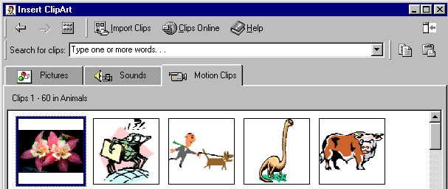

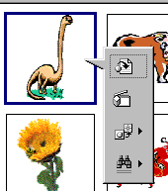
The images you see on your screen are really animated; you just can’t see the movement until you do something neat. Lightly click the left mouse button on one of the images. We’re going to choose the dinosaur. When we click on the dinosaur we’ll see the button menu appear (just like it did when we worked with clip art a little while ago). Except that there is a big difference in the second button. You’ll notice the second button down (arrow on left) indicates - Play Clip. If you click on this button you will see a small screen appear in which you can see the dinosaur chewing its peanut butter sandwich and a lump, as it swallows the sandwich, going down its long neck. This is an animation. If you desire to insert this image you simply click on the top button as you did before. You won’t see this animation when you insert this image into your slide. You will only see the animation when you “run” your slide show. We’ll be running the slide show in a little while.

Click-on several animations and then click the Play Clip button to see the animation. Have some fun and insert several if you wish.

Save your work!

Another “Golly Gee” feature in Microsoft PowerPoint 2000 – Clips Online!

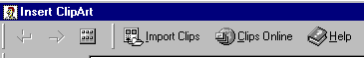
If the clip art images you saw are not enough clips for you – there are still more! You can go online from the Insert ClipArt Menu Screen and get even more clip art. Not only is everything in the ClipArt Gallery available – but even more! Above you will see the top of the button bar that appears when you access the Insert ClipArt Gallery. Notice, there is a button, which indicates: Clips Online (arrow). If you are online – click on the Clips Online button.
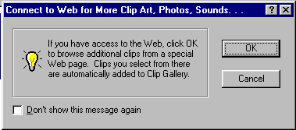
The information screen to the left will now appear. This screen just reminds you that you need to be on the Internet. When you click-on OK the browser you are using will go to the Microsoft Clips Online web page.

It will take a few moments, but the screen below will load.
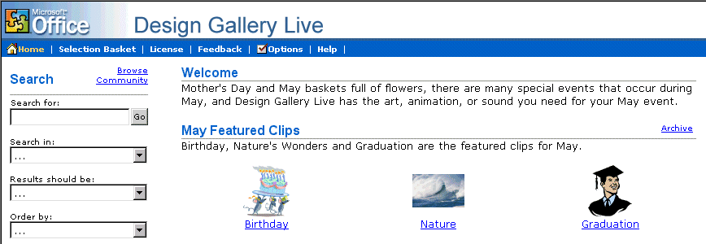
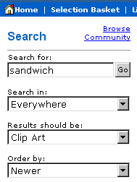

You’ll notice the arrow above points to Search. We filled in the Search for: and Search in: boxes as indicated in the image on the right. When we clicked on Go we received thirteen pages – 13 ! - of sandwich images – everything from hamburgers to subs – and even several that looked like PBJ’s! The neat thing is that if you use one of these images it is automatically added to your Insert ClipArt Gallery!

The top of the Design Gallery web page should look something like the one below. You can view each page by clicking on the >> at the top right of the page.

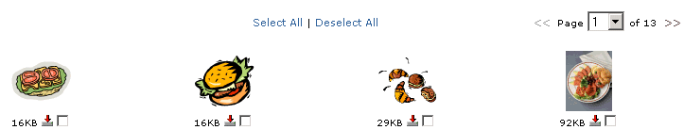

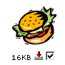
We chose a “hamburger” for our selection. When we clicked-in the little box our screen looked like the image at the right. When we clicked-in the box the check mark appeared and it indicated Download 1 Clip at the top of the screen.

If you select (click) several images, you will see the Download Clip increase as you click-on each box.
When you have selected all of the clips that you desire,
click-on the Download Clips link.

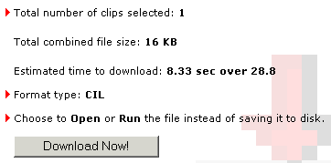
Your monitor screen should now be similar to the one on the left. It indicates how many clips you selected, how much disk space they require, and how long it will take to download them over a modem.

Click-on Download Now!

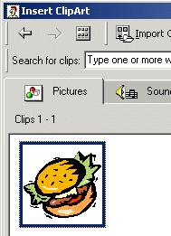

When the download is complete, a screen similar to the one on the right will appear.

Notice that the image you chose now appears in the Insert Clip Art Menu screen. But, if you want that image in the future, where is it “really” located in the Insert Clip Art Menu screen?

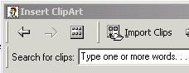
To locate your Downloaded images, click-on the All Categories button at the top of the Insert Clip Art Menu screen.

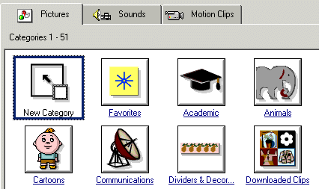

The Insert Clip Art Menu screen at the left will appear. Notice that there is a Downloaded Clips Button. Click-on this Downloaded Clips button and you will see all of the images you have downloaded.

Note: Regular images will be on the Pictures Tab, Sounds will be on the Sounds Tab, and Animated Clips will be on the Motion Clips Tab.

Anytime, in the future, that you desire to use these clips, they will be in the Downloaded Clips area of your Insert Clip Art area. You would load them as we did on Page 9.

Save your work!

Click on New Slide button once again.

Slide 4

Point cursor to the second slide layout (Bulleted List). Click-on it to select the slide, and then click on OK.

Click on the Click to add title box and type: Directions

Click on the • Click to add text box and type:

Open jars of peanut butter and jam (tap Enter)
Spread peanut butter on one slice of bread with a knife (tap Enter)
Use a spoon to get jam and spread it on the other slice of bread (tap Enter)
Put two slices together and cut the sandwich in half (tap Enter)
Put the sandwich on a plate (tap Enter)
Pour a glass of milk (tap Enter)
Enjoy

If your text won’t fit in the box completely, click-on the box and a border will appear around the box. You will notice “little Boxes” at the four corners, and in the middle of the top and bottom, and on each side. Point to either the center top or center bottom box. Click-on either box (and hold down the left mouse button) and drag the top box up or the bottom box down a little to enlarge the larger text area so that text fits on the screen. If your “Directions” are now “mixed-in” with the text below, click-on Directions. Then click-on the “edge” of the “box” (a small up-down-left-right arrow will appear), hold down the left mouse button, and drag the box up a bit.

Save your work!
Click on New Slide button once again.

Slide 5

Click on the first slide in the second row (Text and Chart). Click OK.

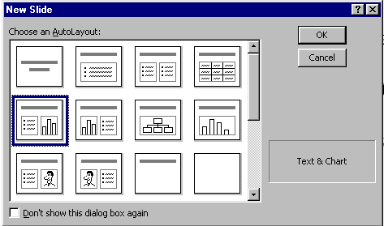

Click on the Click to Add title text box and type: Why use strawberry jam?

Click on the • Click to add text box and type:

100 Children and adults were surveyed to find out what goes best with peanut butter: grape jelly, honey, strawberry jam or sliced bananas (you don’t have to tap enter, as this is one long statement).

Now we’ll make a graph to show the survey data.

Double click-on the Click to add graph box. A Datasheet appears.

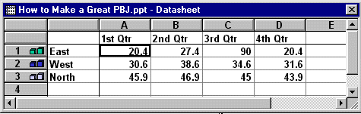

We are going to enter data for our graph in this Datasheet. Click-on the box with “East” and replace “East” with (type-in) Grape, then “West” with Honey, “North” with Straw, and in the cell (box) below North (now Straw), enter Banana. Now, click on “1st Qtr” and type-in Best. Now click-on the cell (box) in the “A” column next to Grape and enter 33, then by Honey enter 11, by Straw enter 46, and by Banana enter 10. Your Datasheet should now look like this:

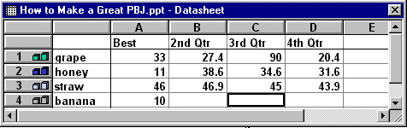

Note: As you are changing the labels and numbers you’ll see the graph that appeared with this datasheet changing to reflect the changes. This is an interactive graph. Really neat – you can see your graph “forming” as you type.

We want a simple graph so we need to delete the rest of the columns. To do this, put your cursor on the B in the Gray area at the top of the Datasheet. Click and hold down the left mouse button and drag right until B, C and D are highlighted. Release the mouse button. Your Datasheet should now look like this:

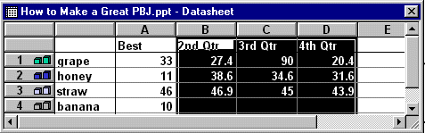

Now tap the Delete key on the keyboard and the columns you have highlighted will disappear.
Your Datasheet should now look like this:
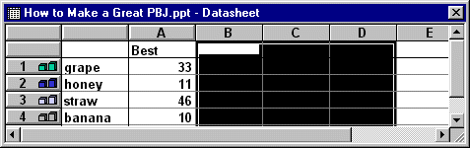

Click the small “X” in the upper right hand corner of the Datasheet.

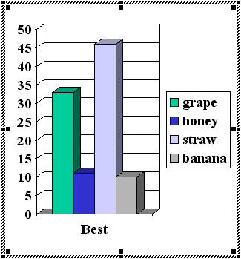

If you did everything right, your graph should look like this:

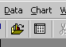
Every now and then you might make a mistake in the Datasheet. If you have “closed” the datasheet as we did above, you can get it back by clicking-on the Datasheet button below the Menu Bar.

This is the Datasheet button

You may or may not desire to alter the appearance of your graph. Your graph may need some adjusting so that all of the “words” show completely. You may want to change the size of the box the graph is in, so click-on the graph. Click-on the side, using the “grabber” boxes on the side like you did previously, and drag the side until the graph gets larger. If you make the graph wider, the word “Best” will move to one line. Click-on the legend (the box with the grape, honey, etc. inside) and move that whole box to the top right hand part of the graph figure to make it more legible. Work with the various parts of the graph until it looks OK. If you make any changes, click-away from the graph to “turn off” the “box” around the graph – so you can see the new slide button.
Save your work!
Click on New Slide button once again.

Slide 6

Highlight the second slide layout (Bulleted List) again.

Click on Add title text box and type: Occasions For Eating PBJ’s

Click on the • Click to add text box and type:

School lunches (tap Enter)
Birthday parties (tap Enter)
Picnics (tap Enter)
Visits from persnickety
grandchildren (tap Enter)
Late night snacks (tap Enter)
At the pool

Now move cursor to the tool bar at the top and click on Insert.

Scroll down to Picture and click. A Clip Art item will then appear. Click-on it.. Once again the Clip Art window appears. Select some picture you like. Try a Motion Clip. Preview the clip as you desire then click on the insert button and the image will appear in your slide. Sometimes the Insert ClipArt menu screen will remain on the screen. If this happens, click the little “X” in the upper right hand corner of the Insert ClipArt screen and the screen will close.

You may need to adjust the position (click in the middle of the picture and drag) and size (by grabbing one of the little white squares [grabbers]on the frame and dragging it to the desired location and to change its size).

Save your work!
Click on New Slide button once again.

Slide 7

Click on the third slide, third row (Title Only) to highlight and click on OK.

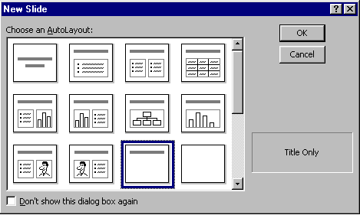

Click in the Click to add title box and type: Enjoy your sandwich!

Now, let’s make the letters larger. Highlight your ending (Enjoy your sandwich!) by putting your cursor at the beginning of the first word, click and hold down the left mouse button and drag it across the words, then release the left button. The Title should be highlighted it should look like the picture below.



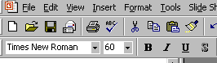
Now, put your cursor on the box under the tool bar that has a number in it (when your cursor is on it the Text Help box will indicate Font Size). Click on the down triangle and scroll down to 60 and click. You should now see larger text than you had before. You can do this to any text in your PowerPoint presentation. You can also change your font style by clicking on the box to the left of Font Size if you desire.

Save your work!
AutoShapes

We’re now going to try something new – a technique for adding clever shapes and a few “secret” things to our slides.

First, point the cursor away from the Title box and click the left mouse button. This is called “clicking away.” This will “turn-off” the square “box” around the Title.

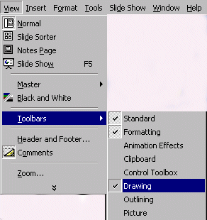
Next, point to View in the Menu Bar and click. When the menu list appears, move the cursor down to Toolbars. Look at the Toolbars drop down list. Notice that, normally, the first two selections (Standard and Formatting) have a small check mark in front of them. This indicates that these toolbars are visible on the screen. Look further down the list until you see Drawing. If you see a check mark (like in the picture on the left), then simply point away from the drop down menu, click the mouse, and look for the Drawing Tool bar. If you do not see a check mark, click-on Drawing. The Drawing toolbar will appear at the top, side or bottom of the screen. It will look like the tool bar below.

Now click-on AutoShapes and a small box of shapes will appear.

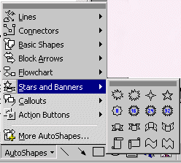
Move up and down the pop up menu box and notice the different shapes that appear next to each choice. Then,
click-on Stars and Banners. Click-on the first starburst in the top row. When you have clicked, the cursor will change to “cross hairs” when you move it into the slide area.

Now move the cross hairs up into the area just below the title. Click and hold down the left mouse button, and drag down and to the right. Release the button. A starburst should appear as below.



Enhancing the presentation:

Not too spectacular? Let’s spice it up!

Click-in the of the starburst. Then, type the word WOW! You will see WOW! appear in the starburst. It’s sort of like a “hidden” text box. Click the left mouse button in front of WOW!, hold down the left mouse button, and drag across WOW! to highlight the word. Click-on Format in the Menu Bar and then click-on Font. The following Font Menu screen will appear. Change the Font style, Size, and Color. Bold or Italicize if you want. Be as creative as you desire and then click-on OK.

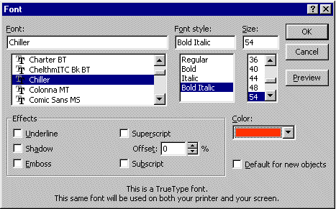

From now on you can “change” any of your text using this method.

Save your work!
Click on New Slide button once again.

Slide 8

For the final slide choose the third slide in the third row – Blank.

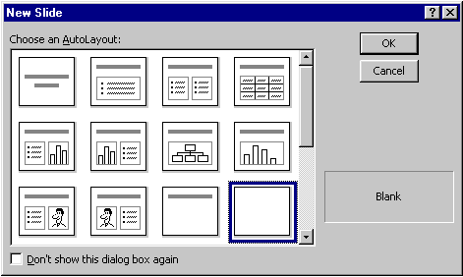

Text Art:

Now we’ll use some Text Art. In the Drawing Bar, which should be open, find a “blue A” that is slightly tilted (like the one on the right). When you pass your cursor over this “button,” it will indicate: insert WordArt. If the Drawing Bar is not available, click-on View in the Menu Bar, then click-on Toolbars and select Drawing by clicking-on it. Click-on the Insert WordArt button. The following WordArt Gallery menu screen will appear. Select one of the WordArt patterns by clicking on it. Next, click-on OK.
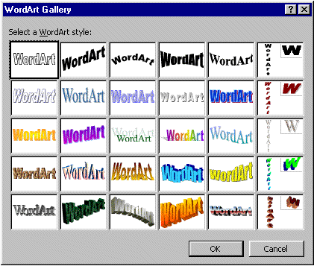

The following Edit WordArt Text screen will appear. Where the screen indicates Your Text Here, type-in: Enjoy your Sandwich. Select a different font and size, if you desire, then click-on OK.

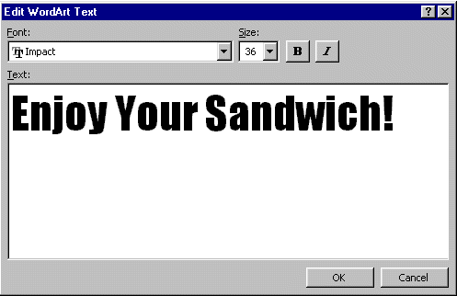

You will return to Slide 8 and see the WordArt you created. You use the “grabbers” (little squares on the corners) to make the text larger. You may also move your text as you desire.

If you want to change the “look” of your WordArt, you’ll need to be able to see the WordArt toolbar. It looks like the toolbar below.

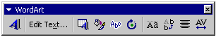

Most of the time the toolbar appears when you click on OK and the WordArt you selected appears. If the toolbar does not appear, point to the center of the WordArt and click the RIGHT mouse button. A WordArt drop down screen will appear. A choice will be: Show WordArt toolbar. Click on this choice and the toolbar will appear.

You may click-on the different “buttons” to edit your text. We’ll get into this more on the next page.

Insert WordArt and Edit WordArt Text

Starting from the left you already know what the first two buttons will do. The blue A will allow you to add another WordArt. The Edit Text button will allow you to change the text in your WordArt.

If, for some reason, you accidentally “click-away” from your WordArt, you’ll loose the grabbers and your WordArt toolbar. Not a big deal. To “activate” both, simply place the cursor over the WordArt and click the left button on the WordArt. Both will re-appear.

WordArt Gallery

The third button in from the left will bring up the WordArt Gallery again. If you do not like the WordArt “style” you chose, you can choose another.

Format WordArt
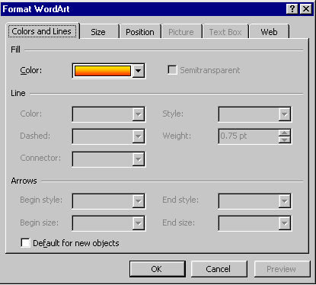

The fourth button in from the left will allow you to change a number of “things” in WordArt, and in other PowerPoint features. When you click on this button the menu screen to the left will appear.

Notice that there are a number of “tabs” at the top of the menu. You can click- on the tabs and get a “feel” for what each will do. We’ll just click-on the Color choice for now (see arrow to the left).

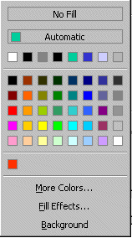

When you click-on Color the drop down menu to the left will appear. We’ll work with a similar menu later on. For now, just move your cursor down to More Colors and click on it. The Colors menus will appear similar to the one below.

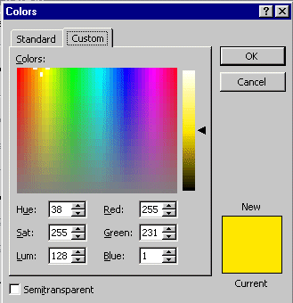
There are a lot of really unique features with the color palettes in Microsoft software. The Custom color pallet that you see on the left has two “big” features. The first feature is that you can click anywhere in the pallet and the color in the area where you click will be shown in the lower right corner. After you have selected a color you can “drag” the small arrow “triangle” on the right of the screen up and down to lighten or darken the color you chose. We’ve marked where you can click and the “up and down” triangle with arrows in the diagram on the left. Select a color and give it a try.

Once you have selected a color, click-on OK. You will see the changes in your WordArt.

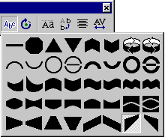
WordArt Shape

When you click-on the fifth button from the left, it has an “Abc” on it, the image at the right will drop down. If you would like to change the shape of your WordArt text to a new shape, click-on one of the shapes in the choices chart to the right. You will see your WordArt change to that shape. Give it a try.

Free Rotate

When you choose the sixth button from the left – it will indicate Free Rotate. When you click-on it you will see small green circles at the four corners of your WordArt image. When you move your cursor off the toolbar you will notice that the cursor has changed to look like the toolbar button – a small circle with an arrow. When you place the circle-arrow “around” one of the corner green dots and hold down the left mouse button, and drag, you will notice that your whole WordArt will rotate as much as you want it to. Give this a try.

The last four buttons on the right adjust text spacing, alignment, etc. Work with them, as you desire.

When you have finished your editing, you can close the WordArt edit toolbar by clicking-on the little “X.” in the upper right corner of the toolbar.

Save your work!

Text Box

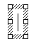
The last “tool” we’ll work with is the Text Box. The Text Box is also in the Drawing toolbar. The Text Box button will allow you to insert text in your slides if the template you chose does not have the desired Title and Bullet boxes. To insert text, click on the Text Box button. It has an “A” in the upper left corner of the button with some text below (it looks like the button above on the right). After you click-on the Text Box button, move the cursor into an “open” area of Slide 8. It will look like a “little sword” as you move the cursor. When you get to an appropriate place, click the left mouse button and a “text entry area” will appear (it looks like the image on the right).

Don’t worry about its size. Just type the following: THE END. The text box will automatically resize to the text entered. You may now highlight this text, and by clicking-on Format in the Menu Bar and Font, as you have done before. Edit this text – make it larger, change the font and pick a color that you like.

Save your work!

Viewing your Slide Show

You have just completed the first stage of your presentation. Go back to Slide 1. You can do this by using the “elevator bar” on the right edge of your screen. If you click at the top of the elevator bar you will keep moving up, from Slide 8 until you come to your first slide. It will indicate Slide 1 of 8 in the status area in the lower left corner of your screen. You should recognize this slide as your first slide on how to make a PBJ.

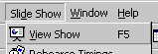
If you would like to view how your slide show will look when you project it onto a screen or a monitor, go to the tool bar at the top and click on Slide Show and click on View Show (like the image on the right).
Or, you can click-on the small Slide Show button in the view buttons bar at the lower left of the screen.

There are several ways to advance through your slide show. You can tap the space bar, tap the Enter key, tap the right arrow key, or click the left mouse button to move forward from one slide to the next during the show. When you get to the end of the “show” the presentation will return to your slides. Anytime you want to end the show, simply tap the Esc key in the upper left-hand corner of the keyboard or click the right mouse button and click on End Show in the pop up menu that appears. If you end the show “early” you will be on the slide you were viewing when you tapped Esc or clicked-on End Show.

To “go backward” to a previous slide in your show you can tap the Backspace key, or the left arrow key.

Transitions:

Now we’ll add some pizzazz to our presentation. When you viewed your slide show a few moments ago it was simply like “flopping down” plastic transparencies on an overhead projector. Nothing really fantastic. Now we’ll add some motion, animation, sound, and color and really make our presentation something to view.

Go to the Slide Sorter button at the bottom left area of your screen. Click on the button with four white squares.

You can now see all eight slides (as shown below). Lightly, click once on the first slide to highlight the slide (a heavy black border will surround the slide – see arrow below). Now point in the middle of the slide and click on your RIGHT mouse button. The right click will “always bring up” a menu that is “tailored” to the “place” where you click. This will work in any Microsoft Windows product. You can always tell “where” you click the right mouse button for the cursor arrow will always be in a corner of the menu that appears. From the menu that appears, select Slide Transition (click-on it – see arrow below and to the right).

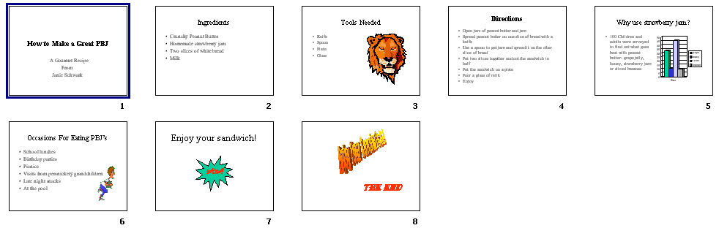
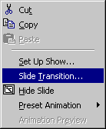

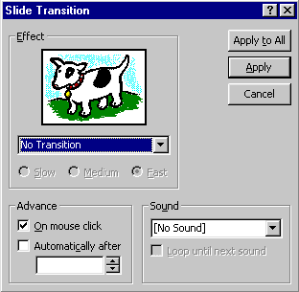

You will now see the menu box to the left - Slide Transition. This menu box will allow us to create “transitions” as we go from one slide to the next. You’ll see what Transitions are as we work with them. To determine how the slides will “change or look” you need to watch the little dog and the Key as you do the following.

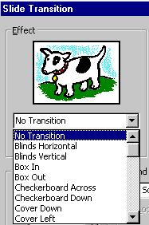
To activate a transition, click on the triangle on the right hand side of the box, which indicates: No Transition (see arrow on left), to see your choices. Scroll up and down the list noticing how each transition works by clicking on it and then watching the dog or key in the Effect box.

If you think the show is moving too fast, click in the little circle to the left of Medium or Slow.

Each time you click-on the Dog or Key you will see the transition you selected repeat itself. Give this a try.

This screen also allows you to time you transitions from slide to slide. For now, leave it as it is. When we complete all of the enhancements, to all of the slides, you can do one of several things to “automate” your slide show. Later on, you can return here and Click on Advance Automatically After, and insert 5 to 10 (for seconds) in the box. Or, you can “rehearse times” for each slide and all of its effects. We’ll come back to this in detail at the end of the tutorial.

Notice that instead of the normal OK, that Apply and Apply to All are listed for Transitions. Apply activates the transition you chose for just the slide you are “on.” Apply to All activates the transition you chose for ALL of the slides in the “show.” If you scroll down to the last choice in the transition list you will see Random Transition. This will place a different transition every time you click the mouse to go to the next slide, or if you select Apply to All, each slide will have a different transition. You can follow this procedure for each of the eight individual slides, or select Apply to All. To transition “each” slide individually, click on Apply, then click on the next slide to highlight the slide, click the right mouse button, select transition, choose your effect, and select Apply.

Also notice in the lower right corner the Sound area. Currently, the box indicates [No Sound]. You can click-on the down triangle and see Microsoft “Clip Sounds”. If you choose one of these sounds, the sound will be heard as your slide transitions. You can pick one now, or wait until later. Make sure that the volume on your computer, speaker or headphone is on and “up” so you can hear the sounds as the slide’s transition.

Again notice in the upper right corner of the Slide Transition box that it indicates Apply to All - and also Apply. If you click-on Apply to All, PowerPoint 2000 will apply the transition and sound you chose to ALL of the slides. This is wonderful if you want the same sound, each time, a slide transitions. If you don’t want this effect, click-on Apply, and the transition and sound will only apply to the slide you’re on. We’d like to hold off on the sounds here. Again, if you “run” all the way down to the bottom of the Effects box, you will see Random Transition. If you click-on Random Transition, and then click-on Apply to All, then all the slides will each transition randomly. You can alternately click-on the dog and key to view the transition effects. When you have decided which transition you want click-on either Apply or Apply to All.

When you return to Slide Sorter View, you will notice a small box with an arrow at the lower left corner. This indicates that a slide will transition. If you click-on it you will see the effect each time you click.

Build:

Building is a term indicating how each line of the text, on a slide, will enter the screen. The lines, words, letters, pictures and charts can fly in from almost any direction. To Build the text on each slide, follow these directions.

Go back to Normal View. You can do this in Slide Sorter View by double clicking-on the first slide, or Clicking on the Normal View button on the lower left of the screen. When the Normal View screen appears, click-on the first line of text. The “box” you saw, when you first typed text in this box, will appear. This indicates that the box is “active.” It will appear as below.

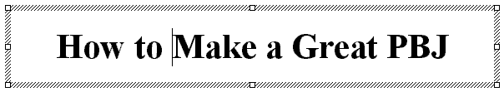

Now, right click in the box.

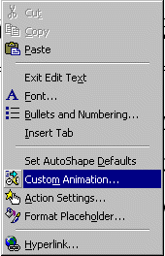

When you right-click, the following menu will appear. Click-on Custom Animation…

The following screen will appear:
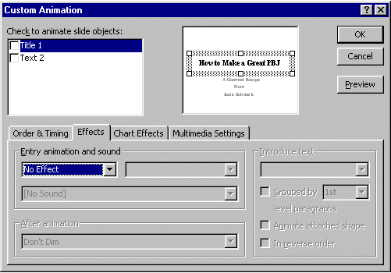

Notice a number of “things” in this menu screen. In the upper right, you see a small picture of the “text area” you clicked-on (see arrow). This confirms your “click.” In the lower half of the screen there is a “tab box.” Notice that it “defaults” to an Effects ”tab”. In a manner similar to Slide Transitions, text, graphics, and pictures can also transition. Click-on the small triangle to the right of No Effect (see arrows). You will see effects similar to those in Slide Transition. Select an effect and click-on one. You will not see the effect immediately, as you did in the Slide Transition screen. Notice, however, as soon as you select an effect, several other areas of this menu screen become “active.” See the image below.
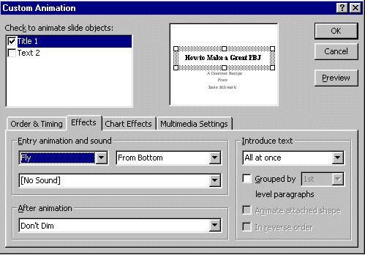

Preview Button

First notice to the right an area labeled “Introduce text.” Click-on the small triangle.
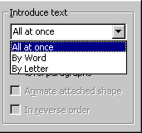

This area indicates the manner in which the text you have selected will enter the slide. All at once means what is says. The whole title will enter at once. By Word means that the text will enter word by word. By Letter means that the text will enter letter by letter. It’s a lot of fun to experiment here. Try them all.

Next we’ll cover sound. It is neat to combine certain sounds with certain text introductions. For example, the By Letter introduction combined with the Typewriter sound, looks and sounds like text being typed in one letter at a time.

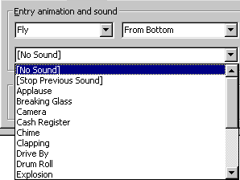

Now notice the Sound area on the left. Click-on the small triangle and select a sound from the list.

When you are good with these sounds you can try the sounds you saw in ClipArt earlier.

You can view these build effects by clicking on the Preview button (in the upper right corner of the Custom Animation Menu Screen – see arrow and label above). You can click the Preview button any time you desire - as you are creating text, picture or other animations. You will notice in the upper left corner of the Custom Animation Menu box an Animation Order box. Each time you click-on OK, as you complete an animation, the “thing” you animate will be added to the list, in the order in which you added it to the slide. If you desire to change the order of your animated “things,” you can click-on the thing you desire to move up or down and then, by clicking-on the arrows to the right, you can move the text or object up or down. When you have completed the first slide, move to each successive slide, click-on the various text boxes or objects, and repeat the process.

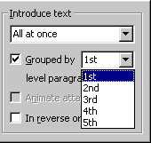
One additional “item” in the Custom Animation menu screen. When you click-on a text area that is a bulleted list you will see an additional effect – Introduce text. The Grouped by “1st” level paragraph indicates whether one line, or multiple lines, will enter. Here is another area where it is fun to experiment.

Dimming

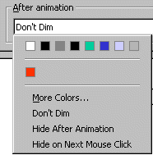
Notice below the Sound area an area that indicates After animation:. This applies to the text in Bulleted Lists. To “highlight” the bullet, to which you are speaking, you can “dim” previous bullets by clicking-on the small down triangle to the right of Don’t Dim. After you click-on the triangle you will see a “set” of colors selected for the background which you are using. You can click-on a color of your choice and then look at the slide in Slide Show. As you click-on each successive bullet in the Slide Show you will see the “dimming” effect.

Sound

Be Careful with Sound

This simply reminds you not to forget sounds for Transitions and Builds can enhance your presentation. Be careful, sometimes too many effects can overwhelm and detract from a presentation. As you become more experienced with sounds and web pages you will find web pages devoted to sounds and clip art. In the Front Page 98 and 2000 tutorials there is a section on WAV sounds. If you desire a copy of either of these tutorials, simply e-mail the addresses at the end of this tutorial. You may want to experiment with some other sounds you “download and save” form the internet.

Don’t forget to keep saving your presentation often as you enhance it with these effects.

Add color

Slide Color Schemes

Now for some color!

There are a number of different methods you can use to add color. First we’ll use some basic methods and then try some “exotic” effects.

First go to Slide Sorter View and then click-on Slide 1. By being in Slide Sorter View you’ll be able to see the different color effects in several slides at the same time.

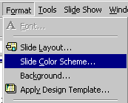
Now, click-on Format in the Menu Bar and then click-on Slide Color Scheme.

The following menu screen will appear.

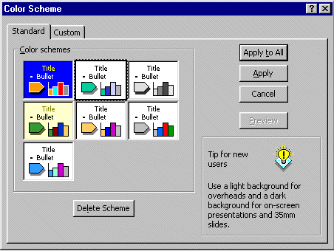

As you can see in the screen above, there are several color schemes from which you can choose. Click-on one, and then click-on Apply. The first slide in Slide Sorter View will now have those effects. Repeat the process until you find one you like. Note: if you click-on Apply, this applies the colors to just Slide 1. And, if you click-on Apply to All, then all of the slides have the selected color scheme.

You will notice at the top of the Menu screen that there are two tabs (see the arrow above). You are currently on the Standard tab. Click-on the Custom tab (the menu screen on the next page will appear). This allows you to change specific colors in the Slide Scheme that you chose. Click-on a couple of these to see how this works.

Save your work every now and then!

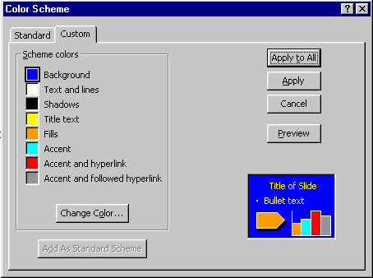

You can try this on several slides, if you want. Once you have the hang of it, there are several ways you can enhance these effects.

Backgrounds

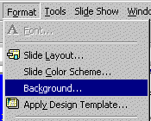
Now click-on Format in the Menu Bar again. Next, click-on Background.

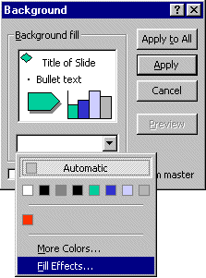

The following Menu Screen will appear. Click-on the small triangle in the bottom portion of this screen. Now click-on Fill Effects.

Notice, in the Fill Effects Screen Menu below, that there are a number of choices (tabs at the top) – Gradient, Texture, Pattern and Picture (see arrow below).
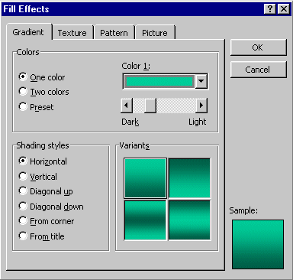

Gradient

Click-on several of the Shading Styles (Horizontal, Vertical, etc.) and observe the effects in the lower right in the Variants and Sample areas. Notice that there are four choices in the Variants area. As you click-on each of the individual “squares” the choice will appear in the Sample area. If you click on OK at any time, the Background you see in the Sample will be the background on the slide. You will return to the Background Menu screen when you click-on OK. You will see a miniature version of what your slide will look like in the lower right corner of the Background menu screen.

Note there are three color choices: One color, Two colors and Preset. If you click-on one of these, you will see the same color choices that you saw when you used them for text. So, have some fun and “click-away.”

Texture and Pattern

Also, note the tabs at the top. Click-on Texture and Pattern and observe the effects. In Texture you use the “elevator bar” to the right of the textures to see all the selections. You then click-on the Texture of your choice. In Patterns, you simply click-on the Pattern of your choice.
Picture

If you want your entire slide to have a picture as its Background, this is what the last tab is for. You need to click-on Select Picture. This will take you to the Windows “Open File” and then you can select a picture you have saved. The FrontPage 2000 tutorial goes into this in great detail. When you have the picture you like, click-on OK and then click-on Apply.

Design Templates

Now we’ll do something that’s awesome. We’ll apply Design Templates to our slides. Design Templates will convert ALL of our slides into a theme. Each slide will have the same color scheme and the formatting will change to a special look.

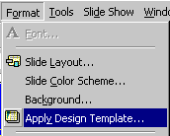
You can be in any View (Normal View, Slide View and Slide Sorter View are preferable) to select Design Templates. Click-on Format in the Menu Bar, and then Click-on Apply Design Template.

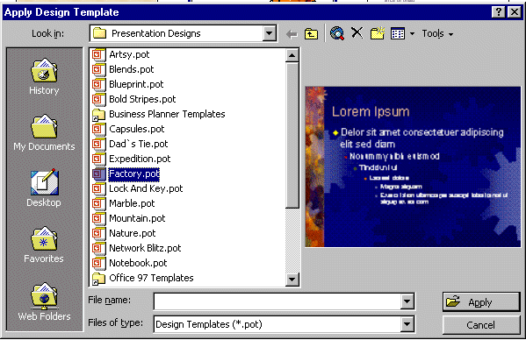
Click on the choices on the left side of the window (see arrow below). On the right side a special template will appear with its own formatting. Pick a Design Template you like and then click on Apply. Be sure to scroll up and down and to click on additional choices. Note: with Designs, they are automatically applied to all of the slides. You may choose additional effects for the Designs by using the Background and Slide Color Scheme selections.

Run the show:

Well, now you have a real presentation. Make sure you are on Slide # 1. Go to Slide # 1 either in Slide Sorter View, Normal View, or Slide View. If you would like to view how your show looks, either go to the Menu Bar at the top and click-on Slide Show, then click on View Show, or you can just click on the Slide Show button at the bottom of the screen. Then, to advance, either tap the left mouse button, Space Bar or Enter key. If you desire to end the show, either tap the Esc key, in the upper left portion of the keyboard, or click the right mouse button and then click-on End Show.

If you have set times for your slides and desire to have the show run in “automatic,” Click-on View Show and then on Set Up Show in the Menu Bar. The following menu screen will appear.

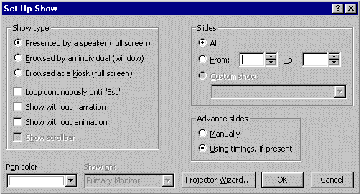

In the Advance slides box, click-in the circular area to the left of Using timings, if present. This will then run the show with the timings you selected.

Notice that there are a lot of enhancements in this Set Up Show menu screen. Experiment, as you desire. You can always come back and change them. Click-on OK when you have made your changes.

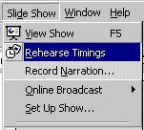
To really get precise timing for each slide transition, sound and build you can use a feature to set each movement precisely. Click-on Slide Show in the Menu bar and then on Rehearse Timings.

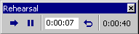
A small, rehearse timings “box” will appear – like the one on the left. It will “show” a running clock on the right side of the menu – that indicates the time for the entire show. In the center you will see another time for each “click” – transition, build, etc. When you click through your show, as indicated above, the timings will be recorded. When you then run the show it will run at the recorded pace. You can do this as often as you like.

Now save the presentation as you did before. Then File, Exit Power Point.

These are the basics for a PowerPoint presentation. You may want to try tinkering with the color menus and the timing options.

If you have any comments on this tutorial, send an e-mail to the internet address below.

Murray.t@lynchburg.edu

Thank you for your time, effort, and patience. Good luck!

